UOML Manual

I. Brief Introduction 1
1. Audience 1
2. Overview 1
3. Security Model 2
Overview 2
Roles and Sessions 2
Discretionary Access Control (DAC) 2
Data Signature 3
II. Command Formats 3
1. Operations 3
1.1 UOML_RET, Return Values 3
1.2 UOML_OPEN, Create or Open a DocBase 4
1.3 UOML_DELETE, Delete Some Sub-Object of an Object 4
1.4 UOML_CLOSE, Close a Handle or a DocBase 4
1.5 UOML_SET, Set Object Data 4
1.6 UOML_GET, Get Object Data 5
1.7 UOML_INSERT, Insert an Object to an Index Position of Its Parent Object 5
1.8 UOML_USE, Set Some Object As Current Object 6
1.9 UOML_SYSTEM, System Function 6
2. Example 6
3. DOCBASE Logical Structure 7
III．Definition and describtion 9

Brief Introduction
The article describes the definitions, logic models and object Schema descriptions of Document Operation Language (UOML) based on unstructured data. Unstructured data cannot be abstracted to a three-layer model of structured data. For written documents of unstructured data whose logic depth possibly reach the tenth layer, we take the logic model as a reference to abstractly define a universal and representative UOML.
Keywords:
DocBase (Document Base), UOML (Unstructured-doucment Operation mark-up Language), PageSet, LayerSet and SurXML (an XML binary format from Sursen Corporation)

Audience
UOML users, UOML design reviewers, UOML Standardization Association, DocBase designers and DocBase developers

Overview
UOML is the operation interface orienting written information processing, which separates the core processing technologies (such as description, storage, processing, management and presentation) for written information from actual applications. The application model of UOML is implemented through the DocBase technology. According to the experiences from developing database systems, the implemented DocBase technologies divide industries in the field of written information processing, and forming the situation similar to database industry. The method has the following advantages:
- Providing documents with the best versatility
Applications of different kinds access the DocBase through standard UOML, and extract document information through uniform interfaces, enabling the same document to be universal between different applications.
- Forming industry division, reducing repeated development, and being more professional, complete and correct
Basic operations on documents are performed in the DocBase system, and an application needs not be developed repeatedly. Moreover, the DocBase system is developed by professional vendors, so specialty, completeness and correctness of relevant technologies can be assured. Application software vendors and users can also choose the best DocBase system vendors to ensure the correctness and consistency of the processing effects.
- Providing management mechanism for many documents (even mass documents)
Documents are organized efficiently for retrieving, querying and storage, as well as for embedding powerful information security mechanism.
- Providing better security mechanism
Several roles can be set, and the permissions of each role can be set fine-granularly. Fine-granularity is duplex. On the one hand, you can set the permissions of the whole document or a tiny part of the document; on the other hand, you can set several types of permissions, not just the traditional read/write/inaccessible permissions.
- Innovation and rational competition are encouraged
After the rational industry division is formed, DocBase system vendors and application vendors will compete with each other in corresponding areas. The condition, such as Microsoft Word mo0nopolized application software by the document format, will not occur. Each DocBase system vendor can also add new features beyond the standards to attract users, and the standards will not restrict innovation.
- Optimizing performance with better portability and scalability
All platforms and performance comply with the same calling interface, thus you can continuously optimize performance and migrate it to different platforms without changing UOML standards.

Security Model

Overview
The information security model of the DocBase is role-oriented, consisting of access control and data signature.
Access control implements Discretionary Access Control (DAC), controlling the read, write and print permissions on node trees.
Data signature implements the signature of the node tree.
Permissions in access control and signatures in data signature are specified for roles.

Roles and Sessions
To access a security document, a session must be started. The data controlled by the permissions can only be accessed in the session, and signature and verification can only be implemented in the session.
An application can provide authentication mechanism in one session to log on as one or more roles. Permission checking, signature and verification are for the role as which current session logs on.
The definition of a role, which is identified by a pair of public and private keys, is valid DocBase-wide. The public keys of roles are saved in the DocBase, while the private keys of roles are saved outside of the DocBase. A front-end application is responsible for the security of roles. When you log on as a role in a session, you need to provide the private key of the role.

Discretionary Access Control (DAC)
Access control mechanism of the DocBase is discretionary access control (DAC), namely the security control mode allowing granting or revoking according to the current permissions.
This security model can control the access to a specified node and its sub-tree, which can be called as controlled node (tree). This model can control the read, write, print and administrative permissions of nodes. When authorizing or revoking permissions, current logged role must have administrative permission on corresponding node tree.
Some part of access control is implemented based on the public key encryption mechanism. The controlled node is encrypted in the storage layer, and the encrypted public and private keys are saved in the DocBase in the form of ciphertext. For role r, if r has read permission on the controlled node n, the DocBase must have saved the encrypted private key of n (encrypted using the public key of r); if r has write permission on n, the DocBase must have saved the encrypted public key of n (encrypted using the public key of r). This mechanism ensures that a role cannot get the plaintext of a node if the role does not have corresponding read and write permissions.

Data Signature
Data signature can sign the specified node sub-trees at any possible limited depth, from its root node.
Tree signature of the DocBase implements regularization at binary level. During tree signature, you must sort and code the structure and data of the tree in some way, and then sign the tree. Sorting and coding may cause trees with different data to form the same data to be signed. Currently implemented data signature mechanism can avoid same data caused by data sorting at tree structure, node and attribute levels.
At present, ECDSA is the supported signature mechanism.

Command Formats

Operations

UOML_RET, Return Values
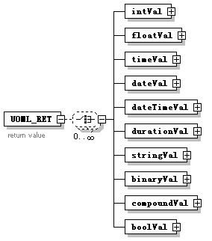
Functions:
Return value is represented by UOML_RET. UOML_RET can contain several return values, each of which is represented by UOML_RETVAL.
In the call level interface (CLI), the return value is generally contained in an XML character string returned by the interface.
You can invoke the corresponding XML analyzer to analyze the data.

Specifications:
Generally, UOML_RET contains at least one val sub-Element describing whether the operation is successful. The name attribute of this val sub-Element is “SUCCESS”. At the same time, the sub-Element boolVal of val appears, whose val attribute is of xs:boolean type, describing whether the operation is successful. If the operation fails, UOML_RET also contains another val sub-Element with the name attribute as “ERR_INFO”. StringVal in this val sub-Element becomes validated, describing the error message. For other return values, refer to the definitions of specific operations.

1.2 UOML_OPEN, Create or Open a DocBase
Figure:
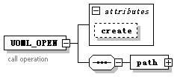
Functions and parameters:
It is used to create or open a DocBase. You need to provide the DocBase path in the path sub-Element. When the value of the create attribute is true, a DocBase will be created.
Note: In UOML operations, parameters often appear as the direct sub-Elements of the operation tag. Available parameter types include all tags beginning with DOT.
Return value specification:
When the operation is successful, the returned UOML_RET also includes one val sub-Element representing the handle of the DocBase. The name of the val sub-Element is “HANDLE” and stringVal sub-Element becomes validated.

1.3 UOML_DELETE, Delete Some Sub-Object of an Object
Figure:
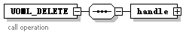
Functions and parameters:
It is used to delete some object. You need to specify the handle of the object.
Return value specifications:
There are no other return values except the general return value.

1.4 UOML_CLOSE, Close a Handle or a DocBase
Figure:
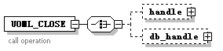
Functions and parameters:
1) Close the object handle and transfer the parameter handle.
2) Close the DocBase and transfer the parameter db_handle.

Return value specifications:
There are no other return values.

1.5 UOML_SET, Set Object Data
Figure:
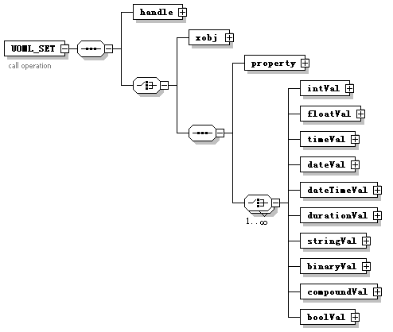

Functions and parameters:
It is used to reset the content of some object. Handle represents the set object and xobj represents the new content.
Return value:
There are no other return values except the general return value.

1.6 UOML_GET, Get Object Data
Figure:
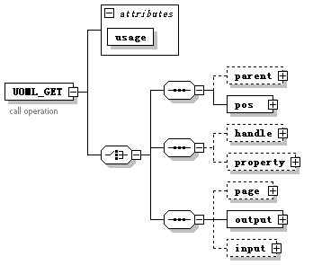
Functions and parameters:
1) When the usage attribute is set as “GetHandle”, this command uses the parameter parent and pos to get the handle of the pos sub-object under parent.
2) When the usage attribute is set as “GetContent”, this command uses the parameter handle to get the xml representation of the handle object.
3) When the usage attribute is set as “GetPageDisp”, this command is used to display the specified page.
a) Page represents the handle of the page to be displayed.
b) Input describes the constraints on the input page. The attribute end of layers describes up to which layer the system displays, clip describes which rectangle area on the page is displayed.
c) Output describes the output method. For branches of the path and format sub-Elements, data is output to the specified path according to the specified bitmap type; for branches of mem_ptr and mem_len, the pixel matrix is output to the buffer mem_ptr with length as mem_len.
Return value specifications:
1) When the operation is successful, a val sub-Element is added as the return value, with name as “handle”. Its stringVal becomes validated, representing the returned handle.
2) When the operation is successful, a val sub-Element is added as the return value, with name as “xobj”. Its compoundVal becomes validated, representing the xml representation of the returned object.
3) Only the general return value is used.

1.7 UOML_INSERT, Insert an Object to an Index Position of Its Parent Object
Figure:
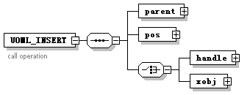
Functions and Parameters:
It is used to insert the object represented by the xobj parameter to the object represented by the parent handle. The index value in the sub-object of parent is pos.
Return value specifications:
When the object is inserted successfully, a val sub-Element with name as “handle” is returned together with the general return values. Its stringVal becomes validated, representing the handle of the newly inserted object.

1.8 UOML_USE, Set Some Object As Current Object
Figure:
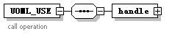
Functions and parameters:
It is used to set the object represented by the parameter handle as current object.
Current object is hierarchical. For example, the parent node of current page is current PageSet. However, this may cause some problems. For example, if some position needs a current object in general, but this parameter is omitted, the object at current object layer is used. There is no general principle for this problem.
Return value specifications:
There are no other return values except the general return value.

1.9 UOML_SYSTEM, System Function
Figure:
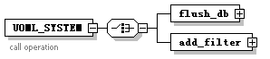
Parameters:
At present, there are two branch functions:
One is flush_db in the figure, which flushes the contents not saved in the DocBase specified by handle to the persistent storage.
The other is add_filter, which is not shown in the figure. It is used to specify filter for the object sub-tree so as to perform compression and encryption. You need to specify specific algorithms for both compression and encryption.
Return values:
There are no other return values except the general return value.

Example
Assuming:
The interface sending a request to UOML implementation is UOML_call, and then the return value is parsed by another interface UOML_parse.
Implementation:
//Create a document base
<UOML_OPEN create="true">
<path val="f:\\data\\doc1.sep"/>
</UOML_OPEN>

//Create a DocSet
<UOML_INSERT >
<parent val="123.456.789"/>
<pos val="1"/>
<xobj>
<docset/>
</xobj>
</UOML_INSERT>

//Save the DocBase
<UOML_SYSTEM >
<flush_db>
<handle val="123.456.789"/>
</flush_db>
</UOML_SYSTEM>
");

//Close the DocBase
<UOML_CLOSE >
<dbhandle val="123.456.789"/>
</UOML_CLOSE>

DOCBASE Logical Structure
The overall logical structure of DOCBASE is as follows (excluding the logical structure of security mechanism):
In consideration of display: the tree is expanded to Doc in figure 1, PageSet is not expanded in figure 2 but is expanded in figure 3.
Application interface layer（UOML）
Logic layer
Physical storage layer
(SurXML)
Document Editing
UOML API
Document management
Electronic government affairs
Doc base
Doc set
Document
Page
Layer
Object
Page set
Layer set
Text object
Graphics object
Others
Graphic status
PlugIn
Compress model
Node model
Free Node
ZP Node
Z Node
Large object unified management
Security model
…….
Resource Retrieving
UOML Processor/Driver
Filter mode

III．Definition and describtion

Elements | Complex types | Simple types
UOML_CALL | UOML_RETVAL | UOMLO_CHARSTYLE
UOML_CLOSE | UOMLO_ARC | UOMLO_CHARTXTDIR
UOML_DELETE | UOMLO_ARCSEG | UOMLO_CMDNAME
UOML_GET | UOMLO_BEZIER | UOMLO_FILLRULE
UOML_INSERT | UOMLO_BEZIERSEG | UOMLO_JOINCAP
UOML_OPEN | UOMLO_CIRCLE | UOMLO_LINECAP
UOML_QUERY | UOMLO_CMD | UOMLO_LINESTYLE
UOML_RET | UOMLO_COLOR_CMYK | UOMLO_ROP
UOML_SET | UOMLO_COLOR_RGB | UOMLO_SHADOWDIR
UOML_SYSTEM | UOMLO_DOC
UOML_USE | UOMLO_DOCBASE
 | UOMLO_DOCSET
 | UOMLO_DOCSIGN
 | UOMLO_DOCWRAPPER
 | UOMLO_ELLIPSE
 | UOMLO_EMBEDFONT
 | UOMLO_FILTER
 | UOMLO_FILTEREDCONTAINER
 | UOMLO_FONTLIST
 | UOMLO_FONTMAP
 | UOMLO_GLYPH
 | UOMLO_GRAPHICSTATE
 | UOMLO_IMAGE
 | UOMLO_KEYLIST
 | UOMLO_LAYER
 | UOMLO_LAYERSET
 | UOMLO_LINE
 | UOMLO_LINESEG
 | UOMLO_MATRIX
 | UOMLO_META
 | UOMLO_METALIST
 | UOMLO_NODESIGN
 | UOMLO_NODESIGNLIST
 | UOMLO_OBJKEY
 | UOMLO_OBJSIGN
 | UOMLO_PAGE
 | UOMLO_PAGESET
 | UOMLO_PATH
 | UOMLO_PDL
 | UOMLO_PLUGIN
 | UOMLO_POINT
 | UOMLO_PRIVENTRY
 | UOMLO_PRIVLIST
 | UOMLO_RECT
 | UOMLO_REF
 | UOMLO_ROLE
 | UOMLO_ROLELIST
 | UOMLO_ROUNDRECT
 | UOMLO_SIGNDEPLIST
 | UOMLO_SUBPATH
 | UOMLO_TEXT
 | UOMLO_TREESIGN
 | UOMLO_TREESIGNLIST
 | UOMLT_BINARY
 | UOMLT_BOOL
 | UOMLT_COMPOUND
 | UOMLT_DATE
 | UOMLT_DATETIME
 | UOMLT_DOUBLE
 | UOMLT_DURATION
 | UOMLT_INT
 | UOMLT_STRING
 | UOMLT_TIME

Element UOML_CALL
diagram | 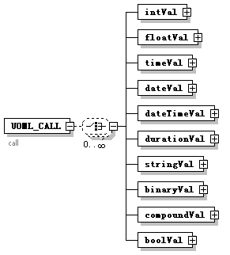
properties
  content | complex
children | intVal floatVal timeVal dateVal dateTimeVal durationVal stringVal binaryVal compoundVal boolVal
annotation
  documentation | call
source | <xs:Element name="UOML_CALL">  <xs:annotation>  <xs:documentation>call</xs:documentation>  </xs:annotation>  <xs:complexType>  <xs:choice minOccurs="0" maxOccurs="unbounded">  <xs:Element name="intVal" type="UOMLT_INT"/>  <xs:Element name="floatVal" type="UOMLT_DOUBLE"/>  <xs:Element name="timeVal" type="UOMLT_TIME"/>  <xs:Element name="dateVal" type="UOMLT_DATE"/>  <xs:Element name="dateTimeVal" type="UOMLT_DATETIME"/>  <xs:Element name="durationVal" type="UOMLT_DURATION"/>  <xs:Element name="stringVal" type="UOMLT_STRING"/>  <xs:Element name="binaryVal" type="UOMLT_BINARY"/>  <xs:Element name="compoundVal" type="UOMLT_COMPOUND"/>  <xs:Element name="boolVal" type="UOMLT_BOOL"/>  </xs:choice>  </xs:complexType>  </xs:Element>

Element UOML_CALL/intVal
diagram | 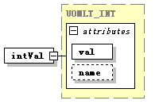
type | UOMLT_INT
properties
  isRef | 0
  content | complex
attributes
  Name | Type | Use | Default | Fixed | Annotation
  val | xs:int | required
  name | xs:string
source | <xs:Element name="intVal" type="UOMLT_INT"/>

Element UOML_CALL/floatVal
diagram | 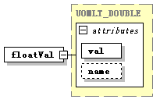
type | UOMLT_DOUBLE
properties
  isRef | 0
  content | complex
attributes
  Name | Type | Use | Default | Fixed | Annotation
  val | xs:double | required
  name | xs:string
source | <xs:Element name="floatVal" type="UOMLT_DOUBLE"/>

Element UOML_CALL/timeVal
diagram | 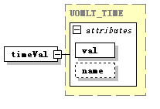
type | UOMLT_TIME
properties
  isRef | 0
  content | complex
attributes
  Name | Type | Use | Default | Fixed | Annotation
  val | xs:time | required
  name | xs:string
source | <xs:Element name="timeVal" type="UOMLT_TIME"/>

Element UOML_CALL/dateVal
diagram | 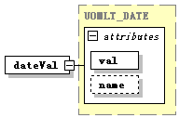
type | UOMLT_DATE
properties
  isRef | 0
  content | complex
attributes
  Name | Type | Use | Default | Fixed | Annotation
  val | xs:date | required
  name | xs:string
source | <xs:Element name="dateVal" type="UOMLT_DATE"/>

Element UOML_CALL/dateTimeVal
diagram | 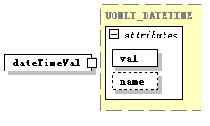
type | UOMLT_DATETIME
properties
  isRef | 0
  content | complex
attributes
  Name | Type | Use | Default | Fixed | Annotation
  val | xs:dateTime | required
  name | xs:string
source | <xs:Element name="dateTimeVal" type="UOMLT_DATETIME"/>

Element UOML_CALL/durationVal
diagram | 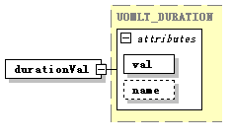
type | UOMLT_DURATION
properties
  isRef | 0
  content | complex
attributes
  Name | Type | Use | Default | Fixed | Annotation
  val | xs:duration | required
  name | xs:string
source | <xs:Element name="durationVal" type="UOMLT_DURATION"/>

Element UOML_CALL/stringVal
diagram | 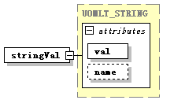
type | UOMLT_STRING
properties
  isRef | 0
  content | complex
attributes
  Name | Type | Use | Default | Fixed | Annotation
  val | xs:string | required
  name | xs:string
source | <xs:Element name="stringVal" type="UOMLT_STRING"/>

Element UOML_CALL/binaryVal
diagram | 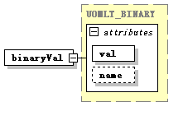
type | UOMLT_BINARY
properties
  isRef | 0
  content | complex
attributes
  Name | Type | Use | Default | Fixed | Annotation
  val | xs:base64Binary | required
  name | xs:string
source | <xs:Element name="binaryVal" type="UOMLT_BINARY"/>

Element UOML_CALL/compoundVal
diagram | 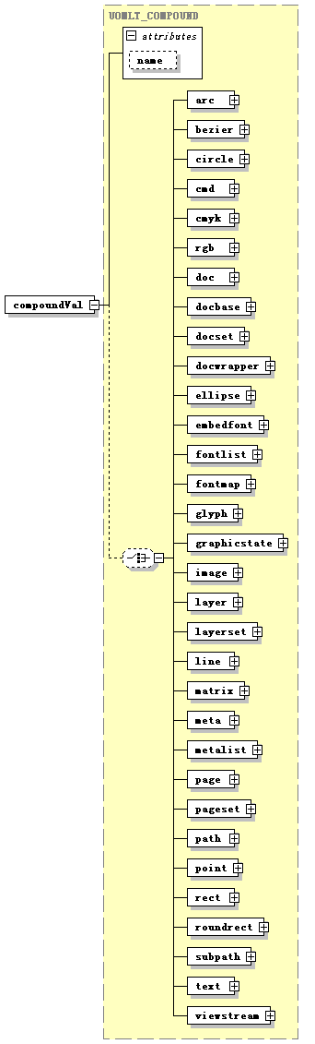
type | UOMLT_COMPOUND
properties
  isRef | 0
  content | complex
children | arc bezier circle cmd cmyk rgb doc docbase docset docwrapper ellipse embedfont fontlist fontmap glyph graphicstate image layer layerset line matrix meta metalist page pageset path point rect roundrect subpath text viewstream
attributes
  Name | Type | Use | Default | Fixed | Annotation
  name | xs:string
source | <xs:Element name="compoundVal" type="UOMLT_COMPOUND"/>

Element UOML_CALL/boolVal
diagram | 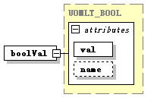
type | UOMLT_BOOL
properties
  isRef | 0
  content | complex
attributes
  Name | Type | Use | Default | Fixed | Annotation
  val | xs:boolean | required
  name | xs:string
source | <xs:Element name="boolVal" type="UOMLT_BOOL"/>

Element UOML_CLOSE
diagram
properties
  content | complex
children | handle db_handle
annotation
  documentation | call operation
source | <xs:Element name="UOML_CLOSE">  <xs:annotation>  <xs:documentation>call operation</xs:documentation>  </xs:annotation>  <xs:complexType>  <xs:choice>  <xs:Element name="handle" type="UOMLT_STRING" minOccurs="0"/>  <xs:Element name="db_handle" type="UOMLT_STRING" minOccurs="0"/>  </xs:choice>  </xs:complexType>  </xs:Element>

Element UOML_CLOSE/handle
diagram | 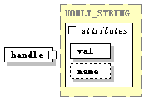
type | UOMLT_STRING
properties
  isRef | 0
  content | complex
attributes
  Name | Type | Use | Default | Fixed | Annotation
  val | xs:string | required
  name | xs:string
source | <xs:Element name="handle" type="UOMLT_STRING" minOccurs="0"/>

Element UOML_CLOSE/db_handle
diagram | 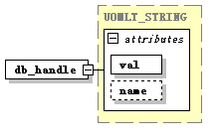
type | UOMLT_STRING
properties
  isRef | 0
  content | complex
attributes
  Name | Type | Use | Default | Fixed | Annotation
  val | xs:string | required
  name | xs:string
source | <xs:Element name="db_handle" type="UOMLT_STRING" minOccurs="0"/>

Element UOML_DELETE
diagram
properties
  content | complex
children | handle
annotation
  documentation | call operation
source | <xs:Element name="UOML_DELETE">  <xs:annotation>  <xs:documentation>call operation</xs:documentation>  </xs:annotation>  <xs:complexType>  <xs:sequence>  <xs:Element name="handle" type="UOMLT_STRING"/>  </xs:sequence>  </xs:complexType>  </xs:Element>

Element UOML_DELETE/handle
diagram
type | UOMLT_STRING
properties
  isRef | 0
  content | complex
attributes
  Name | Type | Use | Default | Fixed | Annotation
  val | xs:string | required
  name | xs:string
source | <xs:Element name="handle" type="UOMLT_STRING"/>

Element UOML_GET
diagram
properties
  content | complex
children | parent pos handle property page output input
attributes
  Name | Type | Use | Default | Fixed | Annotation
  usage | xs:string | required
annotation
  documentation | call operation
source | <xs:Element name="UOML_GET">  <xs:annotation>  <xs:documentation>call operation</xs:documentation>  </xs:annotation>  <xs:complexType>  <xs:choice>  <xs:sequence>  <xs:Element name="parent" type="UOMLT_STRING" minOccurs="0"/>  <xs:Element name="pos" type="UOMLT_INT"/>  </xs:sequence>  <xs:sequence>  <xs:Element name="handle" type="UOMLT_STRING" minOccurs="0"/>  <xs:Element name="property" type="UOMLT_STRING" minOccurs="0"/>  </xs:sequence>  <xs:sequence>  <xs:Element name="page" type="UOMLT_STRING" minOccurs="0"/>  <xs:Element name="output">  <xs:complexType>  <xs:choice>  <xs:sequence>  <xs:Element name="path" type="UOMLT_STRING"/>  <xs:Element name="format" type="UOMLT_STRING"/>  </xs:sequence>  <xs:sequence>  <xs:Element name="mem_ptr" type="UOMLT_STRING"/>  <xs:Element name="mem_len" type="UOMLT_INT"/>  </xs:sequence>  </xs:choice>  </xs:complexType>  </xs:Element>  <xs:Element name="input" minOccurs="0">  <xs:complexType>  <xs:sequence>  <xs:Element name="layers" minOccurs="0">  <xs:complexType>  <xs:attribute name="end" type="xs:int" use="required"/>  </xs:complexType>  </xs:Element>  <xs:Element name="clip" type="UOMLO_RECT" minOccurs="0"/>  </xs:sequence>  </xs:complexType>  </xs:Element>  </xs:sequence>  </xs:choice>  <xs:attribute name="usage" type="xs:string" use="required"/>  </xs:complexType>  </xs:Element>

Element UOML_GET/parent
diagram | 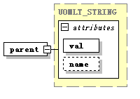
type | UOMLT_STRING
properties
  isRef | 0
  content | complex
attributes
  Name | Type | Use | Default | Fixed | Annotation
  val | xs:string | required
  name | xs:string
source | <xs:Element name="parent" type="UOMLT_STRING" minOccurs="0"/>

Element UOML_GET/pos
diagram | 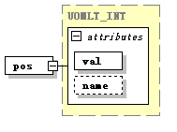
type | UOMLT_INT
properties
  isRef | 0
  content | complex
attributes
  Name | Type | Use | Default | Fixed | Annotation
  val | xs:int | required
  name | xs:string
source | <xs:Element name="pos" type="UOMLT_INT"/>

Element UOML_GET/handle
diagram
type | UOMLT_STRING
properties
  isRef | 0
  content | complex
attributes
  Name | Type | Use | Default | Fixed | Annotation
  val | xs:string | required
  name | xs:string
source | <xs:Element name="handle" type="UOMLT_STRING" minOccurs="0"/>

Element UOML_GET/property
diagram | 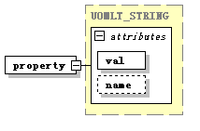
type | UOMLT_STRING
properties
  isRef | 0
  content | complex
attributes
  Name | Type | Use | Default | Fixed | Annotation
  val | xs:string | required
  name | xs:string
source | <xs:Element name="property" type="UOMLT_STRING" minOccurs="0"/>

Element UOML_GET/page
diagram | 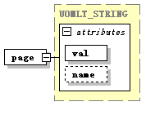
type | UOMLT_STRING
properties
  isRef | 0
  content | complex
attributes
  Name | Type | Use | Default | Fixed | Annotation
  val | xs:string | required
  name | xs:string
source | <xs:Element name="page" type="UOMLT_STRING" minOccurs="0"/>

Element UOML_GET/output
diagram | 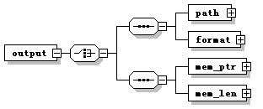
properties
  isRef | 0
  content | complex
children | path format mem_ptr mem_len
source | <xs:Element name="output">  <xs:complexType>  <xs:choice>  <xs:sequence>  <xs:Element name="path" type="UOMLT_STRING"/>  <xs:Element name="format" type="UOMLT_STRING"/>  </xs:sequence>  <xs:sequence>  <xs:Element name="mem_ptr" type="UOMLT_STRING"/>  <xs:Element name="mem_len" type="UOMLT_INT"/>  </xs:sequence>  </xs:choice>  </xs:complexType>  </xs:Element>

Element UOML_GET/output/path
diagram | 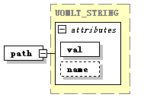
type | UOMLT_STRING
properties
  isRef | 0
  content | complex
attributes
  Name | Type | Use | Default | Fixed | Annotation
  val | xs:string | required
  name | xs:string
source | <xs:Element name="path" type="UOMLT_STRING"/>

Element UOML_GET/output/format
diagram | 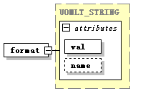
type | UOMLT_STRING
properties
  isRef | 0
  content | complex
attributes
  Name | Type | Use | Default | Fixed | Annotation
  val | xs:string | required
  name | xs:string
source | <xs:Element name="format" type="UOMLT_STRING"/>

Element UOML_GET/output/mem_ptr
diagram | 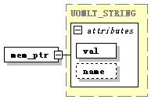
type | UOMLT_STRING
properties
  isRef | 0
  content | complex
attributes
  Name | Type | Use | Default | Fixed | Annotation
  val | xs:string | required
  name | xs:string
source | <xs:Element name="mem_ptr" type="UOMLT_STRING"/>

Element UOML_GET/output/mem_len
diagram | 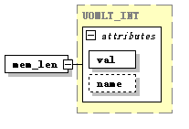
type | UOMLT_INT
properties
  isRef | 0
  content | complex
attributes
  Name | Type | Use | Default | Fixed | Annotation
  val | xs:int | required
  name | xs:string
source | <xs:Element name="mem_len" type="UOMLT_INT"/>

Element UOML_GET/input
diagram | 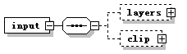
properties
  isRef | 0
  content | complex
children | layers clip
source | <xs:Element name="input" minOccurs="0">  <xs:complexType>  <xs:sequence>  <xs:Element name="layers" minOccurs="0">  <xs:complexType>  <xs:attribute name="end" type="xs:int" use="required"/>  </xs:complexType>  </xs:Element>  <xs:Element name="clip" type="UOMLO_RECT" minOccurs="0"/>  </xs:sequence>  </xs:complexType>  </xs:Element>

Element UOML_GET/input/layers
diagram | 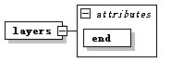
properties
  isRef | 0
  content | complex
attributes
  Name | Type | Use | Default | Fixed | Annotation
  end | xs:int | required
source | <xs:Element name="layers" minOccurs="0">  <xs:complexType>  <xs:attribute name="end" type="xs:int" use="required"/>  </xs:complexType>  </xs:Element>

Element UOML_GET/input/clip
diagram | 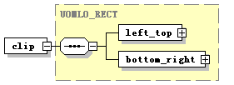
type | UOMLO_RECT
properties
  isRef | 0
  content | complex
children | left_top bottom_right
source | <xs:Element name="clip" type="UOMLO_RECT" minOccurs="0"/>

Element UOML_INSERT
diagram
properties
  content | complex
children | parent pos handle xobj
annotation
  documentation | call operation
source | <xs:Element name="UOML_INSERT">  <xs:annotation>  <xs:documentation>call operation</xs:documentation>  </xs:annotation>  <xs:complexType>  <xs:sequence>  <xs:Element name="parent" type="UOMLT_STRING"/>  <xs:Element name="pos" type="UOMLT_INT"/>  <xs:choice>  <xs:Element name="handle" type="UOMLT_STRING"/>  <xs:Element name="xobj" type="UOMLT_COMPOUND"/>  </xs:choice>  </xs:sequence>  </xs:complexType>  </xs:Element>

Element UOML_INSERT/parent
diagram
type | UOMLT_STRING
properties
  isRef | 0
  content | complex
attributes
  Name | Type | Use | Default | Fixed | Annotation
  val | xs:string | required
  name | xs:string
source | <xs:Element name="parent" type="UOMLT_STRING"/>

Element UOML_INSERT/pos
diagram
type | UOMLT_INT
properties
  isRef | 0
  content | complex
attributes
  Name | Type | Use | Default | Fixed | Annotation
  val | xs:int | required
  name | xs:string
source | <xs:Element name="pos" type="UOMLT_INT"/>

Element UOML_INSERT/handle
diagram
type | UOMLT_STRING
properties
  isRef | 0
  content | complex
attributes
  Name | Type | Use | Default | Fixed | Annotation
  val | xs:string | required
  name | xs:string
source | <xs:Element name="handle" type="UOMLT_STRING"/>

Element UOML_INSERT/xobj
diagram | 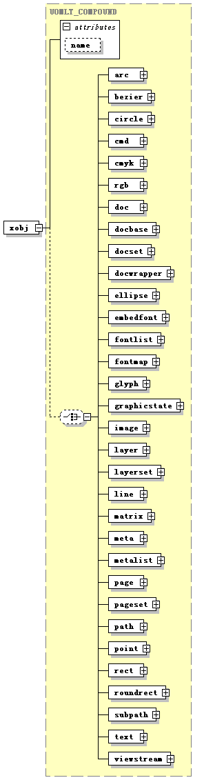
type | UOMLT_COMPOUND
properties
  isRef | 0
  content | complex
children | arc bezier circle cmd cmyk rgb doc docbase docset docwrapper ellipse embedfont fontlist fontmap glyph graphicstate image layer layerset line matrix meta metalist page pageset path point rect roundrect subpath text viewstream
attributes
  Name | Type | Use | Default | Fixed | Annotation
  name | xs:string
source | <xs:Element name="xobj" type="UOMLT_COMPOUND"/>

Element UOML_OPEN
diagram
properties
  content | complex
children | path
attributes
  Name | Type | Use | Default | Fixed | Annotation
  create | xs:boolean
annotation
  documentation | call operation
source | <xs:Element name="UOML_OPEN">  <xs:annotation>  <xs:documentation>call operation</xs:documentation>  </xs:annotation>  <xs:complexType>  <xs:sequence>  <xs:Element name="path" type="UOMLT_STRING"/>  </xs:sequence>  <xs:attribute name="create" type="xs:boolean"/>  </xs:complexType>  </xs:Element>

Element UOML_OPEN/path
diagram
type | UOMLT_STRING
properties
  isRef | 0
  content | complex
attributes
  Name | Type | Use | Default | Fixed | Annotation
  val | xs:string | required
  name | xs:string
source | <xs:Element name="path" type="UOMLT_STRING"/>

Element UOML_QUERY
diagram | 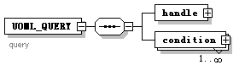
properties
  content | complex
children | handle condition
annotation
  documentation | query
source | <xs:Element name="UOML_QUERY">  <xs:annotation>  <xs:documentation>query  </xs:documentation>  </xs:annotation>  <xs:complexType>  <xs:sequence>  <xs:Element name="handle" type="UOMLT_STRING"/>  <xs:Element name="condition" maxOccurs="unbounded">  <xs:complexType>  <xs:sequence>  <xs:Element name="term" type="UOMLT_STRING"/>  <xs:Element name="operator" type="UOMLT_STRING"/>  <xs:Element name="val">  <xs:complexType>  <xs:choice>  <xs:Element name="intVal" type="UOMLT_INT"/>  <xs:Element name="floatVal" type="UOMLT_DOUBLE"/>  <xs:Element name="timeVal" type="UOMLT_TIME"/>  <xs:Element name="dateVal" type="UOMLT_DATE"/>  <xs:Element name="dateTimeVal" type="UOMLT_DATETIME"/>  <xs:Element name="durationVal" type="UOMLT_DURATION"/>  <xs:Element name="stringVal" type="UOMLT_STRING"/>  <xs:Element name="binaryVal" type="UOMLT_BINARY"/>  <xs:Element name="compoundVal" type="UOMLT_COMPOUND"/>  <xs:Element name="boolVal" type="UOMLT_BOOL"/>  </xs:choice>  </xs:complexType>  </xs:Element>  </xs:sequence>  </xs:complexType>  </xs:Element>  </xs:sequence>  </xs:complexType>  </xs:Element>

Element UOML_QUERY/handle
diagram
type | UOMLT_STRING
properties
  isRef | 0
  content | complex
attributes
  Name | Type | Use | Default | Fixed | Annotation
  val | xs:string | required
  name | xs:string
source | <xs:Element name="handle" type="UOMLT_STRING"/>

Element UOML_QUERY/condition
diagram | 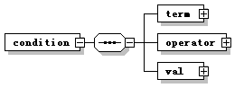
properties
  isRef | 0
  content | complex
children | term operator val
source | <xs:Element name="condition" maxOccurs="unbounded">  <xs:complexType>  <xs:sequence>  <xs:Element name="term" type="UOMLT_STRING"/>  <xs:Element name="operator" type="UOMLT_STRING"/>  <xs:Element name="val">  <xs:complexType>  <xs:choice>  <xs:Element name="intVal" type="UOMLT_INT"/>  <xs:Element name="floatVal" type="UOMLT_DOUBLE"/>  <xs:Element name="timeVal" type="UOMLT_TIME"/>  <xs:Element name="dateVal" type="UOMLT_DATE"/>  <xs:Element name="dateTimeVal" type="UOMLT_DATETIME"/>  <xs:Element name="durationVal" type="UOMLT_DURATION"/>  <xs:Element name="stringVal" type="UOMLT_STRING"/>  <xs:Element name="binaryVal" type="UOMLT_BINARY"/>  <xs:Element name="compoundVal" type="UOMLT_COMPOUND"/>  <xs:Element name="boolVal" type="UOMLT_BOOL"/>  </xs:choice>  </xs:complexType>  </xs:Element>  </xs:sequence>  </xs:complexType>  </xs:Element>

Element UOML_QUERY/condition/term
diagram | 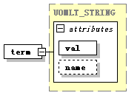
type | UOMLT_STRING
properties
  isRef | 0
  content | complex
attributes
  Name | Type | Use | Default | Fixed | Annotation
  val | xs:string | required
  name | xs:string
source | <xs:Element name="term" type="UOMLT_STRING"/>

Element UOML_QUERY/condition/operator
diagram | 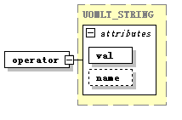
type | UOMLT_STRING
properties
  isRef | 0
  content | complex
attributes
  Name | Type | Use | Default | Fixed | Annotation
  val | xs:string | required
  name | xs:string
source | <xs:Element name="operator" type="UOMLT_STRING"/>

Element UOML_QUERY/condition/val
diagram | 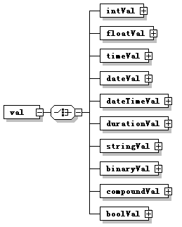
properties
  isRef | 0
  content | complex
children | intVal floatVal timeVal dateVal dateTimeVal durationVal stringVal binaryVal compoundVal boolVal
source | <xs:Element name="val">  <xs:complexType>  <xs:choice>  <xs:Element name="intVal" type="UOMLT_INT"/>  <xs:Element name="floatVal" type="UOMLT_DOUBLE"/>  <xs:Element name="timeVal" type="UOMLT_TIME"/>  <xs:Element name="dateVal" type="UOMLT_DATE"/>  <xs:Element name="dateTimeVal" type="UOMLT_DATETIME"/>  <xs:Element name="durationVal" type="UOMLT_DURATION"/>  <xs:Element name="stringVal" type="UOMLT_STRING"/>  <xs:Element name="binaryVal" type="UOMLT_BINARY"/>  <xs:Element name="compoundVal" type="UOMLT_COMPOUND"/>  <xs:Element name="boolVal" type="UOMLT_BOOL"/>  </xs:choice>  </xs:complexType>  </xs:Element>

Element UOML_QUERY/condition/val/intVal
diagram
type | UOMLT_INT
properties
  isRef | 0
  content | complex
attributes
  Name | Type | Use | Default | Fixed | Annotation
  val | xs:int | required
  name | xs:string
source | <xs:Element name="intVal" type="UOMLT_INT"/>

Element UOML_QUERY/condition/val/floatVal
diagram
type | UOMLT_DOUBLE
properties
  isRef | 0
  content | complex
attributes
  Name | Type | Use | Default | Fixed | Annotation
  val | xs:double | required
  name | xs:string
source | <xs:Element name="floatVal" type="UOMLT_DOUBLE"/>

Element UOML_QUERY/condition/val/timeVal
diagram
type | UOMLT_TIME
properties
  isRef | 0
  content | complex
attributes
  Name | Type | Use | Default | Fixed | Annotation
  val | xs:time | required
  name | xs:string
source | <xs:Element name="timeVal" type="UOMLT_TIME"/>

Element UOML_QUERY/condition/val/dateVal
diagram
type | UOMLT_DATE
properties
  isRef | 0
  content | complex
attributes
  Name | Type | Use | Default | Fixed | Annotation
  val | xs:date | required
  name | xs:string
source | <xs:Element name="dateVal" type="UOMLT_DATE"/>

Element UOML_QUERY/condition/val/dateTimeVal
diagram
type | UOMLT_DATETIME
properties
  isRef | 0
  content | complex
attributes
  Name | Type | Use | Default | Fixed | Annotation
  val | xs:dateTime | required
  name | xs:string
source | <xs:Element name="dateTimeVal" type="UOMLT_DATETIME"/>

Element UOML_QUERY/condition/val/durationVal
diagram
type | UOMLT_DURATION
properties
  isRef | 0
  content | complex
attributes
  Name | Type | Use | Default | Fixed | Annotation
  val | xs:duration | required
  name | xs:string
source | <xs:Element name="durationVal" type="UOMLT_DURATION"/>

Element UOML_QUERY/condition/val/stringVal
diagram
type | UOMLT_STRING
properties
  isRef | 0
  content | complex
attributes
  Name | Type | Use | Default | Fixed | Annotation
  val | xs:string | required
  name | xs:string
source | <xs:Element name="stringVal" type="UOMLT_STRING"/>

Element UOML_QUERY/condition/val/binaryVal
diagram
type | UOMLT_BINARY
properties
  isRef | 0
  content | complex
attributes
  Name | Type | Use | Default | Fixed | Annotation
  val | xs:base64Binary | required
  name | xs:string
source | <xs:Element name="binaryVal" type="UOMLT_BINARY"/>

Element UOML_QUERY/condition/val/compoundVal
diagram
type | UOMLT_COMPOUND
properties
  isRef | 0
  content | complex
children | arc bezier circle cmd cmyk rgb doc docbase docset docwrapper ellipse embedfont fontlist fontmap glyph graphicstate image layer layerset line matrix meta metalist page pageset path point rect roundrect subpath text viewstream
attributes
  Name | Type | Use | Default | Fixed | Annotation
  name | xs:string
source | <xs:Element name="compoundVal" type="UOMLT_COMPOUND"/>

Element UOML_QUERY/condition/val/boolVal
diagram
type | UOMLT_BOOL
properties
  isRef | 0
  content | complex
attributes
  Name | Type | Use | Default | Fixed | Annotation
  val | xs:boolean | required
  name | xs:string
source | <xs:Element name="boolVal" type="UOMLT_BOOL"/>

Element UOML_RET
diagram
properties
  content | complex
children | intVal floatVal timeVal dateVal dateTimeVal durationVal stringVal binaryVal compoundVal boolVal
annotation
  documentation | return value
source | <xs:Element name="UOML_RET">  <xs:annotation>  <xs:documentation>return value</xs:documentation>  </xs:annotation>  <xs:complexType>  <xs:choice minOccurs="0" maxOccurs="unbounded">  <xs:Element name="intVal" type="UOMLT_INT"/>  <xs:Element name="floatVal" type="UOMLT_DOUBLE"/>  <xs:Element name="timeVal" type="UOMLT_TIME"/>  <xs:Element name="dateVal" type="UOMLT_DATE"/>  <xs:Element name="dateTimeVal" type="UOMLT_DATETIME"/>  <xs:Element name="durationVal" type="UOMLT_DURATION"/>  <xs:Element name="stringVal" type="UOMLT_STRING"/>  <xs:Element name="binaryVal" type="UOMLT_BINARY"/>  <xs:Element name="compoundVal" type="UOMLT_COMPOUND"/>  <xs:Element name="boolVal" type="UOMLT_BOOL"/>  </xs:choice>  </xs:complexType>  </xs:Element>

Element UOML_RET/intVal
diagram
type | UOMLT_INT
properties
  isRef | 0
  content | complex
attributes
  Name | Type | Use | Default | Fixed | Annotation
  val | xs:int | required
  name | xs:string
source | <xs:Element name="intVal" type="UOMLT_INT"/>

Element UOML_RET/floatVal
diagram
type | UOMLT_DOUBLE
properties
  isRef | 0
  content | complex
attributes
  Name | Type | Use | Default | Fixed | Annotation
  val | xs:double | required
  name | xs:string
source | <xs:Element name="floatVal" type="UOMLT_DOUBLE"/>

Element UOML_RET/timeVal
diagram
type | UOMLT_TIME
properties
  isRef | 0
  content | complex
attributes
  Name | Type | Use | Default | Fixed | Annotation
  val | xs:time | required
  name | xs:string
source | <xs:Element name="timeVal" type="UOMLT_TIME"/>

Element UOML_RET/dateVal
diagram
type | UOMLT_DATE
properties
  isRef | 0
  content | complex
attributes
  Name | Type | Use | Default | Fixed | Annotation
  val | xs:date | required
  name | xs:string
source | <xs:Element name="dateVal" type="UOMLT_DATE"/>

Element UOML_RET/dateTimeVal
diagram
type | UOMLT_DATETIME
properties
  isRef | 0
  content | complex
attributes
  Name | Type | Use | Default | Fixed | Annotation
  val | xs:dateTime | required
  name | xs:string
source | <xs:Element name="dateTimeVal" type="UOMLT_DATETIME"/>

Element UOML_RET/durationVal
diagram
type | UOMLT_DURATION
properties
  isRef | 0
  content | complex
attributes
  Name | Type | Use | Default | Fixed | Annotation
  val | xs:duration | required
  name | xs:string
source | <xs:Element name="durationVal" type="UOMLT_DURATION"/>

Element UOML_RET/stringVal
diagram
type | UOMLT_STRING
properties
  isRef | 0
  content | complex
attributes
  Name | Type | Use | Default | Fixed | Annotation
  val | xs:string | required
  name | xs:string
source | <xs:Element name="stringVal" type="UOMLT_STRING"/>

Element UOML_RET/binaryVal
diagram
type | UOMLT_BINARY
properties
  isRef | 0
  content | complex
attributes
  Name | Type | Use | Default | Fixed | Annotation
  val | xs:base64Binary | required
  name | xs:string
source | <xs:Element name="binaryVal" type="UOMLT_BINARY"/>

Element UOML_RET/compoundVal
diagram
type | UOMLT_COMPOUND
properties
  isRef | 0
  content | complex
children | arc bezier circle cmd cmyk rgb doc docbase docset docwrapper ellipse embedfont fontlist fontmap glyph graphicstate image layer layerset line matrix meta metalist page pageset path point rect roundrect subpath text viewstream
attributes
  Name | Type | Use | Default | Fixed | Annotation
  name | xs:string
source | <xs:Element name="compoundVal" type="UOMLT_COMPOUND"/>

Element UOML_RET/boolVal
diagram
type | UOMLT_BOOL
properties
  isRef | 0
  content | complex
attributes
  Name | Type | Use | Default | Fixed | Annotation
  val | xs:boolean | required
  name | xs:string
source | <xs:Element name="boolVal" type="UOMLT_BOOL"/>

Element UOML_SET
diagram
properties
  content | complex
children | handle xobj property intVal floatVal timeVal dateVal dateTimeVal durationVal stringVal binaryVal compoundVal boolVal
annotation
  documentation | call operation
source | <xs:Element name="UOML_SET">  <xs:annotation>  <xs:documentation>call operation</xs:documentation>  </xs:annotation>  <xs:complexType>  <xs:sequence>  <xs:Element name="handle" type="UOMLT_STRING"/>  <xs:choice>  <xs:Element name="xobj" type="UOMLT_COMPOUND"/>  <xs:sequence>  <xs:Element name="property" type="UOMLT_STRING"/>  <xs:choice maxOccurs="unbounded">  <xs:Element name="intVal" type="UOMLT_INT"/>  <xs:Element name="floatVal" type="UOMLT_DOUBLE"/>  <xs:Element name="timeVal" type="UOMLT_TIME"/>  <xs:Element name="dateVal" type="UOMLT_DATE"/>  <xs:Element name="dateTimeVal" type="UOMLT_DATETIME"/>  <xs:Element name="durationVal" type="UOMLT_DURATION"/>  <xs:Element name="stringVal" type="UOMLT_STRING"/>  <xs:Element name="binaryVal" type="UOMLT_BINARY"/>  <xs:Element name="compoundVal" type="UOMLT_COMPOUND"/>  <xs:Element name="boolVal" type="UOMLT_BOOL"/>  </xs:choice>  </xs:sequence>  </xs:choice>  </xs:sequence>  </xs:complexType>  </xs:Element>

Element UOML_SET/handle
diagram
type | UOMLT_STRING
properties
  isRef | 0
  content | complex
attributes
  Name | Type | Use | Default | Fixed | Annotation
  val | xs:string | required
  name | xs:string
source | <xs:Element name="handle" type="UOMLT_STRING"/>

Element UOML_SET/xobj
diagram
type | UOMLT_COMPOUND
properties
  isRef | 0
  content | complex
children | arc bezier circle cmd cmyk rgb doc docbase docset docwrapper ellipse embedfont fontlist fontmap glyph graphicstate image layer layerset line matrix meta metalist page pageset path point rect roundrect subpath text viewstream
attributes
  Name | Type | Use | Default | Fixed | Annotation
  name | xs:string
source | <xs:Element name="xobj" type="UOMLT_COMPOUND"/>

Element UOML_SET/property
diagram
type | UOMLT_STRING
properties
  isRef | 0
  content | complex
attributes
  Name | Type | Use | Default | Fixed | Annotation
  val | xs:string | required
  name | xs:string
source | <xs:Element name="property" type="UOMLT_STRING"/>

Element UOML_SET/intVal
diagram
type | UOMLT_INT
properties
  isRef | 0
  content | complex
attributes
  Name | Type | Use | Default | Fixed | Annotation
  val | xs:int | required
  name | xs:string
source | <xs:Element name="intVal" type="UOMLT_INT"/>

Element UOML_SET/floatVal
diagram
type | UOMLT_DOUBLE
properties
  isRef | 0
  content | complex
attributes
  Name | Type | Use | Default | Fixed | Annotation
  val | xs:double | required
  name | xs:string
source | <xs:Element name="floatVal" type="UOMLT_DOUBLE"/>

Element UOML_SET/timeVal
diagram
type | UOMLT_TIME
properties
  isRef | 0
  content | complex
attributes
  Name | Type | Use | Default | Fixed | Annotation
  val | xs:time | required
  name | xs:string
source | <xs:Element name="timeVal" type="UOMLT_TIME"/>

Element UOML_SET/dateVal
diagram
type | UOMLT_DATE
properties
  isRef | 0
  content | complex
attributes
  Name | Type | Use | Default | Fixed | Annotation
  val | xs:date | required
  name | xs:string
source | <xs:Element name="dateVal" type="UOMLT_DATE"/>

Element UOML_SET/dateTimeVal
diagram
type | UOMLT_DATETIME
properties
  isRef | 0
  content | complex
attributes
  Name | Type | Use | Default | Fixed | Annotation
  val | xs:dateTime | required
  name | xs:string
source | <xs:Element name="dateTimeVal" type="UOMLT_DATETIME"/>

Element UOML_SET/durationVal
diagram
type | UOMLT_DURATION
properties
  isRef | 0
  content | complex
attributes
  Name | Type | Use | Default | Fixed | Annotation
  val | xs:duration | required
  name | xs:string
source | <xs:Element name="durationVal" type="UOMLT_DURATION"/>

Element UOML_SET/stringVal
diagram
type | UOMLT_STRING
properties
  isRef | 0
  content | complex
attributes
  Name | Type | Use | Default | Fixed | Annotation
  val | xs:string | required
  name | xs:string
source | <xs:Element name="stringVal" type="UOMLT_STRING"/>

Element UOML_SET/binaryVal
diagram
type | UOMLT_BINARY
properties
  isRef | 0
  content | complex
attributes
  Name | Type | Use | Default | Fixed | Annotation
  val | xs:base64Binary | required
  name | xs:string
source | <xs:Element name="binaryVal" type="UOMLT_BINARY"/>

Element UOML_SET/compoundVal
diagram
type | UOMLT_COMPOUND
properties
  isRef | 0
  content | complex
children | arc bezier circle cmd cmyk rgb doc docbase docset docwrapper ellipse embedfont fontlist fontmap glyph graphicstate image layer layerset line matrix meta metalist page pageset path point rect roundrect subpath text viewstream
attributes
  Name | Type | Use | Default | Fixed | Annotation
  name | xs:string
source | <xs:Element name="compoundVal" type="UOMLT_COMPOUND"/>

Element UOML_SET/boolVal
diagram
type | UOMLT_BOOL
properties
  isRef | 0
  content | complex
attributes
  Name | Type | Use | Default | Fixed | Annotation
  val | xs:boolean | required
  name | xs:string
source | <xs:Element name="boolVal" type="UOMLT_BOOL"/>

Element UOML_SYSTEM
diagram
properties
  content | complex
children | flush_db add_filter
annotation
  documentation | call operation
source | <xs:Element name="UOML_SYSTEM">  <xs:annotation>  <xs:documentation>call operation</xs:documentation>  </xs:annotation>  <xs:complexType>  <xs:choice>  <xs:Element name="flush_db">  <xs:complexType>  <xs:sequence>  <xs:Element name="handle" type="UOMLT_STRING"/>  <xs:Element name="path" type="UOMLT_STRING" minOccurs="0"/>  <xs:Element name="password" type="UOMLT_STRING" minOccurs="0"/>  </xs:sequence>  </xs:complexType>  </xs:Element>  <xs:Element name="add_filter">  <xs:complexType>  <xs:sequence>  <xs:Element name="handle" type="UOMLT_STRING"/>  </xs:sequence>  <xs:attribute name="name" type="xs:string" use="required"/>  <xs:attribute name="param" type="xs:anySimpleType"/>  </xs:complexType>  </xs:Element>  </xs:choice>  </xs:complexType>  </xs:Element>

Element UOML_SYSTEM/flush_db
diagram | 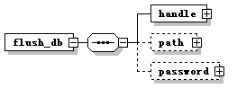
properties
  isRef | 0
  content | complex
children | handle path password
source | <xs:Element name="flush_db">  <xs:complexType>  <xs:sequence>  <xs:Element name="handle" type="UOMLT_STRING"/>  <xs:Element name="path" type="UOMLT_STRING" minOccurs="0"/>  <xs:Element name="password" type="UOMLT_STRING" minOccurs="0"/>  </xs:sequence>  </xs:complexType>  </xs:Element>

Element UOML_SYSTEM/flush_db/handle
diagram
type | UOMLT_STRING
properties
  isRef | 0
  content | complex
attributes
  Name | Type | Use | Default | Fixed | Annotation
  val | xs:string | required
  name | xs:string
source | <xs:Element name="handle" type="UOMLT_STRING"/>

Element UOML_SYSTEM/flush_db/path
diagram
type | UOMLT_STRING
properties
  isRef | 0
  content | complex
attributes
  Name | Type | Use | Default | Fixed | Annotation
  val | xs:string | required
  name | xs:string
source | <xs:Element name="path" type="UOMLT_STRING" minOccurs="0"/>

Element UOML_SYSTEM/flush_db/password
diagram | 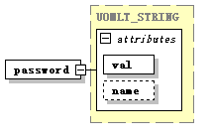
type | UOMLT_STRING
properties
  isRef | 0
  content | complex
attributes
  Name | Type | Use | Default | Fixed | Annotation
  val | xs:string | required
  name | xs:string
source | <xs:Element name="password" type="UOMLT_STRING" minOccurs="0"/>

Element UOML_SYSTEM/add_filter
diagram | 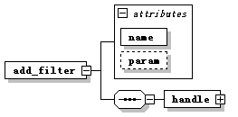
properties
  isRef | 0
  content | complex
children | handle
attributes
  Name | Type | Use | Default | Fixed | Annotation
  name | xs:string | required
  param | xs:anySimpleType
source | <xs:Element name="add_filter">  <xs:complexType>  <xs:sequence>  <xs:Element name="handle" type="UOMLT_STRING"/>  </xs:sequence>  <xs:attribute name="name" type="xs:string" use="required"/>  <xs:attribute name="param" type="xs:anySimpleType"/>  </xs:complexType>  </xs:Element>

Element UOML_SYSTEM/add_filter/handle
diagram
type | UOMLT_STRING
properties
  isRef | 0
  content | complex
attributes
  Name | Type | Use | Default | Fixed | Annotation
  val | xs:string | required
  name | xs:string
source | <xs:Element name="handle" type="UOMLT_STRING"/>

Element UOML_USE
diagram
properties
  content | complex
children | handle
annotation
  documentation | call operation
source | <xs:Element name="UOML_USE">  <xs:annotation>  <xs:documentation>call operation</xs:documentation>  </xs:annotation>  <xs:complexType>  <xs:sequence>  <xs:Element name="handle" type="UOMLT_STRING"/>  </xs:sequence>  </xs:complexType>  </xs:Element>

Element UOML_USE/handle
diagram
type | UOMLT_STRING
properties
  isRef | 0
  content | complex
attributes
  Name | Type | Use | Default | Fixed | Annotation
  val | xs:string | required
  name | xs:string
source | <xs:Element name="handle" type="UOMLT_STRING"/>

complexType UOML_RETVAL
diagram | 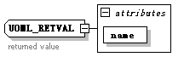
attributes
  Name | Type | Use | Default | Fixed | Annotation
  name | xs:string | required
annotation
  documentation | returned value
source | <xs:complexType name="UOML_RETVAL">  <xs:annotation>  <xs:documentation>returned value</xs:documentation>  </xs:annotation>  <xs:attribute name="name" type="xs:string" use="required"/>  </xs:complexType>

complexType UOMLO_ARC
diagram | 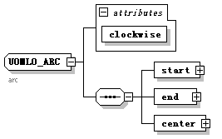
children | start end center
used by
  Element | UOMLT_COMPOUND/arc
attributes
  Name | Type | Use | Default | Fixed | Annotation
  clockwise | xs:boolean | required
annotation
  documentation | arc
source | <xs:complexType name="UOMLO_ARC">  <xs:annotation>  <xs:documentation>arc</xs:documentation>  </xs:annotation>  <xs:sequence>  <xs:Element name="start" type="UOMLO_POINT"/>  <xs:Element name="end" type="UOMLO_POINT"/>  <xs:Element name="center" type="UOMLO_POINT"/>  </xs:sequence>  <xs:attribute name="clockwise" type="xs:boolean" use="required"/>  </xs:complexType>

Element UOMLO_ARC/start
diagram | 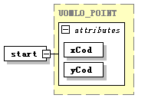
type | UOMLO_POINT
properties
  isRef | 0
  content | complex
attributes
  Name | Type | Use | Default | Fixed | Annotation
  xCod | xs:float | required
  yCod | xs:float | required
source | <xs:Element name="start" type="UOMLO_POINT"/>

Element UOMLO_ARC/end
diagram | 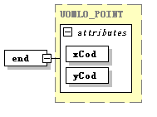
type | UOMLO_POINT
properties
  isRef | 0
  content | complex
attributes
  Name | Type | Use | Default | Fixed | Annotation
  xCod | xs:float | required
  yCod | xs:float | required
source | <xs:Element name="end" type="UOMLO_POINT"/>

Element UOMLO_ARC/center
diagram | 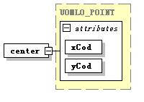
type | UOMLO_POINT
properties
  isRef | 0
  content | complex
attributes
  Name | Type | Use | Default | Fixed | Annotation
  xCod | xs:float | required
  yCod | xs:float | required
source | <xs:Element name="center" type="UOMLO_POINT"/>

complexType UOMLO_ARCSEG
diagram | 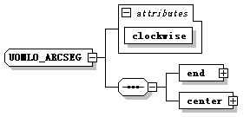
children | end center
used by
  Element | UOMLO_SUBPATH/arcseg
attributes
  Name | Type | Use | Default | Fixed | Annotation
  clockwise | xs:boolean | required
source | <xs:complexType name="UOMLO_ARCSEG">  <xs:sequence>  <xs:Element name="end" type="UOMLO_POINT"/>  <xs:Element name="center" type="UOMLO_POINT"/>  </xs:sequence>  <xs:attribute name="clockwise" type="xs:boolean" use="required"/>  </xs:complexType>

Element UOMLO_ARCSEG/end
diagram
type | UOMLO_POINT
properties
  isRef | 0
  content | complex
attributes
  Name | Type | Use | Default | Fixed | Annotation
  xCod | xs:float | required
  yCod | xs:float | required
source | <xs:Element name="end" type="UOMLO_POINT"/>

Element UOMLO_ARCSEG/center
diagram
type | UOMLO_POINT
properties
  isRef | 0
  content | complex
attributes
  Name | Type | Use | Default | Fixed | Annotation
  xCod | xs:float | required
  yCod | xs:float | required
source | <xs:Element name="center" type="UOMLO_POINT"/>

complexType UOMLO_BEZIER
diagram | 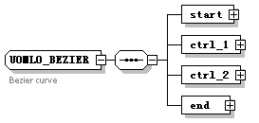
children | start ctrl_1 ctrl_2 end
used by
  Element | UOMLT_COMPOUND/bezier
annotation
  documentation | Bezier curve
source | <xs:complexType name="UOMLO_BEZIER">  <xs:annotation>  <xs:documentation>Bezier curve </xs:documentation>  </xs:annotation>  <xs:sequence>  <xs:Element name="start" type="UOMLO_POINT"/>  <xs:Element name="ctrl_1" type="UOMLO_POINT"/>  <xs:Element name="ctrl_2" type="UOMLO_POINT"/>  <xs:Element name="end" type="UOMLO_POINT"/>  </xs:sequence>  </xs:complexType>

Element UOMLO_BEZIER/start
diagram
type | UOMLO_POINT
properties
  isRef | 0
  content | complex
attributes
  Name | Type | Use | Default | Fixed | Annotation
  xCod | xs:float | required
  yCod | xs:float | required
source | <xs:Element name="start" type="UOMLO_POINT"/>

Element UOMLO_BEZIER/ctrl_1
diagram | 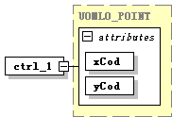
type | UOMLO_POINT
properties
  isRef | 0
  content | complex
attributes
  Name | Type | Use | Default | Fixed | Annotation
  xCod | xs:float | required
  yCod | xs:float | required
source | <xs:Element name="ctrl_1" type="UOMLO_POINT"/>

Element UOMLO_BEZIER/ctrl_2
diagram | 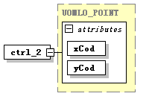
type | UOMLO_POINT
properties
  isRef | 0
  content | complex
attributes
  Name | Type | Use | Default | Fixed | Annotation
  xCod | xs:float | required
  yCod | xs:float | required
source | <xs:Element name="ctrl_2" type="UOMLO_POINT"/>

Element UOMLO_BEZIER/end
diagram
type | UOMLO_POINT
properties
  isRef | 0
  content | complex
attributes
  Name | Type | Use | Default | Fixed | Annotation
  xCod | xs:float | required
  yCod | xs:float | required
source | <xs:Element name="end" type="UOMLO_POINT"/>

complexType UOMLO_BEZIERSEG
diagram | 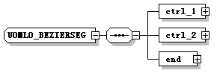
children | ctrl_1 ctrl_2 end
used by
  Element | UOMLO_SUBPATH/bezierseg
source | <xs:complexType name="UOMLO_BEZIERSEG">  <xs:sequence>  <xs:Element name="ctrl_1" type="UOMLO_POINT"/>  <xs:Element name="ctrl_2" type="UOMLO_POINT"/>  <xs:Element name="end" type="UOMLO_POINT"/>  </xs:sequence>  </xs:complexType>

Element UOMLO_BEZIERSEG/ctrl_1
diagram
type | UOMLO_POINT
properties
  isRef | 0
  content | complex
attributes
  Name | Type | Use | Default | Fixed | Annotation
  xCod | xs:float | required
  yCod | xs:float | required
source | <xs:Element name="ctrl_1" type="UOMLO_POINT"/>

Element UOMLO_BEZIERSEG/ctrl_2
diagram
type | UOMLO_POINT
properties
  isRef | 0
  content | complex
attributes
  Name | Type | Use | Default | Fixed | Annotation
  xCod | xs:float | required
  yCod | xs:float | required
source | <xs:Element name="ctrl_2" type="UOMLO_POINT"/>

Element UOMLO_BEZIERSEG/end
diagram
type | UOMLO_POINT
properties
  isRef | 0
  content | complex
attributes
  Name | Type | Use | Default | Fixed | Annotation
  xCod | xs:float | required
  yCod | xs:float | required
source | <xs:Element name="end" type="UOMLO_POINT"/>

complexType UOMLO_CIRCLE
diagram | 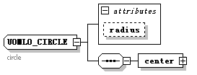
children | center
used by
  Elements | UOMLO_PATH/circle UOMLT_COMPOUND/circle
attributes
  Name | Type | Use | Default | Fixed | Annotation
  radius | xs:float
annotation
  documentation | circle
source | <xs:complexType name="UOMLO_CIRCLE">  <xs:annotation>  <xs:documentation>circle</xs:documentation>  </xs:annotation>  <xs:sequence>  <xs:Element name="center" type="UOMLO_POINT"/>  </xs:sequence>  <xs:attribute name="radius" type="xs:float"/>  </xs:complexType>

Element UOMLO_CIRCLE/center
diagram
type | UOMLO_POINT
properties
  isRef | 0
  content | complex
attributes
  Name | Type | Use | Default | Fixed | Annotation
  xCod | xs:float | required
  yCod | xs:float | required
source | <xs:Element name="center" type="UOMLO_POINT"/>

complexType UOMLO_CMD
diagram | 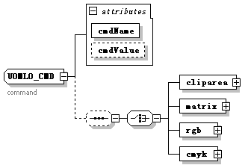
children | cliparea matrix rgb cmyk
used by
  Element | UOMLT_COMPOUND/cmd
attributes
  Name | Type | Use | Default | Fixed | Annotation
  cmdName | UOMLO_CMDNAME | required
  cmdValue | xs:anySimpleType
annotation
  documentation | command
source | <xs:complexType name="UOMLO_CMD">  <xs:annotation>  <xs:documentation>command</xs:documentation>  </xs:annotation>  <xs:sequence minOccurs="0">  <xs:choice>  <xs:Element name="cliparea" type="UOMLO_PATH"/>  <xs:Element name="matrix" type="UOMLO_MATRIX"/>  <xs:Element name="rgb" type="UOMLO_COLOR_RGB"/>  <xs:Element name="cmyk" type="UOMLO_COLOR_CMYK"/>  </xs:choice>  </xs:sequence>  <xs:attribute name="cmdName" type="UOMLO_CMDNAME" use="required"/>  <xs:attribute name="cmdValue" type="xs:anySimpleType"/>  </xs:complexType>

Element UOMLO_CMD/cliparea
diagram | 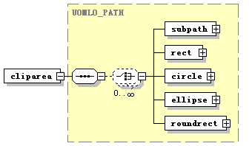
type | UOMLO_PATH
properties
  isRef | 0
  content | complex
children | subpath rect circle ellipse roundrect
source | <xs:Element name="cliparea" type="UOMLO_PATH"/>

Element UOMLO_CMD/matrix
diagram | 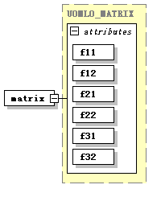
type | UOMLO_MATRIX
properties
  isRef | 0
  content | complex
attributes
  Name | Type | Use | Default | Fixed | Annotation
  f11 | xs:float | required
  f12 | xs:float | required
  f21 | xs:float | required
  f22 | xs:float | required
  f31 | xs:float | required
  f32 | xs:float | required
source | <xs:Element name="matrix" type="UOMLO_MATRIX"/>

Element UOMLO_CMD/rgb
diagram | 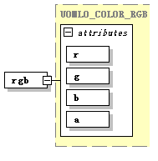
type | UOMLO_COLOR_RGB
properties
  isRef | 0
  content | complex
attributes
  Name | Type | Use | Default | Fixed | Annotation
  r | xs:short | required
  g | xs:short | required
  b | xs:short | required
  a | xs:short | required
source | <xs:Element name="rgb" type="UOMLO_COLOR_RGB"/>

Element UOMLO_CMD/cmyk
diagram | 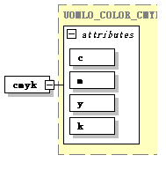
type | UOMLO_COLOR_CMYK
properties
  isRef | 0
  content | complex
attributes
  Name | Type | Use | Default | Fixed | Annotation
  c | xs:short | required
  m | xs:short | required
  y | xs:short | required
  k | xs:short | required
source | <xs:Element name="cmyk" type="UOMLO_COLOR_CMYK"/>

complexType UOMLO_COLOR_CMYK
diagram | 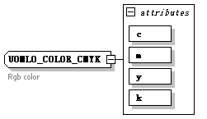
used by
  Elements | UOMLO_CMD/cmyk UOMLO_GRAPHICSTATE/lineColor/cmyk UOMLO_GRAPHICSTATE/fillColor/cmyk UOMLO_GRAPHICSTATE/backColor/cmyk UOMLO_GRAPHICSTATE/textColor/cmyk UOMLO_GRAPHICSTATE/shadowColor/cmyk UOMLO_GRAPHICSTATE/outlineColor/cmyk UOMLT_COMPOUND/cmyk
attributes
  Name | Type | Use | Default | Fixed | Annotation
  c | xs:short | required
  m | xs:short | required
  y | xs:short | required
  k | xs:short | required
annotation
  documentation | Rgb color
source | <xs:complexType name="UOMLO_COLOR_CMYK">  <xs:annotation>  <xs:documentation>Rgb color </xs:documentation>  </xs:annotation>  <xs:attribute name="c" type="xs:short" use="required"/>  <xs:attribute name="m" type="xs:short" use="required"/>  <xs:attribute name="y" type="xs:short" use="required"/>  <xs:attribute name="k" type="xs:short" use="required"/>  </xs:complexType>

complexType UOMLO_COLOR_RGB
diagram | 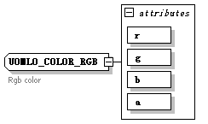
used by
  Elements | UOMLO_CMD/rgb UOMLO_GRAPHICSTATE/lineColor/rgb UOMLO_GRAPHICSTATE/fillColor/rgb UOMLO_GRAPHICSTATE/backColor/rgb UOMLO_GRAPHICSTATE/textColor/rgb UOMLO_GRAPHICSTATE/shadowColor/rgb UOMLO_GRAPHICSTATE/outlineColor/rgb UOMLT_COMPOUND/rgb
attributes
  Name | Type | Use | Default | Fixed | Annotation
  r | xs:short | required
  g | xs:short | required
  b | xs:short | required
  a | xs:short | required
annotation
  documentation | Rgb color
source | <xs:complexType name="UOMLO_COLOR_RGB">  <xs:annotation>  <xs:documentation>Rgb color </xs:documentation>  </xs:annotation>  <xs:attribute name="r" type="xs:short" use="required"/>  <xs:attribute name="g" type="xs:short" use="required"/>  <xs:attribute name="b" type="xs:short" use="required"/>  <xs:attribute name="a" type="xs:short" use="required"/>  </xs:complexType>

complexType UOMLO_DOC
diagram | 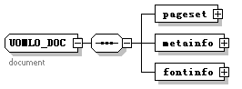
children | pageset metainfo fontinfo
used by
  Elements | UOMLT_COMPOUND/doc UOMLO_DOCWRAPPER/docdata
annotation
  documentation | document
source | <xs:complexType name="UOMLO_DOC">  <xs:annotation>  <xs:documentation>document</xs:documentation>  </xs:annotation>  <xs:sequence>  <xs:Element name="pageset" type="UOMLO_PAGESET"/>  <xs:Element name="metainfo" type="UOMLO_METALIST"/>  <xs:Element name="fontinfo" type="UOMLO_FONTLIST"/>  </xs:sequence>  </xs:complexType>

Element UOMLO_DOC/pageset
diagram | 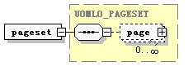
type | UOMLO_PAGESET
properties
  isRef | 0
  content | complex
children | page
source | <xs:Element name="pageset" type="UOMLO_PAGESET"/>

Element UOMLO_DOC/metainfo
diagram | 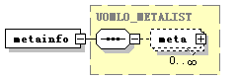
type | UOMLO_METALIST
properties
  isRef | 0
  content | complex
children | meta
source | <xs:Element name="metainfo" type="UOMLO_METALIST"/>

Element UOMLO_DOC/fontinfo
diagram | 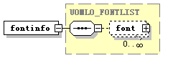
type | UOMLO_FONTLIST
properties
  isRef | 0
  content | complex
children | font
source | <xs:Element name="fontinfo" type="UOMLO_FONTLIST"/>

complexType UOMLO_DOCBASE
diagram | 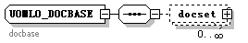
children | docset
used by
  Element | UOMLT_COMPOUND/docbase
annotation
  documentation | docbase
source | <xs:complexType name="UOMLO_DOCBASE">  <xs:annotation>  <xs:documentation>docbase</xs:documentation>  </xs:annotation>  <xs:sequence>  <xs:Element name="docset" type="UOMLO_DOCSET" minOccurs="0" maxOccurs="unbounded"/>  </xs:sequence>  </xs:complexType>

Element UOMLO_DOCBASE/docset
diagram | 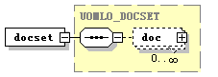
type | UOMLO_DOCSET
properties
  isRef | 0
  content | complex
children | doc
source | <xs:Element name="docset" type="UOMLO_DOCSET" minOccurs="0" maxOccurs="unbounded"/>

complexType UOMLO_DOCSET
diagram | 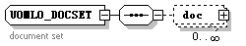
children | doc
used by
  Elements | UOMLO_DOCBASE/docset UOMLT_COMPOUND/docset
annotation
  documentation | document set
source | <xs:complexType name="UOMLO_DOCSET">  <xs:annotation>  <xs:documentation>document set</xs:documentation>  </xs:annotation>  <xs:sequence>  <xs:Element name="doc" type="UOMLO_DOCWRAPPER" minOccurs="0" maxOccurs="unbounded"/>  </xs:sequence>  </xs:complexType>

Element UOMLO_DOCSET/doc
diagram | 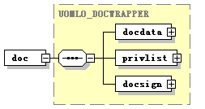
type | UOMLO_DOCWRAPPER
properties
  isRef | 0
  content | complex
children | docdata privlist docsign
source | <xs:Element name="doc" type="UOMLO_DOCWRAPPER" minOccurs="0" maxOccurs="unbounded"/>

complexType UOMLO_DOCSIGN
diagram | 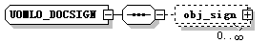
children | obj_sign
used by
  Element | UOMLO_DOCWRAPPER/docsign
source | <xs:complexType name="UOMLO_DOCSIGN">  <xs:sequence>  <xs:Element name="obj_sign" type="UOMLO_OBJSIGN" minOccurs="0" maxOccurs="unbounded"/>  </xs:sequence>  </xs:complexType>

Element UOMLO_DOCSIGN/obj_sign
diagram | 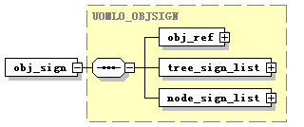
type | UOMLO_OBJSIGN
properties
  isRef | 0
  content | complex
children | obj_ref tree_sign_list node_sign_list
source | <xs:Element name="obj_sign" type="UOMLO_OBJSIGN" minOccurs="0" maxOccurs="unbounded"/>

complexType UOMLO_DOCWRAPPER
diagram | 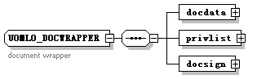
children | docdata privlist docsign
used by
  Elements | UOMLO_DOCSET/doc UOMLT_COMPOUND/docwrapper
annotation
  documentation | document wrapper
source | <xs:complexType name="UOMLO_DOCWRAPPER">  <xs:annotation>  <xs:documentation>document wrapper</xs:documentation>  </xs:annotation>  <xs:sequence>  <xs:Element name="docdata" type="UOMLO_DOC"/>  <xs:Element name="privlist" type="UOMLO_PRIVLIST"/>  <xs:Element name="docsign" type="UOMLO_DOCSIGN"/>  </xs:sequence>  </xs:complexType>

Element UOMLO_DOCWRAPPER/docdata
diagram | 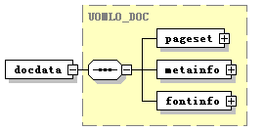
type | UOMLO_DOC
properties
  isRef | 0
  content | complex
children | pageset metainfo fontinfo
source | <xs:Element name="docdata" type="UOMLO_DOC"/>

Element UOMLO_DOCWRAPPER/privlist
diagram | 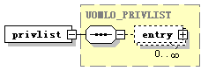
type | UOMLO_PRIVLIST
properties
  isRef | 0
  content | complex
children | entry
source | <xs:Element name="privlist" type="UOMLO_PRIVLIST"/>

Element UOMLO_DOCWRAPPER/docsign
diagram | 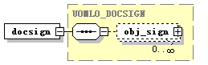
type | UOMLO_DOCSIGN
properties
  isRef | 0
  content | complex
children | obj_sign
source | <xs:Element name="docsign" type="UOMLO_DOCSIGN"/>

complexType UOMLO_ELLIPSE
diagram | 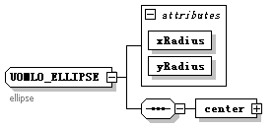
children | center
used by
  Elements | UOMLO_PATH/ellipse UOMLT_COMPOUND/ellipse
attributes
  Name | Type | Use | Default | Fixed | Annotation
  xRadius | xs:float | required
  yRadius | xs:float | required
annotation
  documentation | ellipse
source | <xs:complexType name="UOMLO_ELLIPSE">  <xs:annotation>  <xs:documentation>ellipse  </xs:documentation>  </xs:annotation>  <xs:sequence>  <xs:Element name="center" type="UOMLO_POINT"/>  </xs:sequence>  <xs:attribute name="xRadius" type="xs:float" use="required"/>  <xs:attribute name="yRadius" type="xs:float" use="required"/>  </xs:complexType>

Element UOMLO_ELLIPSE/center
diagram
type | UOMLO_POINT
properties
  isRef | 0
  content | complex
attributes
  Name | Type | Use | Default | Fixed | Annotation
  xCod | xs:float | required
  yCod | xs:float | required
source | <xs:Element name="center" type="UOMLO_POINT"/>

complexType UOMLO_EMBEDFONT
diagram | 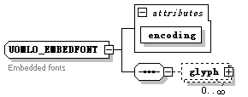
children | glyph
used by
  Elements | UOMLO_FONTMAP/embedFont UOMLT_COMPOUND/embedfont
attributes
  Name | Type | Use | Default | Fixed | Annotation
  encoding | xs:string | required
annotation
  documentation | Embedded fonts
source | <xs:complexType name="UOMLO_EMBEDFONT">  <xs:annotation>  <xs:documentation>Embedded fonts </xs:documentation>  </xs:annotation>  <xs:sequence>  <xs:Element name="glyph" type="UOMLO_GLYPH" minOccurs="0" maxOccurs="unbounded"/>  </xs:sequence>  <xs:attribute name="encoding" type="xs:string" use="required"/>  </xs:complexType>

Element UOMLO_EMBEDFONT/glyph
diagram | 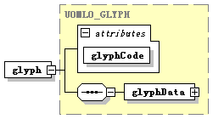
type | UOMLO_GLYPH
properties
  isRef | 0
  content | complex
children | glyphData
attributes
  Name | Type | Use | Default | Fixed | Annotation
  glyphCode | xs:int | required
source | <xs:Element name="glyph" type="UOMLO_GLYPH" minOccurs="0" maxOccurs="unbounded"/>

complexType UOMLO_FILTER
diagram | 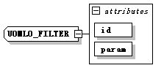
used by
  Element | UOMLO_FILTEREDCONTAINER/filter
attributes
  Name | Type | Use | Default | Fixed | Annotation
  id | xs:string | required
  param | xs:string | required
source | <xs:complexType name="UOMLO_FILTER">  <xs:attribute name="id" type="xs:string" use="required"/>  <xs:attribute name="param" type="xs:string" use="required"/>  </xs:complexType>

complexType UOMLO_FILTEREDCONTAINER
diagram | 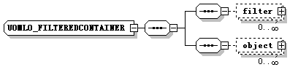
children | filter object
source | <xs:complexType name="UOMLO_FILTEREDCONTAINER">  <xs:sequence>  <xs:sequence>  <xs:Element name="filter" type="UOMLO_FILTER" minOccurs="0" maxOccurs="unbounded"/>  </xs:sequence>  <xs:sequence>  <xs:Element name="object" type="UOMLT_COMPOUND" minOccurs="0" maxOccurs="unbounded"/>  </xs:sequence>  </xs:sequence>  </xs:complexType>

Element UOMLO_FILTEREDCONTAINER/filter
diagram | 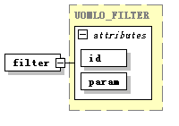
type | UOMLO_FILTER
properties
  isRef | 0
  content | complex
attributes
  Name | Type | Use | Default | Fixed | Annotation
  id | xs:string | required
  param | xs:string | required
source | <xs:Element name="filter" type="UOMLO_FILTER" minOccurs="0" maxOccurs="unbounded"/>

Element UOMLO_FILTEREDCONTAINER/object
diagram | 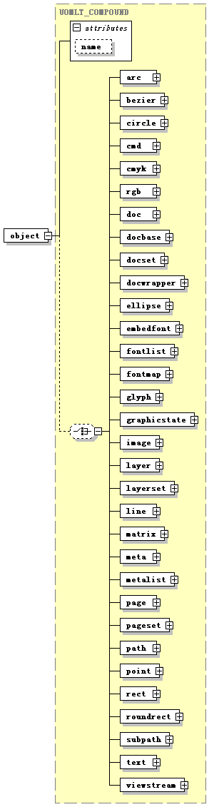
type | UOMLT_COMPOUND
properties
  isRef | 0
  content | complex
children | arc bezier circle cmd cmyk rgb doc docbase docset docwrapper ellipse embedfont fontlist fontmap glyph graphicstate image layer layerset line matrix meta metalist page pageset path point rect roundrect subpath text viewstream
attributes
  Name | Type | Use | Default | Fixed | Annotation
  name | xs:string
source | <xs:Element name="object" type="UOMLT_COMPOUND" minOccurs="0" maxOccurs="unbounded"/>

complexType UOMLO_FONTLIST
diagram | 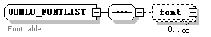
children | font
used by
  Elements | UOMLO_DOC/fontinfo UOMLT_COMPOUND/fontlist
annotation
  documentation | Font table
source | <xs:complexType name="UOMLO_FONTLIST">  <xs:annotation>  <xs:documentation>Font table </xs:documentation>  </xs:annotation>  <xs:sequence>  <xs:Element name="font" type="UOMLO_FONTMAP" minOccurs="0" maxOccurs="unbounded"/>  </xs:sequence>  </xs:complexType>

Element UOMLO_FONTLIST/font
diagram | 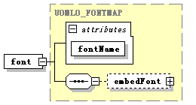
type | UOMLO_FONTMAP
properties
  isRef | 0
  content | complex
children | embedFont
attributes
  Name | Type | Use | Default | Fixed | Annotation
  fontName | xs:string | required
source | <xs:Element name="font" type="UOMLO_FONTMAP" minOccurs="0" maxOccurs="unbounded"/>

complexType UOMLO_FONTMAP
diagram | 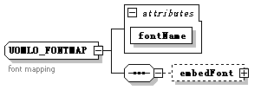
children | embedFont
used by
  Elements | UOMLO_FONTLIST/font UOMLT_COMPOUND/fontmap
attributes
  Name | Type | Use | Default | Fixed | Annotation
  fontName | xs:string | required
annotation
  documentation | font mapping
source | <xs:complexType name="UOMLO_FONTMAP">  <xs:annotation>  <xs:documentation>font mapping</xs:documentation>  </xs:annotation>  <xs:sequence>  <xs:Element name="embedFont" type="UOMLO_EMBEDFONT" minOccurs="0"/>  </xs:sequence>  <xs:attribute name="fontName" type="xs:string" use="required"/>  </xs:complexType>

Element UOMLO_FONTMAP/embedFont
diagram | 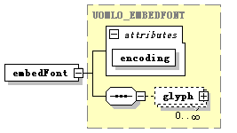
type | UOMLO_EMBEDFONT
properties
  isRef | 0
  content | complex
children | glyph
attributes
  Name | Type | Use | Default | Fixed | Annotation
  encoding | xs:string | required
source | <xs:Element name="embedFont" type="UOMLO_EMBEDFONT" minOccurs="0"/>

complexType UOMLO_GLYPH
diagram | 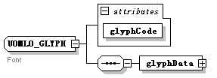
children | glyphData
used by
  Elements | UOMLO_EMBEDFONT/glyph UOMLT_COMPOUND/glyph
attributes
  Name | Type | Use | Default | Fixed | Annotation
  glyphCode | xs:int | required
annotation
  documentation | Font
source | <xs:complexType name="UOMLO_GLYPH">  <xs:annotation>  <xs:documentation>Font </xs:documentation>  </xs:annotation>  <xs:sequence>  <xs:Element name="glyphData" type="UOMLO_PATH"/>  </xs:sequence>  <xs:attribute name="glyphCode" type="xs:int" use="required"/>  </xs:complexType>

Element UOMLO_GLYPH/glyphData
diagram | 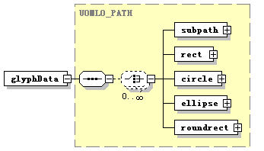
type | UOMLO_PATH
properties
  isRef | 0
  content | complex
children | subpath rect circle ellipse roundrect
source | <xs:Element name="glyphData" type="UOMLO_PATH"/>

complexType UOMLO_GRAPHICSTATE
diagram | 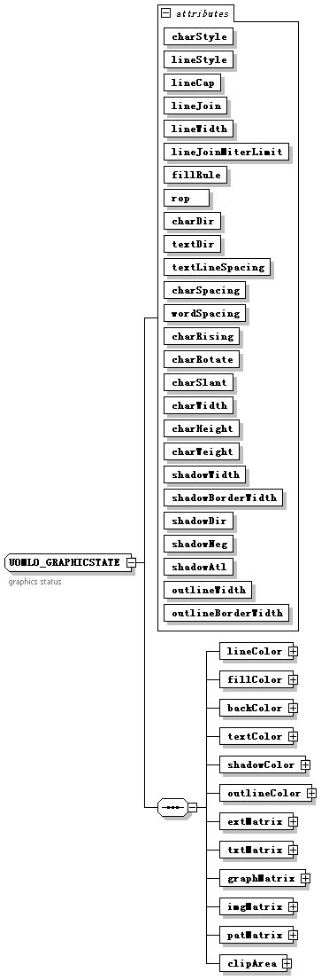
children | lineColor fillColor backColor textColor shadowColor outlineColor extMatrix txtMatrix graphMatrix imgMatrix patMatrix clipArea
used by
  Elements | UOMLT_COMPOUND/graphicstate UOMLO_PAGE/gs
attributes
  Name | Type | Use | Default | Fixed | Annotation
  charStyle | UOMLO_CHARSTYLE | required
  lineStyle | UOMLO_LINESTYLE | required
  lineCap | UOMLO_LINECAP | required
  lineJoin | UOMLO_JOINCAP | required
  lineWidth | xs:float | required
  lineJoinMiterLimit | xs:float | required
  fillRule | UOMLO_FILLRULE | required
  rop | xs:string | required
  charDir | UOMLO_CHARTXTDIR | required
  textDir | UOMLO_CHARTXTDIR | required
  textLineSpacing | xs:float | required
  charSpacing | xs:float | required
  wordSpacing | xs:float | required
  charRising | xs:float | required
  charRotate | xs:float | required
  charSlant | xs:float | required
  charWidth | xs:float | required
  charHeight | xs:float | required
  charWeight | xs:float | required
  shadowWidth | xs:float | required
  shadowBorderWidth | xs:float | required
  shadowDir | UOMLO_SHADOWDIR | required
  shadowNeg | xs:boolean | required
  shadowAtl | xs:boolean | required
  outlineWidth | xs:float | required
  outlineBorderWidth | xs:float | required
annotation
  documentation | graphics status
source | <xs:complexType name="UOMLO_GRAPHICSTATE">  <xs:annotation>  <xs:documentation>graphics status</xs:documentation>  </xs:annotation>  <xs:sequence>  <xs:Element name="lineColor">  <xs:complexType>  <xs:choice>  <xs:Element name="rgb" type="UOMLO_COLOR_RGB"/>  <xs:Element name="cmyk" type="UOMLO_COLOR_CMYK"/>  </xs:choice>  </xs:complexType>  </xs:Element>  <xs:Element name="fillColor">  <xs:complexType>  <xs:choice>  <xs:Element name="rgb" type="UOMLO_COLOR_RGB"/>  <xs:Element name="cmyk" type="UOMLO_COLOR_CMYK"/>  </xs:choice>  </xs:complexType>  </xs:Element>  <xs:Element name="backColor">  <xs:complexType>  <xs:choice>  <xs:Element name="rgb" type="UOMLO_COLOR_RGB"/>  <xs:Element name="cmyk" type="UOMLO_COLOR_CMYK"/>  </xs:choice>  </xs:complexType>  </xs:Element>  <xs:Element name="textColor">  <xs:complexType>  <xs:choice>  <xs:Element name="rgb" type="UOMLO_COLOR_RGB"/>  <xs:Element name="cmyk" type="UOMLO_COLOR_CMYK"/>  </xs:choice>  </xs:complexType>  </xs:Element>  <xs:Element name="shadowColor">  <xs:complexType>  <xs:choice>  <xs:Element name="rgb" type="UOMLO_COLOR_RGB"/>  <xs:Element name="cmyk" type="UOMLO_COLOR_CMYK"/>  </xs:choice>  </xs:complexType>  </xs:Element>  <xs:Element name="outlineColor">  <xs:complexType>  <xs:choice>  <xs:Element name="rgb" type="UOMLO_COLOR_RGB"/>  <xs:Element name="cmyk" type="UOMLO_COLOR_CMYK"/>  </xs:choice>  </xs:complexType>  </xs:Element>  <xs:Element name="extMatrix" type="UOMLO_MATRIX"/>  <xs:Element name="txtMatrix" type="UOMLO_MATRIX"/>  <xs:Element name="graphMatrix" type="UOMLO_MATRIX"/>  <xs:Element name="imgMatrix" type="UOMLO_MATRIX"/>  <xs:Element name="patMatrix" type="UOMLO_MATRIX"/>  <xs:Element name="clipArea" type="UOMLO_PATH"/>  </xs:sequence>  <xs:attribute name="charStyle" type="UOMLO_CHARSTYLE" use="required"/>  <xs:attribute name="lineStyle" type="UOMLO_LINESTYLE" use="required"/>  <xs:attribute name="lineCap" type="UOMLO_LINECAP" use="required"/>  <xs:attribute name="lineJoin" type="UOMLO_JOINCAP" use="required"/>  <xs:attribute name="lineWidth" type="xs:float" use="required"/>  <xs:attribute name="lineJoinMiterLimit" type="xs:float" use="required"/>  <xs:attribute name="fillRule" type="UOMLO_FILLRULE" use="required"/>  <xs:attribute name="rop" type="xs:string" use="required"/>  <xs:attribute name="charDir" type="UOMLO_CHARTXTDIR" use="required"/>  <xs:attribute name="textDir" type="UOMLO_CHARTXTDIR" use="required"/>  <xs:attribute name="textLineSpacing" type="xs:float" use="required"/>  <xs:attribute name="charSpacing" type="xs:float" use="required"/>  <xs:attribute name="wordSpacing" type="xs:float" use="required"/>  <xs:attribute name="charRising" type="xs:float" use="required"/>  <xs:attribute name="charRotate" type="xs:float" use="required"/>  <xs:attribute name="charSlant" type="xs:float" use="required"/>  <xs:attribute name="charWidth" type="xs:float" use="required"/>  <xs:attribute name="charHeight" type="xs:float" use="required"/>  <xs:attribute name="charWeight" type="xs:float" use="required"/>  <xs:attribute name="shadowWidth" type="xs:float" use="required"/>  <xs:attribute name="shadowBorderWidth" type="xs:float" use="required"/>  <xs:attribute name="shadowDir" type="UOMLO_SHADOWDIR" use="required"/>  <xs:attribute name="shadowNeg" type="xs:boolean" use="required"/>  <xs:attribute name="shadowAtl" type="xs:boolean" use="required"/>  <xs:attribute name="outlineWidth" type="xs:float" use="required"/>  <xs:attribute name="outlineBorderWidth" type="xs:float" use="required"/>  </xs:complexType>

Element UOMLO_GRAPHICSTATE/lineColor
diagram | 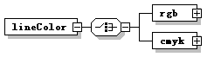
properties
  isRef | 0
  content | complex
children | rgb cmyk
source | <xs:Element name="lineColor">  <xs:complexType>  <xs:choice>  <xs:Element name="rgb" type="UOMLO_COLOR_RGB"/>  <xs:Element name="cmyk" type="UOMLO_COLOR_CMYK"/>  </xs:choice>  </xs:complexType>  </xs:Element>

Element UOMLO_GRAPHICSTATE/lineColor/rgb
diagram
type | UOMLO_COLOR_RGB
properties
  isRef | 0
  content | complex
attributes
  Name | Type | Use | Default | Fixed | Annotation
  r | xs:short | required
  g | xs:short | required
  b | xs:short | required
  a | xs:short | required
source | <xs:Element name="rgb" type="UOMLO_COLOR_RGB"/>

Element UOMLO_GRAPHICSTATE/lineColor/cmyk
diagram
type | UOMLO_COLOR_CMYK
properties
  isRef | 0
  content | complex
attributes
  Name | Type | Use | Default | Fixed | Annotation
  c | xs:short | required
  m | xs:short | required
  y | xs:short | required
  k | xs:short | required
source | <xs:Element name="cmyk" type="UOMLO_COLOR_CMYK"/>

Element UOMLO_GRAPHICSTATE/fillColor
diagram | 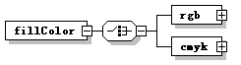
properties
  isRef | 0
  content | complex
children | rgb cmyk
source | <xs:Element name="fillColor">  <xs:complexType>  <xs:choice>  <xs:Element name="rgb" type="UOMLO_COLOR_RGB"/>  <xs:Element name="cmyk" type="UOMLO_COLOR_CMYK"/>  </xs:choice>  </xs:complexType>  </xs:Element>

Element UOMLO_GRAPHICSTATE/fillColor/rgb
diagram
type | UOMLO_COLOR_RGB
properties
  isRef | 0
  content | complex
attributes
  Name | Type | Use | Default | Fixed | Annotation
  r | xs:short | required
  g | xs:short | required
  b | xs:short | required
  a | xs:short | required
source | <xs:Element name="rgb" type="UOMLO_COLOR_RGB"/>

Element UOMLO_GRAPHICSTATE/fillColor/cmyk
diagram
type | UOMLO_COLOR_CMYK
properties
  isRef | 0
  content | complex
attributes
  Name | Type | Use | Default | Fixed | Annotation
  c | xs:short | required
  m | xs:short | required
  y | xs:short | required
  k | xs:short | required
source | <xs:Element name="cmyk" type="UOMLO_COLOR_CMYK"/>

Element UOMLO_GRAPHICSTATE/backColor
diagram | 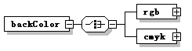
properties
  isRef | 0
  content | complex
children | rgb cmyk
source | <xs:Element name="backColor">  <xs:complexType>  <xs:choice>  <xs:Element name="rgb" type="UOMLO_COLOR_RGB"/>  <xs:Element name="cmyk" type="UOMLO_COLOR_CMYK"/>  </xs:choice>  </xs:complexType>  </xs:Element>

Element UOMLO_GRAPHICSTATE/backColor/rgb
diagram
type | UOMLO_COLOR_RGB
properties
  isRef | 0
  content | complex
attributes
  Name | Type | Use | Default | Fixed | Annotation
  r | xs:short | required
  g | xs:short | required
  b | xs:short | required
  a | xs:short | required
source | <xs:Element name="rgb" type="UOMLO_COLOR_RGB"/>

Element UOMLO_GRAPHICSTATE/backColor/cmyk
diagram
type | UOMLO_COLOR_CMYK
properties
  isRef | 0
  content | complex
attributes
  Name | Type | Use | Default | Fixed | Annotation
  c | xs:short | required
  m | xs:short | required
  y | xs:short | required
  k | xs:short | required
source | <xs:Element name="cmyk" type="UOMLO_COLOR_CMYK"/>

Element UOMLO_GRAPHICSTATE/textColor
diagram | 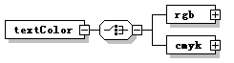
properties
  isRef | 0
  content | complex
children | rgb cmyk
source | <xs:Element name="textColor">  <xs:complexType>  <xs:choice>  <xs:Element name="rgb" type="UOMLO_COLOR_RGB"/>  <xs:Element name="cmyk" type="UOMLO_COLOR_CMYK"/>  </xs:choice>  </xs:complexType>  </xs:Element>

Element UOMLO_GRAPHICSTATE/textColor/rgb
diagram
type | UOMLO_COLOR_RGB
properties
  isRef | 0
  content | complex
attributes
  Name | Type | Use | Default | Fixed | Annotation
  r | xs:short | required
  g | xs:short | required
  b | xs:short | required
  a | xs:short | required
source | <xs:Element name="rgb" type="UOMLO_COLOR_RGB"/>

Element UOMLO_GRAPHICSTATE/textColor/cmyk
diagram
type | UOMLO_COLOR_CMYK
properties
  isRef | 0
  content | complex
attributes
  Name | Type | Use | Default | Fixed | Annotation
  c | xs:short | required
  m | xs:short | required
  y | xs:short | required
  k | xs:short | required
source | <xs:Element name="cmyk" type="UOMLO_COLOR_CMYK"/>

Element UOMLO_GRAPHICSTATE/shadowColor
diagram | 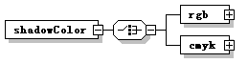
properties
  isRef | 0
  content | complex
children | rgb cmyk
source | <xs:Element name="shadowColor">  <xs:complexType>  <xs:choice>  <xs:Element name="rgb" type="UOMLO_COLOR_RGB"/>  <xs:Element name="cmyk" type="UOMLO_COLOR_CMYK"/>  </xs:choice>  </xs:complexType>  </xs:Element>

Element UOMLO_GRAPHICSTATE/shadowColor/rgb
diagram
type | UOMLO_COLOR_RGB
properties
  isRef | 0
  content | complex
attributes
  Name | Type | Use | Default | Fixed | Annotation
  r | xs:short | required
  g | xs:short | required
  b | xs:short | required
  a | xs:short | required
source | <xs:Element name="rgb" type="UOMLO_COLOR_RGB"/>

Element UOMLO_GRAPHICSTATE/shadowColor/cmyk
diagram
type | UOMLO_COLOR_CMYK
properties
  isRef | 0
  content | complex
attributes
  Name | Type | Use | Default | Fixed | Annotation
  c | xs:short | required
  m | xs:short | required
  y | xs:short | required
  k | xs:short | required
source | <xs:Element name="cmyk" type="UOMLO_COLOR_CMYK"/>

Element UOMLO_GRAPHICSTATE/outlineColor
diagram | 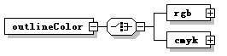
properties
  isRef | 0
  content | complex
children | rgb cmyk
source | <xs:Element name="outlineColor">  <xs:complexType>  <xs:choice>  <xs:Element name="rgb" type="UOMLO_COLOR_RGB"/>  <xs:Element name="cmyk" type="UOMLO_COLOR_CMYK"/>  </xs:choice>  </xs:complexType>  </xs:Element>

Element UOMLO_GRAPHICSTATE/outlineColor/rgb
diagram
type | UOMLO_COLOR_RGB
properties
  isRef | 0
  content | complex
attributes
  Name | Type | Use | Default | Fixed | Annotation
  r | xs:short | required
  g | xs:short | required
  b | xs:short | required
  a | xs:short | required
source | <xs:Element name="rgb" type="UOMLO_COLOR_RGB"/>

Element UOMLO_GRAPHICSTATE/outlineColor/cmyk
diagram
type | UOMLO_COLOR_CMYK
properties
  isRef | 0
  content | complex
attributes
  Name | Type | Use | Default | Fixed | Annotation
  c | xs:short | required
  m | xs:short | required
  y | xs:short | required
  k | xs:short | required
source | <xs:Element name="cmyk" type="UOMLO_COLOR_CMYK"/>

Element UOMLO_GRAPHICSTATE/extMatrix
diagram | 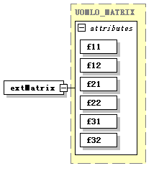
type | UOMLO_MATRIX
properties
  isRef | 0
  content | complex
attributes
  Name | Type | Use | Default | Fixed | Annotation
  f11 | xs:float | required
  f12 | xs:float | required
  f21 | xs:float | required
  f22 | xs:float | required
  f31 | xs:float | required
  f32 | xs:float | required
source | <xs:Element name="extMatrix" type="UOMLO_MATRIX"/>

Element UOMLO_GRAPHICSTATE/txtMatrix
diagram | 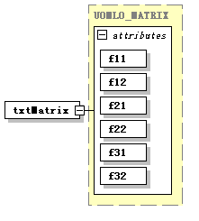
type | UOMLO_MATRIX
properties
  isRef | 0
  content | complex
attributes
  Name | Type | Use | Default | Fixed | Annotation
  f11 | xs:float | required
  f12 | xs:float | required
  f21 | xs:float | required
  f22 | xs:float | required
  f31 | xs:float | required
  f32 | xs:float | required
source | <xs:Element name="txtMatrix" type="UOMLO_MATRIX"/>

Element UOMLO_GRAPHICSTATE/graphMatrix
diagram | 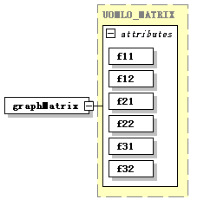
type | UOMLO_MATRIX
properties
  isRef | 0
  content | complex
attributes
  Name | Type | Use | Default | Fixed | Annotation
  f11 | xs:float | required
  f12 | xs:float | required
  f21 | xs:float | required
  f22 | xs:float | required
  f31 | xs:float | required
  f32 | xs:float | required
source | <xs:Element name="graphMatrix" type="UOMLO_MATRIX"/>

Element UOMLO_GRAPHICSTATE/imgMatrix
diagram | 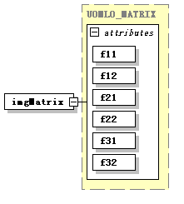
type | UOMLO_MATRIX
properties
  isRef | 0
  content | complex
attributes
  Name | Type | Use | Default | Fixed | Annotation
  f11 | xs:float | required
  f12 | xs:float | required
  f21 | xs:float | required
  f22 | xs:float | required
  f31 | xs:float | required
  f32 | xs:float | required
source | <xs:Element name="imgMatrix" type="UOMLO_MATRIX"/>

Element UOMLO_GRAPHICSTATE/patMatrix
diagram | 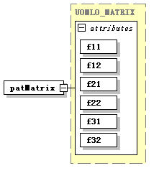
type | UOMLO_MATRIX
properties
  isRef | 0
  content | complex
attributes
  Name | Type | Use | Default | Fixed | Annotation
  f11 | xs:float | required
  f12 | xs:float | required
  f21 | xs:float | required
  f22 | xs:float | required
  f31 | xs:float | required
  f32 | xs:float | required
source | <xs:Element name="patMatrix" type="UOMLO_MATRIX"/>

Element UOMLO_GRAPHICSTATE/clipArea
diagram | 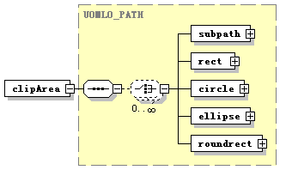
type | UOMLO_PATH
properties
  isRef | 0
  content | complex
children | subpath rect circle ellipse roundrect
source | <xs:Element name="clipArea" type="UOMLO_PATH"/>

complexType UOMLO_IMAGE
diagram | 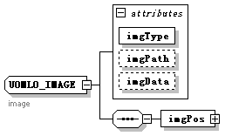
children | imgPos
used by
  Element | UOMLT_COMPOUND/image
attributes
  Name | Type | Use | Default | Fixed | Annotation
  imgType | xs:string | required
  imgPath | xs:string
  imgData | xs:string
annotation
  documentation | image
source | <xs:complexType name="UOMLO_IMAGE">  <xs:annotation>  <xs:documentation>image</xs:documentation>  </xs:annotation>  <xs:sequence>  <xs:Element name="imgPos" type="UOMLO_RECT"/>  </xs:sequence>  <xs:attribute name="imgType" type="xs:string" use="required"/>  <xs:attribute name="imgPath" type="xs:string"/>  <xs:attribute name="imgData" type="xs:string"/>  </xs:complexType>

Element UOMLO_IMAGE/imgPos
diagram | 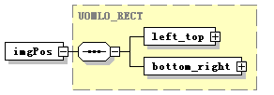
type | UOMLO_RECT
properties
  isRef | 0
  content | complex
children | left_top bottom_right
source | <xs:Element name="imgPos" type="UOMLO_RECT"/>

complexType UOMLO_KEYLIST
diagram | 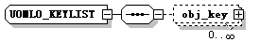
children | obj_key
used by
  Element | UOMLO_PRIVENTRY/keylist
source | <xs:complexType name="UOMLO_KEYLIST">  <xs:sequence>  <xs:Element name="obj_key" type="UOMLO_OBJKEY" minOccurs="0" maxOccurs="unbounded"/>  </xs:sequence>  </xs:complexType>

Element UOMLO_KEYLIST/obj_key
diagram | 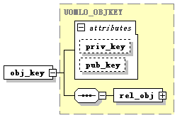
type | UOMLO_OBJKEY
properties
  isRef | 0
  content | complex
children | rel_obj
attributes
  Name | Type | Use | Default | Fixed | Annotation
  priv_key | xs:string
  pub_key | xs:string
source | <xs:Element name="obj_key" type="UOMLO_OBJKEY" minOccurs="0" maxOccurs="unbounded"/>

complexType UOMLO_LAYER
diagram | 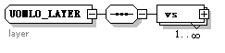
children | vs
used by
  Elements | UOMLO_LAYERSET/layer UOMLT_COMPOUND/layer
annotation
  documentation | layer
source | <xs:complexType name="UOMLO_LAYER">  <xs:annotation>  <xs:documentation>layer  </xs:documentation>  </xs:annotation>  <xs:sequence>  <xs:Element name="vs" type="UOMLO_PDL" maxOccurs="unbounded"/>  </xs:sequence>  </xs:complexType>

Element UOMLO_LAYER/vs
diagram | 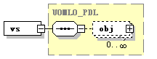
type | UOMLO_PDL
properties
  isRef | 0
  content | complex
children | obj
source | <xs:Element name="vs" type="UOMLO_PDL" maxOccurs="unbounded"/>

complexType UOMLO_LAYERSET
diagram | 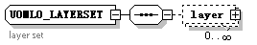
children | layer
used by
  Elements | UOMLO_PAGE/layers UOMLT_COMPOUND/layerset
annotation
  documentation | layer set
source | <xs:complexType name="UOMLO_LAYERSET">  <xs:annotation>  <xs:documentation>layer set</xs:documentation>  </xs:annotation>  <xs:sequence>  <xs:Element name="layer" type="UOMLO_LAYER" minOccurs="0" maxOccurs="unbounded"/>  </xs:sequence>  </xs:complexType>

Element UOMLO_LAYERSET/layer
diagram | 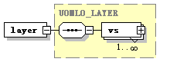
type | UOMLO_LAYER
properties
  isRef | 0
  content | complex
children | vs
source | <xs:Element name="layer" type="UOMLO_LAYER" minOccurs="0" maxOccurs="unbounded"/>

complexType UOMLO_LINE
diagram | 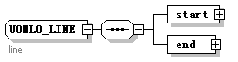
children | start end
used by
  Element | UOMLT_COMPOUND/line
annotation
  documentation | line
source | <xs:complexType name="UOMLO_LINE">  <xs:annotation>  <xs:documentation>line</xs:documentation>  </xs:annotation>  <xs:sequence>  <xs:Element name="start" type="UOMLO_POINT"/>  <xs:Element name="end" type="UOMLO_POINT"/>  </xs:sequence>  </xs:complexType>

Element UOMLO_LINE/start
diagram
type | UOMLO_POINT
properties
  isRef | 0
  content | complex
attributes
  Name | Type | Use | Default | Fixed | Annotation
  xCod | xs:float | required
  yCod | xs:float | required
source | <xs:Element name="start" type="UOMLO_POINT"/>

Element UOMLO_LINE/end
diagram
type | UOMLO_POINT
properties
  isRef | 0
  content | complex
attributes
  Name | Type | Use | Default | Fixed | Annotation
  xCod | xs:float | required
  yCod | xs:float | required
source | <xs:Element name="end" type="UOMLO_POINT"/>

complexType UOMLO_LINESEG
diagram | 
children | end
used by
  Element | UOMLO_SUBPATH/lineseg
source | <xs:complexType name="UOMLO_LINESEG">  <xs:sequence>  <xs:Element name="end" type="UOMLO_POINT"/>  </xs:sequence>  </xs:complexType>

Element UOMLO_LINESEG/end
diagram
type | UOMLO_POINT
properties
  isRef | 0
  content | complex
attributes
  Name | Type | Use | Default | Fixed | Annotation
  xCod | xs:float | required
  yCod | xs:float | required
source | <xs:Element name="end" type="UOMLO_POINT"/>

complexType UOMLO_MATRIX
diagram | 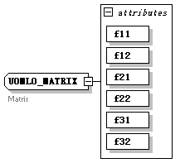
used by
  Elements | UOMLO_GRAPHICSTATE/extMatrix UOMLO_GRAPHICSTATE/graphMatrix UOMLO_GRAPHICSTATE/imgMatrix UOMLO_CMD/matrix UOMLT_COMPOUND/matrix UOMLO_GRAPHICSTATE/patMatrix UOMLO_GRAPHICSTATE/txtMatrix
attributes
  Name | Type | Use | Default | Fixed | Annotation
  f11 | xs:float | required
  f12 | xs:float | required
  f21 | xs:float | required
  f22 | xs:float | required
  f31 | xs:float | required
  f32 | xs:float | required
annotation
  documentation | Matrix
source | <xs:complexType name="UOMLO_MATRIX">  <xs:annotation>  <xs:documentation>Matrix </xs:documentation>  </xs:annotation>  <xs:attribute name="f11" type="xs:float" use="required"/>  <xs:attribute name="f12" type="xs:float" use="required"/>  <xs:attribute name="f21" type="xs:float" use="required"/>  <xs:attribute name="f22" type="xs:float" use="required"/>  <xs:attribute name="f31" type="xs:float" use="required"/>  <xs:attribute name="f32" type="xs:float" use="required"/>  </xs:complexType>

complexType UOMLO_META
diagram | 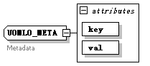
used by
  Elements | UOMLO_METALIST/meta UOMLT_COMPOUND/meta
attributes
  Name | Type | Use | Default | Fixed | Annotation
  key | xs:string | required
  val | xs:string | required
annotation
  documentation | Metadata
source | <xs:complexType name="UOMLO_META">  <xs:annotation>  <xs:documentation>Metadata </xs:documentation>  </xs:annotation>  <xs:attribute name="key" type="xs:string" use="required"/>  <xs:attribute name="val" type="xs:string" use="required"/>  </xs:complexType>

complexType UOMLO_METALIST
diagram | 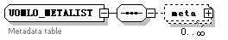
children | meta
used by
  Elements | UOMLO_DOC/metainfo UOMLT_COMPOUND/metalist
annotation
  documentation | Metadata table
source | <xs:complexType name="UOMLO_METALIST">  <xs:annotation>  <xs:documentation>Metadata table</xs:documentation>  </xs:annotation>  <xs:sequence>  <xs:Element name="meta" type="UOMLO_META" minOccurs="0" maxOccurs="unbounded"/>  </xs:sequence>  </xs:complexType>

Element UOMLO_METALIST/meta
diagram | 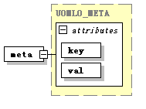
type | UOMLO_META
properties
  isRef | 0
  content | complex
attributes
  Name | Type | Use | Default | Fixed | Annotation
  key | xs:string | required
  val | xs:string | required
source | <xs:Element name="meta" type="UOMLO_META" minOccurs="0" maxOccurs="unbounded"/>

complexType UOMLO_NODESIGN
diagram | 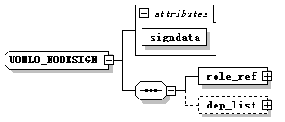
children | role_ref dep_list
used by
  Element | UOMLO_NODESIGNLIST/node_sign
attributes
  Name | Type | Use | Default | Fixed | Annotation
  signdata | xs:string | required
source | <xs:complexType name="UOMLO_NODESIGN">  <xs:sequence>  <xs:Element name="role_ref" type="UOMLO_REF"/>  <xs:Element name="dep_list" type="UOMLO_SIGNDEPLIST" minOccurs="0"/>  </xs:sequence>  <xs:attribute name="signdata" type="xs:string" use="required"/>  </xs:complexType>

Element UOMLO_NODESIGN/role_ref
diagram | 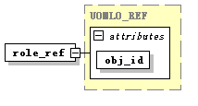
type | UOMLO_REF
properties
  isRef | 0
  content | complex
attributes
  Name | Type | Use | Default | Fixed | Annotation
  obj_id | xs:int | required
source | <xs:Element name="role_ref" type="UOMLO_REF"/>

Element UOMLO_NODESIGN/dep_list
diagram | 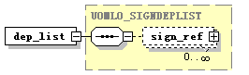
type | UOMLO_SIGNDEPLIST
properties
  isRef | 0
  content | complex
children | sign_ref
source | <xs:Element name="dep_list" type="UOMLO_SIGNDEPLIST" minOccurs="0"/>

complexType UOMLO_NODESIGNLIST
diagram | 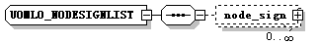
children | node_sign
used by
  Element | UOMLO_OBJSIGN/node_sign_list
source | <xs:complexType name="UOMLO_NODESIGNLIST">  <xs:sequence>  <xs:Element name="node_sign" type="UOMLO_NODESIGN" minOccurs="0" maxOccurs="unbounded"/>  </xs:sequence>  </xs:complexType>

Element UOMLO_NODESIGNLIST/node_sign
diagram | 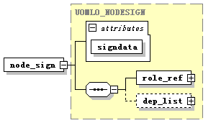
type | UOMLO_NODESIGN
properties
  isRef | 0
  content | complex
children | role_ref dep_list
attributes
  Name | Type | Use | Default | Fixed | Annotation
  signdata | xs:string | required
source | <xs:Element name="node_sign" type="UOMLO_NODESIGN" minOccurs="0" maxOccurs="unbounded"/>

complexType UOMLO_OBJKEY
diagram | 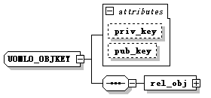
children | rel_obj
used by
  Element | UOMLO_KEYLIST/obj_key
attributes
  Name | Type | Use | Default | Fixed | Annotation
  priv_key | xs:string
  pub_key | xs:string
source | <xs:complexType name="UOMLO_OBJKEY">  <xs:sequence>  <xs:Element name="rel_obj" type="UOMLO_REF"/>  </xs:sequence>  <xs:attribute name="priv_key" type="xs:string"/>  <xs:attribute name="pub_key" type="xs:string"/>  </xs:complexType>

Element UOMLO_OBJKEY/rel_obj
diagram | 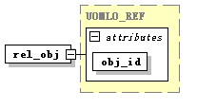
type | UOMLO_REF
properties
  isRef | 0
  content | complex
attributes
  Name | Type | Use | Default | Fixed | Annotation
  obj_id | xs:int | required
source | <xs:Element name="rel_obj" type="UOMLO_REF"/>

complexType UOMLO_OBJSIGN
diagram | 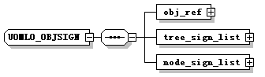
children | obj_ref tree_sign_list node_sign_list
used by
  Element | UOMLO_DOCSIGN/obj_sign
source | <xs:complexType name="UOMLO_OBJSIGN">  <xs:sequence>  <xs:Element name="obj_ref" type="UOMLO_REF"/>  <xs:Element name="tree_sign_list" type="UOMLO_TREESIGNLIST"/>  <xs:Element name="node_sign_list" type="UOMLO_NODESIGNLIST"/>  </xs:sequence>  </xs:complexType>

Element UOMLO_OBJSIGN/obj_ref
diagram | 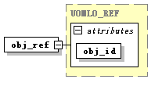
type | UOMLO_REF
properties
  isRef | 0
  content | complex
attributes
  Name | Type | Use | Default | Fixed | Annotation
  obj_id | xs:int | required
source | <xs:Element name="obj_ref" type="UOMLO_REF"/>

Element UOMLO_OBJSIGN/tree_sign_list
diagram | 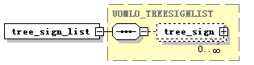
type | UOMLO_TREESIGNLIST
properties
  isRef | 0
  content | complex
children | tree_sign
source | <xs:Element name="tree_sign_list" type="UOMLO_TREESIGNLIST"/>

Element UOMLO_OBJSIGN/node_sign_list
diagram | 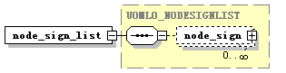
type | UOMLO_NODESIGNLIST
properties
  isRef | 0
  content | complex
children | node_sign
source | <xs:Element name="node_sign_list" type="UOMLO_NODESIGNLIST"/>

complexType UOMLO_PAGE
diagram | 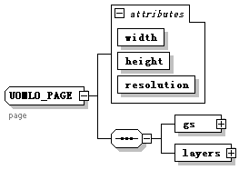
children | gs layers
used by
  Elements | UOMLO_PAGESET/page UOMLT_COMPOUND/page
attributes
  Name | Type | Use | Default | Fixed | Annotation
  width | xs:float | required
  height | xs:float | required
  resolution | xs:int | required
annotation
  documentation | page
source | <xs:complexType name="UOMLO_PAGE">  <xs:annotation>  <xs:documentation>page</xs:documentation>  </xs:annotation>  <xs:sequence>  <xs:Element name="gs" type="UOMLO_GRAPHICSTATE"/>  <xs:Element name="layers" type="UOMLO_LAYERSET"/>  </xs:sequence>  <xs:attribute name="width" type="xs:float" use="required"/>  <xs:attribute name="height" type="xs:float" use="required"/>  <xs:attribute name="resolution" type="xs:int" use="required"/>  </xs:complexType>

Element UOMLO_PAGE/gs
diagram | 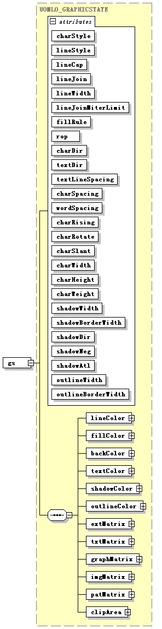
type | UOMLO_GRAPHICSTATE
properties
  isRef | 0
  content | complex
children | lineColor fillColor backColor textColor shadowColor outlineColor extMatrix txtMatrix graphMatrix imgMatrix patMatrix clipArea
attributes
  Name | Type | Use | Default | Fixed | Annotation
  charStyle | UOMLO_CHARSTYLE | required
  lineStyle | UOMLO_LINESTYLE | required
  lineCap | UOMLO_LINECAP | required
  lineJoin | UOMLO_JOINCAP | required
  lineWidth | xs:float | required
  lineJoinMiterLimit | xs:float | required
  fillRule | UOMLO_FILLRULE | required
  rop | xs:string | required
  charDir | UOMLO_CHARTXTDIR | required
  textDir | UOMLO_CHARTXTDIR | required
  textLineSpacing | xs:float | required
  charSpacing | xs:float | required
  wordSpacing | xs:float | required
  charRising | xs:float | required
  charRotate | xs:float | required
  charSlant | xs:float | required
  charWidth | xs:float | required
  charHeight | xs:float | required
  charWeight | xs:float | required
  shadowWidth | xs:float | required
  shadowBorderWidth | xs:float | required
  shadowDir | UOMLO_SHADOWDIR | required
  shadowNeg | xs:boolean | required
  shadowAtl | xs:boolean | required
  outlineWidth | xs:float | required
  outlineBorderWidth | xs:float | required
source | <xs:Element name="gs" type="UOMLO_GRAPHICSTATE"/>

Element UOMLO_PAGE/layers
diagram | 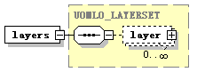
type | UOMLO_LAYERSET
properties
  isRef | 0
  content | complex
children | layer
source | <xs:Element name="layers" type="UOMLO_LAYERSET"/>

complexType UOMLO_PAGESET
diagram | 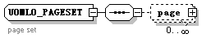
children | page
used by
  Elements | UOMLO_DOC/pageset UOMLT_COMPOUND/pageset
annotation
  documentation | page set
source | <xs:complexType name="UOMLO_PAGESET">  <xs:annotation>  <xs:documentation>page set</xs:documentation>  </xs:annotation>  <xs:sequence>  <xs:Element name="page" type="UOMLO_PAGE" minOccurs="0" maxOccurs="unbounded"/>  </xs:sequence>  </xs:complexType>

Element UOMLO_PAGESET/page
diagram | 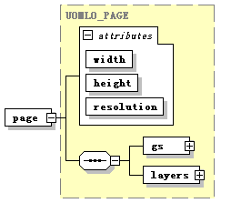
type | UOMLO_PAGE
properties
  isRef | 0
  content | complex
children | gs layers
attributes
  Name | Type | Use | Default | Fixed | Annotation
  width | xs:float | required
  height | xs:float | required
  resolution | xs:int | required
source | <xs:Element name="page" type="UOMLO_PAGE" minOccurs="0" maxOccurs="unbounded"/>

complexType UOMLO_PATH
diagram | 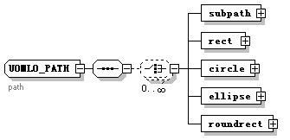
children | subpath rect circle ellipse roundrect
used by
  Elements | UOMLO_CMD/cliparea UOMLO_GRAPHICSTATE/clipArea UOMLO_GLYPH/glyphData UOMLT_COMPOUND/path
annotation
  documentation | path
source | <xs:complexType name="UOMLO_PATH">  <xs:annotation>  <xs:documentation>path</xs:documentation>  </xs:annotation>  <xs:sequence>  <xs:choice minOccurs="0" maxOccurs="unbounded">  <xs:Element name="subpath" type="UOMLO_SUBPATH"/>  <xs:Element name="rect" type="UOMLO_RECT"/>  <xs:Element name="circle" type="UOMLO_CIRCLE"/>  <xs:Element name="ellipse" type="UOMLO_ELLIPSE"/>  <xs:Element name="roundrect" type="UOMLO_ROUNDRECT"/>  </xs:choice>  </xs:sequence>  </xs:complexType>

Element UOMLO_PATH/subpath
diagram | 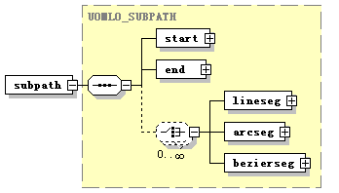
type | UOMLO_SUBPATH
properties
  isRef | 0
  content | complex
children | start end lineseg arcseg bezierseg
source | <xs:Element name="subpath" type="UOMLO_SUBPATH"/>

Element UOMLO_PATH/rect
diagram | 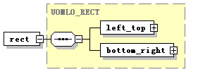
type | UOMLO_RECT
properties
  isRef | 0
  content | complex
children | left_top bottom_right
source | <xs:Element name="rect" type="UOMLO_RECT"/>

Element UOMLO_PATH/circle
diagram | 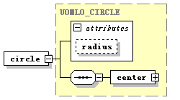
type | UOMLO_CIRCLE
properties
  isRef | 0
  content | complex
children | center
attributes
  Name | Type | Use | Default | Fixed | Annotation
  radius | xs:float
source | <xs:Element name="circle" type="UOMLO_CIRCLE"/>

Element UOMLO_PATH/ellipse
diagram | 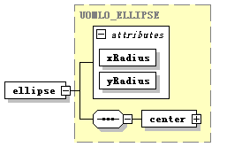
type | UOMLO_ELLIPSE
properties
  isRef | 0
  content | complex
children | center
attributes
  Name | Type | Use | Default | Fixed | Annotation
  xRadius | xs:float | required
  yRadius | xs:float | required
source | <xs:Element name="ellipse" type="UOMLO_ELLIPSE"/>

Element UOMLO_PATH/roundrect
diagram | 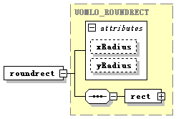
type | UOMLO_ROUNDRECT
properties
  isRef | 0
  content | complex
children | rect
attributes
  Name | Type | Use | Default | Fixed | Annotation
  xRadius | xs:float
  yRadius | xs:float
source | <xs:Element name="roundrect" type="UOMLO_ROUNDRECT"/>

complexType UOMLO_PDL
diagram | 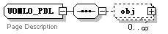
children | obj
used by
  Elements | UOMLT_COMPOUND/viewstream UOMLO_LAYER/vs
annotation
  documentation | Page Description
source | <xs:complexType name="UOMLO_PDL">  <xs:annotation>  <xs:documentation>Page Description</xs:documentation>  </xs:annotation>  <xs:sequence>  <xs:Element name="obj" type="UOMLT_COMPOUND" minOccurs="0" maxOccurs="unbounded"/>  </xs:sequence>  </xs:complexType>

Element UOMLO_PDL/obj
diagram | 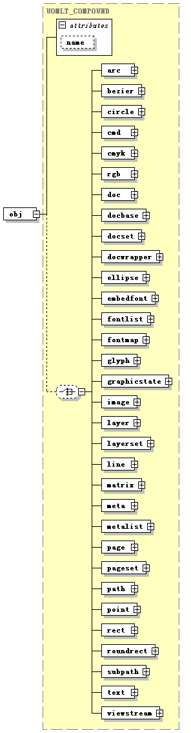
type | UOMLT_COMPOUND
properties
  isRef | 0
  content | complex
children | arc bezier circle cmd cmyk rgb doc docbase docset docwrapper ellipse embedfont fontlist fontmap glyph graphicstate image layer layerset line matrix meta metalist page pageset path point rect roundrect subpath text viewstream
attributes
  Name | Type | Use | Default | Fixed | Annotation
  name | xs:string
source | <xs:Element name="obj" type="UOMLT_COMPOUND" minOccurs="0" maxOccurs="unbounded"/>

complexType UOMLO_PLUGIN
diagram | 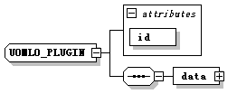
children | data
attributes
  Name | Type | Use | Default | Fixed | Annotation
  id | xs:string | required
source | <xs:complexType name="UOMLO_PLUGIN">  <xs:sequence>  <xs:Element name="data" type="UOMLT_STRING"/>  </xs:sequence>  <xs:attribute name="id" type="xs:string" use="required"/>  </xs:complexType>

Element UOMLO_PLUGIN/data
diagram | 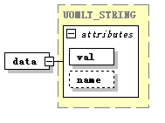
type | UOMLT_STRING
properties
  isRef | 0
  content | complex
attributes
  Name | Type | Use | Default | Fixed | Annotation
  val | xs:string | required
  name | xs:string
source | <xs:Element name="data" type="UOMLT_STRING"/>

complexType UOMLO_POINT
diagram | 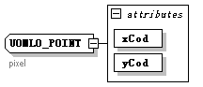
used by
  Elements | UOMLO_RECT/bottom_right UOMLO_ARC/center UOMLO_ARCSEG/center UOMLO_CIRCLE/center UOMLO_ELLIPSE/center UOMLO_BEZIERSEG/ctrl_1 UOMLO_BEZIER/ctrl_1 UOMLO_BEZIERSEG/ctrl_2 UOMLO_BEZIER/ctrl_2 UOMLO_BEZIERSEG/end UOMLO_ARCSEG/end UOMLO_LINESEG/end UOMLO_SUBPATH/end UOMLO_LINE/end UOMLO_BEZIER/end UOMLO_ARC/end UOMLO_RECT/left_top UOMLT_COMPOUND/point UOMLO_SUBPATH/start UOMLO_LINE/start UOMLO_BEZIER/start UOMLO_ARC/start
attributes
  Name | Type | Use | Default | Fixed | Annotation
  xCod | xs:float | required
  yCod | xs:float | required
annotation
  documentation | pixel
source | <xs:complexType name="UOMLO_POINT">  <xs:annotation>  <xs:documentation>pixel</xs:documentation>  </xs:annotation>  <xs:attribute name="xCod" type="xs:float" use="required"/>  <xs:attribute name="yCod" type="xs:float" use="required"/>  </xs:complexType>

complexType UOMLO_PRIVENTRY
diagram | 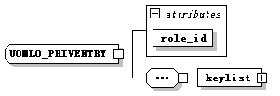
children | keylist
used by
  Element | UOMLO_PRIVLIST/entry
attributes
  Name | Type | Use | Default | Fixed | Annotation
  role_id | xs:string | required
source | <xs:complexType name="UOMLO_PRIVENTRY">  <xs:sequence>  <xs:Element name="keylist" type="UOMLO_KEYLIST"/>  </xs:sequence>  <xs:attribute name="role_id" type="xs:string" use="required"/>  </xs:complexType>

Element UOMLO_PRIVENTRY/keylist
diagram | 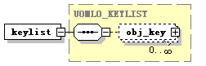
type | UOMLO_KEYLIST
properties
  isRef | 0
  content | complex
children | obj_key
source | <xs:Element name="keylist" type="UOMLO_KEYLIST"/>

complexType UOMLO_PRIVLIST
diagram | 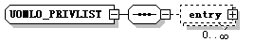
children | entry
used by
  Element | UOMLO_DOCWRAPPER/privlist
source | <xs:complexType name="UOMLO_PRIVLIST">  <xs:sequence>  <xs:Element name="entry" type="UOMLO_PRIVENTRY" minOccurs="0" maxOccurs="unbounded"/>  </xs:sequence>  </xs:complexType>

Element UOMLO_PRIVLIST/entry
diagram | 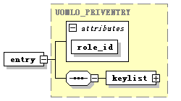
type | UOMLO_PRIVENTRY
properties
  isRef | 0
  content | complex
children | keylist
attributes
  Name | Type | Use | Default | Fixed | Annotation
  role_id | xs:string | required
source | <xs:Element name="entry" type="UOMLO_PRIVENTRY" minOccurs="0" maxOccurs="unbounded"/>

complexType UOMLO_RECT
diagram | 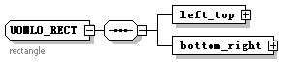
children | left_top bottom_right
used by
  Elements | UOML_GET/input/clip UOMLO_IMAGE/imgPos UOMLO_ROUNDRECT/rect UOMLO_PATH/rect UOMLT_COMPOUND/rect UOMLO_TEXT/txtPos
annotation
  documentation | rectangle
source | <xs:complexType name="UOMLO_RECT">  <xs:annotation>  <xs:documentation>rectangle  </xs:documentation>  </xs:annotation>  <xs:sequence>  <xs:Element name="left_top" type="UOMLO_POINT"/>  <xs:Element name="bottom_right" type="UOMLO_POINT"/>  </xs:sequence>  </xs:complexType>

Element UOMLO_RECT/left_top
diagram | 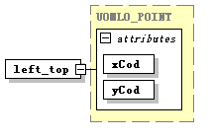
type | UOMLO_POINT
properties
  isRef | 0
  content | complex
attributes
  Name | Type | Use | Default | Fixed | Annotation
  xCod | xs:float | required
  yCod | xs:float | required
source | <xs:Element name="left_top" type="UOMLO_POINT"/>

Element UOMLO_RECT/bottom_right
diagram | 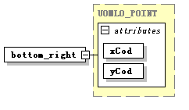
type | UOMLO_POINT
properties
  isRef | 0
  content | complex
attributes
  Name | Type | Use | Default | Fixed | Annotation
  xCod | xs:float | required
  yCod | xs:float | required
source | <xs:Element name="bottom_right" type="UOMLO_POINT"/>

complexType UOMLO_REF
diagram | 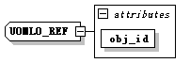
used by
  Elements | UOMLO_OBJSIGN/obj_ref UOMLO_OBJKEY/rel_obj UOMLO_NODESIGN/role_ref UOMLO_TREESIGN/role_ref UOMLO_SIGNDEPLIST/sign_ref
attributes
  Name | Type | Use | Default | Fixed | Annotation
  obj_id | xs:int | required
source | <xs:complexType name="UOMLO_REF">  <xs:attribute name="obj_id" type="xs:int" use="required"/>  </xs:complexType>

complexType UOMLO_ROLE
diagram | 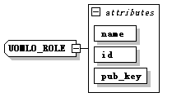
used by
  Element | UOMLO_ROLELIST/role
attributes
  Name | Type | Use | Default | Fixed | Annotation
  name | xs:string | required
  id | xs:string | required
  pub_key | xs:string | required
source | <xs:complexType name="UOMLO_ROLE">  <xs:attribute name="name" type="xs:string" use="required"/>  <xs:attribute name="id" type="xs:string" use="required"/>  <xs:attribute name="pub_key" type="xs:string" use="required"/>  </xs:complexType>

complexType UOMLO_ROLELIST
diagram | 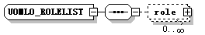
children | role
source | <xs:complexType name="UOMLO_ROLELIST">  <xs:sequence>  <xs:Element name="role" type="UOMLO_ROLE" minOccurs="0" maxOccurs="unbounded"/>  </xs:sequence>  </xs:complexType>

Element UOMLO_ROLELIST/role
diagram | 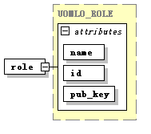
type | UOMLO_ROLE
properties
  isRef | 0
  content | complex
attributes
  Name | Type | Use | Default | Fixed | Annotation
  name | xs:string | required
  id | xs:string | required
  pub_key | xs:string | required
source | <xs:Element name="role" type="UOMLO_ROLE" minOccurs="0" maxOccurs="unbounded"/>

complexType UOMLO_ROUNDRECT
diagram | 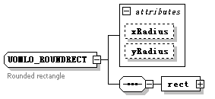
children | rect
used by
  Elements | UOMLO_PATH/roundrect UOMLT_COMPOUND/roundrect
attributes
  Name | Type | Use | Default | Fixed | Annotation
  xRadius | xs:float
  yRadius | xs:float
annotation
  documentation | Rounded rectangle
source | <xs:complexType name="UOMLO_ROUNDRECT">  <xs:annotation>  <xs:documentation>Rounded rectangle </xs:documentation>  </xs:annotation>  <xs:sequence>  <xs:Element name="rect" type="UOMLO_RECT"/>  </xs:sequence>  <xs:attribute name="xRadius" type="xs:float"/>  <xs:attribute name="yRadius" type="xs:float"/>  </xs:complexType>

Element UOMLO_ROUNDRECT/rect
diagram
type | UOMLO_RECT
properties
  isRef | 0
  content | complex
children | left_top bottom_right
source | <xs:Element name="rect" type="UOMLO_RECT"/>

complexType UOMLO_SIGNDEPLIST
diagram | 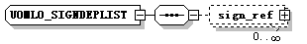
children | sign_ref
used by
  Elements | UOMLO_NODESIGN/dep_list UOMLO_TREESIGN/dep_list
source | <xs:complexType name="UOMLO_SIGNDEPLIST">  <xs:sequence>  <xs:Element name="sign_ref" type="UOMLO_REF" minOccurs="0" maxOccurs="unbounded"/>  </xs:sequence>  </xs:complexType>

Element UOMLO_SIGNDEPLIST/sign_ref
diagram | 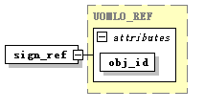
type | UOMLO_REF
properties
  isRef | 0
  content | complex
attributes
  Name | Type | Use | Default | Fixed | Annotation
  obj_id | xs:int | required
source | <xs:Element name="sign_ref" type="UOMLO_REF" minOccurs="0" maxOccurs="unbounded"/>

complexType UOMLO_SUBPATH
diagram | 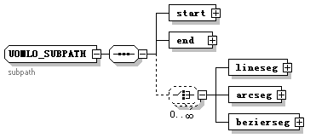
children | start end lineseg arcseg bezierseg
used by
  Elements | UOMLO_PATH/subpath UOMLT_COMPOUND/subpath
annotation
  documentation | subpath
source | <xs:complexType name="UOMLO_SUBPATH">  <xs:annotation>  <xs:documentation>subpath</xs:documentation>  </xs:annotation>  <xs:sequence>  <xs:Element name="start" type="UOMLO_POINT"/>  <xs:Element name="end" type="UOMLO_POINT"/>  <xs:choice minOccurs="0" maxOccurs="unbounded">  <xs:Element name="lineseg" type="UOMLO_LINESEG"/>  <xs:Element name="arcseg" type="UOMLO_ARCSEG"/>  <xs:Element name="bezierseg" type="UOMLO_BEZIERSEG"/>  </xs:choice>  </xs:sequence>  </xs:complexType>

Element UOMLO_SUBPATH/start
diagram
type | UOMLO_POINT
properties
  isRef | 0
  content | complex
attributes
  Name | Type | Use | Default | Fixed | Annotation
  xCod | xs:float | required
  yCod | xs:float | required
source | <xs:Element name="start" type="UOMLO_POINT"/>

Element UOMLO_SUBPATH/end
diagram
type | UOMLO_POINT
properties
  isRef | 0
  content | complex
attributes
  Name | Type | Use | Default | Fixed | Annotation
  xCod | xs:float | required
  yCod | xs:float | required
source | <xs:Element name="end" type="UOMLO_POINT"/>

Element UOMLO_SUBPATH/lineseg
diagram | 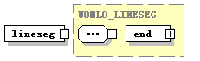
type | UOMLO_LINESEG
properties
  isRef | 0
  content | complex
children | end
source | <xs:Element name="lineseg" type="UOMLO_LINESEG"/>

Element UOMLO_SUBPATH/arcseg
diagram | 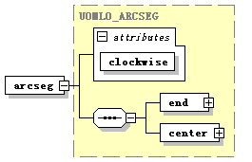
type | UOMLO_ARCSEG
properties
  isRef | 0
  content | complex
children | end center
attributes
  Name | Type | Use | Default | Fixed | Annotation
  clockwise | xs:boolean | required
source | <xs:Element name="arcseg" type="UOMLO_ARCSEG"/>

Element UOMLO_SUBPATH/bezierseg
diagram | 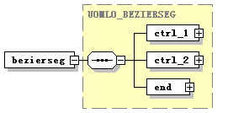
type | UOMLO_BEZIERSEG
properties
  isRef | 0
  content | complex
children | ctrl_1 ctrl_2 end
source | <xs:Element name="bezierseg" type="UOMLO_BEZIERSEG"/>

complexType UOMLO_TEXT
diagram | 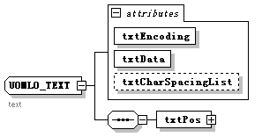
children | txtPos
used by
  Element | UOMLT_COMPOUND/text
attributes
  Name | Type | Use | Default | Fixed | Annotation
  txtEncoding | xs:string | required
  txtData | xs:string | required
  txtCharSpacingList | xs:string
annotation
  documentation | text
source | <xs:complexType name="UOMLO_TEXT">  <xs:annotation>  <xs:documentation>text</xs:documentation>  </xs:annotation>  <xs:sequence>  <xs:Element name="txtPos" type="UOMLO_RECT"/>  </xs:sequence>  <xs:attribute name="txtEncoding" type="xs:string" use="required"/>  <xs:attribute name="txtData" type="xs:string" use="required"/>  <xs:attribute name="txtCharSpacingList" type="xs:string"/>  </xs:complexType>

Element UOMLO_TEXT/txtPos
diagram | 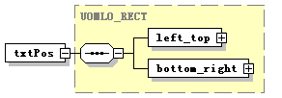
type | UOMLO_RECT
properties
  isRef | 0
  content | complex
children | left_top bottom_right
source | <xs:Element name="txtPos" type="UOMLO_RECT"/>

complexType UOMLO_TREESIGN
diagram | 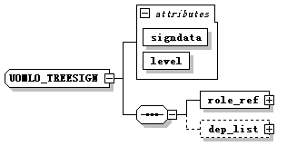
children | role_ref dep_list
used by
  Element | UOMLO_TREESIGNLIST/tree_sign
attributes
  Name | Type | Use | Default | Fixed | Annotation
  signdata | xs:string | required
  level | xs:int | required
source | <xs:complexType name="UOMLO_TREESIGN">  <xs:sequence>  <xs:Element name="role_ref" type="UOMLO_REF"/>  <xs:Element name="dep_list" type="UOMLO_SIGNDEPLIST" minOccurs="0"/>  </xs:sequence>  <xs:attribute name="signdata" type="xs:string" use="required"/>  <xs:attribute name="level" type="xs:int" use="required"/>  </xs:complexType>

Element UOMLO_TREESIGN/role_ref
diagram
type | UOMLO_REF
properties
  isRef | 0
  content | complex
attributes
  Name | Type | Use | Default | Fixed | Annotation
  obj_id | xs:int | required
source | <xs:Element name="role_ref" type="UOMLO_REF"/>

Element UOMLO_TREESIGN/dep_list
diagram
type | UOMLO_SIGNDEPLIST
properties
  isRef | 0
  content | complex
children | sign_ref
source | <xs:Element name="dep_list" type="UOMLO_SIGNDEPLIST" minOccurs="0"/>

complexType UOMLO_TREESIGNLIST
diagram | 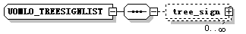
children | tree_sign
used by
  Element | UOMLO_OBJSIGN/tree_sign_list
source | <xs:complexType name="UOMLO_TREESIGNLIST">  <xs:sequence>  <xs:Element name="tree_sign" type="UOMLO_TREESIGN" minOccurs="0" maxOccurs="unbounded"/>  </xs:sequence>  </xs:complexType>

Element UOMLO_TREESIGNLIST/tree_sign
diagram | 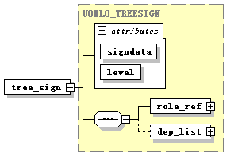
type | UOMLO_TREESIGN
properties
  isRef | 0
  content | complex
children | role_ref dep_list
attributes
  Name | Type | Use | Default | Fixed | Annotation
  signdata | xs:string | required
  level | xs:int | required
source | <xs:Element name="tree_sign" type="UOMLO_TREESIGN" minOccurs="0" maxOccurs="unbounded"/>

complexType UOMLT_BINARY
diagram | 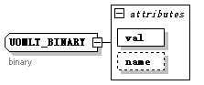
used by
  Elements | UOML_SET/binaryVal UOML_RET/binaryVal UOML_CALL/binaryVal UOML_QUERY/condition/val/binaryVal
attributes
  Name | Type | Use | Default | Fixed | Annotation
  val | xs:base64Binary | required
  name | xs:string
annotation
  documentation | binary
source | <xs:complexType name="UOMLT_BINARY">  <xs:annotation>  <xs:documentation>binary</xs:documentation>  </xs:annotation>  <xs:attribute name="val" type="xs:base64Binary" use="required"/>  <xs:attribute name="name" type="xs:string"/>  </xs:complexType>

complexType UOMLT_BOOL
diagram | 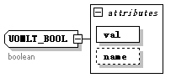
used by
  Elements | UOML_SET/boolVal UOML_RET/boolVal UOML_CALL/boolVal UOML_QUERY/condition/val/boolVal
attributes
  Name | Type | Use | Default | Fixed | Annotation
  val | xs:boolean | required
  name | xs:string
annotation
  documentation | boolean
source | <xs:complexType name="UOMLT_BOOL">  <xs:annotation>  <xs:documentation>boolean</xs:documentation>  </xs:annotation>  <xs:attribute name="val" type="xs:boolean" use="required"/>  <xs:attribute name="name" type="xs:string"/>  </xs:complexType>

complexType UOMLT_COMPOUND
diagram | 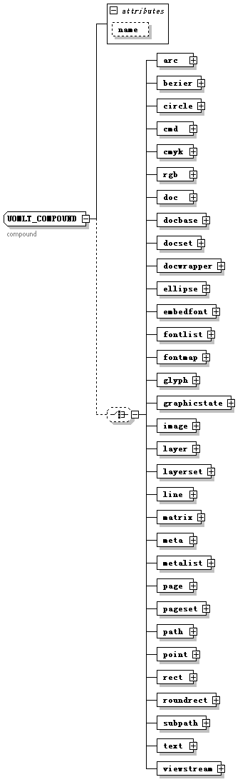
children | arc bezier circle cmd cmyk rgb doc docbase docset docwrapper ellipse embedfont fontlist fontmap glyph graphicstate image layer layerset line matrix meta metalist page pageset path point rect roundrect subpath text viewstream
used by
  Elements | UOML_SET/compoundVal UOML_RET/compoundVal UOML_CALL/compoundVal UOML_QUERY/condition/val/compoundVal UOMLO_PDL/obj UOMLO_FILTEREDCONTAINER/object UOML_INSERT/xobj UOML_SET/xobj
attributes
  Name | Type | Use | Default | Fixed | Annotation
  name | xs:string
annotation
  documentation | compound
source | <xs:complexType name="UOMLT_COMPOUND">  <xs:annotation>  <xs:documentation>compound  </xs:documentation>  </xs:annotation>  <xs:choice minOccurs="0">  <xs:Element name="arc" type="UOMLO_ARC"/>  <xs:Element name="bezier" type="UOMLO_BEZIER"/>  <xs:Element name="circle" type="UOMLO_CIRCLE"/>  <xs:Element name="cmd" type="UOMLO_CMD"/>  <xs:Element name="cmyk" type="UOMLO_COLOR_CMYK"/>  <xs:Element name="rgb" type="UOMLO_COLOR_RGB"/>  <xs:Element name="doc" type="UOMLO_DOC"/>  <xs:Element name="docbase" type="UOMLO_DOCBASE"/>  <xs:Element name="docset" type="UOMLO_DOCSET"/>  <xs:Element name="docwrapper" type="UOMLO_DOCWRAPPER"/>  <xs:Element name="ellipse" type="UOMLO_ELLIPSE"/>  <xs:Element name="embedfont" type="UOMLO_EMBEDFONT"/>  <xs:Element name="fontlist" type="UOMLO_FONTLIST"/>  <xs:Element name="fontmap" type="UOMLO_FONTMAP"/>  <xs:Element name="glyph" type="UOMLO_GLYPH"/>  <xs:Element name="graphicstate" type="UOMLO_GRAPHICSTATE"/>  <xs:Element name="image" type="UOMLO_IMAGE"/>  <xs:Element name="layer" type="UOMLO_LAYER"/>  <xs:Element name="layerset" type="UOMLO_LAYERSET"/>  <xs:Element name="line" type="UOMLO_LINE"/>  <xs:Element name="matrix" type="UOMLO_MATRIX"/>  <xs:Element name="meta" type="UOMLO_META"/>  <xs:Element name="metalist" type="UOMLO_METALIST"/>  <xs:Element name="page" type="UOMLO_PAGE"/>  <xs:Element name="pageset" type="UOMLO_PAGESET"/>  <xs:Element name="path" type="UOMLO_PATH"/>  <xs:Element name="point" type="UOMLO_POINT"/>  <xs:Element name="rect" type="UOMLO_RECT"/>  <xs:Element name="roundrect" type="UOMLO_ROUNDRECT"/>  <xs:Element name="subpath" type="UOMLO_SUBPATH"/>  <xs:Element name="text" type="UOMLO_TEXT"/>  <xs:Element name="viewstream" type="UOMLO_PDL"/>  </xs:choice>  <xs:attribute name="name" type="xs:string"/>  </xs:complexType>

Element UOMLT_COMPOUND/arc
diagram | 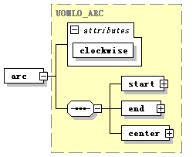
type | UOMLO_ARC
properties
  isRef | 0
  content | complex
children | start end center
attributes
  Name | Type | Use | Default | Fixed | Annotation
  clockwise | xs:boolean | required
source | <xs:Element name="arc" type="UOMLO_ARC"/>

Element UOMLT_COMPOUND/bezier
diagram | 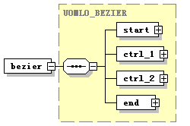
type | UOMLO_BEZIER
properties
  isRef | 0
  content | complex
children | start ctrl_1 ctrl_2 end
source | <xs:Element name="bezier" type="UOMLO_BEZIER"/>

Element UOMLT_COMPOUND/circle
diagram
type | UOMLO_CIRCLE
properties
  isRef | 0
  content | complex
children | center
attributes
  Name | Type | Use | Default | Fixed | Annotation
  radius | xs:float
source | <xs:Element name="circle" type="UOMLO_CIRCLE"/>

Element UOMLT_COMPOUND/cmd
diagram | 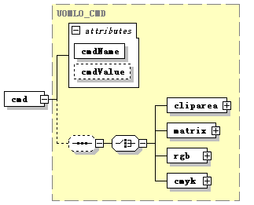
type | UOMLO_CMD
properties
  isRef | 0
  content | complex
children | cliparea matrix rgb cmyk
attributes
  Name | Type | Use | Default | Fixed | Annotation
  cmdName | UOMLO_CMDNAME | required
  cmdValue | xs:anySimpleType
source | <xs:Element name="cmd" type="UOMLO_CMD"/>

Element UOMLT_COMPOUND/cmyk
diagram
type | UOMLO_COLOR_CMYK
properties
  isRef | 0
  content | complex
attributes
  Name | Type | Use | Default | Fixed | Annotation
  c | xs:short | required
  m | xs:short | required
  y | xs:short | required
  k | xs:short | required
source | <xs:Element name="cmyk" type="UOMLO_COLOR_CMYK"/>

Element UOMLT_COMPOUND/rgb
diagram
type | UOMLO_COLOR_RGB
properties
  isRef | 0
  content | complex
attributes
  Name | Type | Use | Default | Fixed | Annotation
  r | xs:short | required
  g | xs:short | required
  b | xs:short | required
  a | xs:short | required
source | <xs:Element name="rgb" type="UOMLO_COLOR_RGB"/>

Element UOMLT_COMPOUND/doc
diagram | 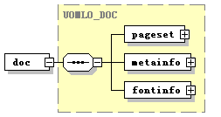
type | UOMLO_DOC
properties
  isRef | 0
  content | complex
children | pageset metainfo fontinfo
source | <xs:Element name="doc" type="UOMLO_DOC"/>

Element UOMLT_COMPOUND/docbase
diagram | 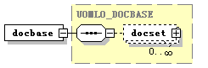
type | UOMLO_DOCBASE
properties
  isRef | 0
  content | complex
children | docset
source | <xs:Element name="docbase" type="UOMLO_DOCBASE"/>

Element UOMLT_COMPOUND/docset
diagram
type | UOMLO_DOCSET
properties
  isRef | 0
  content | complex
children | doc
source | <xs:Element name="docset" type="UOMLO_DOCSET"/>

Element UOMLT_COMPOUND/docwrapper
diagram | 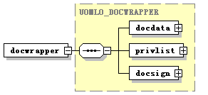
type | UOMLO_DOCWRAPPER
properties
  isRef | 0
  content | complex
children | docdata privlist docsign
source | <xs:Element name="docwrapper" type="UOMLO_DOCWRAPPER"/>

Element UOMLT_COMPOUND/ellipse
diagram
type | UOMLO_ELLIPSE
properties
  isRef | 0
  content | complex
children | center
attributes
  Name | Type | Use | Default | Fixed | Annotation
  xRadius | xs:float | required
  yRadius | xs:float | required
source | <xs:Element name="ellipse" type="UOMLO_ELLIPSE"/>

Element UOMLT_COMPOUND/embedfont
diagram | 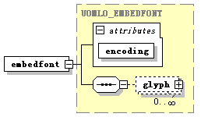
type | UOMLO_EMBEDFONT
properties
  isRef | 0
  content | complex
children | glyph
attributes
  Name | Type | Use | Default | Fixed | Annotation
  encoding | xs:string | required
source | <xs:Element name="embedfont" type="UOMLO_EMBEDFONT"/>

Element UOMLT_COMPOUND/fontlist
diagram | 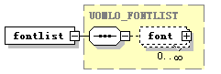
type | UOMLO_FONTLIST
properties
  isRef | 0
  content | complex
children | font
source | <xs:Element name="fontlist" type="UOMLO_FONTLIST"/>

Element UOMLT_COMPOUND/fontmap
diagram | 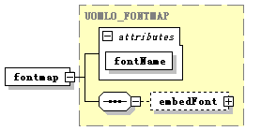
type | UOMLO_FONTMAP
properties
  isRef | 0
  content | complex
children | embedFont
attributes
  Name | Type | Use | Default | Fixed | Annotation
  fontName | xs:string | required
source | <xs:Element name="fontmap" type="UOMLO_FONTMAP"/>

Element UOMLT_COMPOUND/glyph
diagram
type | UOMLO_GLYPH
properties
  isRef | 0
  content | complex
children | glyphData
attributes
  Name | Type | Use | Default | Fixed | Annotation
  glyphCode | xs:int | required
source | <xs:Element name="glyph" type="UOMLO_GLYPH"/>

Element UOMLT_COMPOUND/graphicstate
diagram | 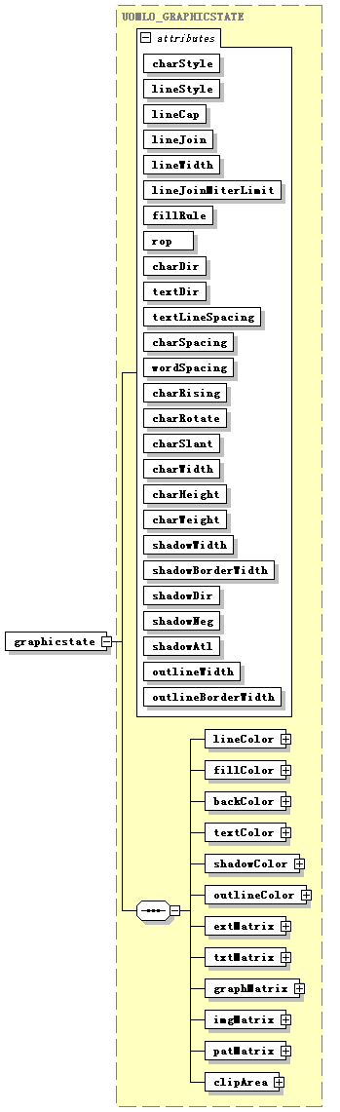
type | UOMLO_GRAPHICSTATE
properties
  isRef | 0
  content | complex
children | lineColor fillColor backColor textColor shadowColor outlineColor extMatrix txtMatrix graphMatrix imgMatrix patMatrix clipArea
attributes
  Name | Type | Use | Default | Fixed | Annotation
  charStyle | UOMLO_CHARSTYLE | required
  lineStyle | UOMLO_LINESTYLE | required
  lineCap | UOMLO_LINECAP | required
  lineJoin | UOMLO_JOINCAP | required
  lineWidth | xs:float | required
  lineJoinMiterLimit | xs:float | required
  fillRule | UOMLO_FILLRULE | required
  rop | xs:string | required
  charDir | UOMLO_CHARTXTDIR | required
  textDir | UOMLO_CHARTXTDIR | required
  textLineSpacing | xs:float | required
  charSpacing | xs:float | required
  wordSpacing | xs:float | required
  charRising | xs:float | required
  charRotate | xs:float | required
  charSlant | xs:float | required
  charWidth | xs:float | required
  charHeight | xs:float | required
  charWeight | xs:float | required
  shadowWidth | xs:float | required
  shadowBorderWidth | xs:float | required
  shadowDir | UOMLO_SHADOWDIR | required
  shadowNeg | xs:boolean | required
  shadowAtl | xs:boolean | required
  outlineWidth | xs:float | required
  outlineBorderWidth | xs:float | required
source | <xs:Element name="graphicstate" type="UOMLO_GRAPHICSTATE"/>

Element UOMLT_COMPOUND/image
diagram | 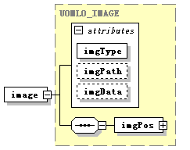
type | UOMLO_IMAGE
properties
  isRef | 0
  content | complex
children | imgPos
attributes
  Name | Type | Use | Default | Fixed | Annotation
  imgType | xs:string | required
  imgPath | xs:string
  imgData | xs:string
source | <xs:Element name="image" type="UOMLO_IMAGE"/>

Element UOMLT_COMPOUND/layer
diagram
type | UOMLO_LAYER
properties
  isRef | 0
  content | complex
children | vs
source | <xs:Element name="layer" type="UOMLO_LAYER"/>

Element UOMLT_COMPOUND/layerset
diagram | 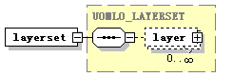
type | UOMLO_LAYERSET
properties
  isRef | 0
  content | complex
children | layer
source | <xs:Element name="layerset" type="UOMLO_LAYERSET"/>

Element UOMLT_COMPOUND/line
diagram | 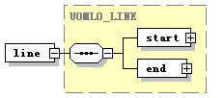
type | UOMLO_LINE
properties
  isRef | 0
  content | complex
children | start end
source | <xs:Element name="line" type="UOMLO_LINE"/>

Element UOMLT_COMPOUND/matrix
diagram
type | UOMLO_MATRIX
properties
  isRef | 0
  content | complex
attributes
  Name | Type | Use | Default | Fixed | Annotation
  f11 | xs:float | required
  f12 | xs:float | required
  f21 | xs:float | required
  f22 | xs:float | required
  f31 | xs:float | required
  f32 | xs:float | required
source | <xs:Element name="matrix" type="UOMLO_MATRIX"/>

Element UOMLT_COMPOUND/meta
diagram
type | UOMLO_META
properties
  isRef | 0
  content | complex
attributes
  Name | Type | Use | Default | Fixed | Annotation
  key | xs:string | required
  val | xs:string | required
source | <xs:Element name="meta" type="UOMLO_META"/>

Element UOMLT_COMPOUND/metalist
diagram | 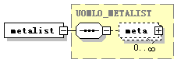
type | UOMLO_METALIST
properties
  isRef | 0
  content | complex
children | meta
source | <xs:Element name="metalist" type="UOMLO_METALIST"/>

Element UOMLT_COMPOUND/page
diagram
type | UOMLO_PAGE
properties
  isRef | 0
  content | complex
children | gs layers
attributes
  Name | Type | Use | Default | Fixed | Annotation
  width | xs:float | required
  height | xs:float | required
  resolution | xs:int | required
source | <xs:Element name="page" type="UOMLO_PAGE"/>

Element UOMLT_COMPOUND/pageset
diagram
type | UOMLO_PAGESET
properties
  isRef | 0
  content | complex
children | page
source | <xs:Element name="pageset" type="UOMLO_PAGESET"/>

Element UOMLT_COMPOUND/path
diagram | 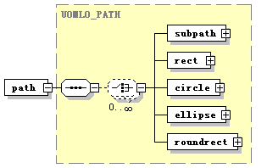
type | UOMLO_PATH
properties
  isRef | 0
  content | complex
children | subpath rect circle ellipse roundrect
source | <xs:Element name="path" type="UOMLO_PATH"/>

Element UOMLT_COMPOUND/point
diagram | 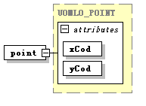
type | UOMLO_POINT
properties
  isRef | 0
  content | complex
attributes
  Name | Type | Use | Default | Fixed | Annotation
  xCod | xs:float | required
  yCod | xs:float | required
source | <xs:Element name="point" type="UOMLO_POINT"/>

Element UOMLT_COMPOUND/rect
diagram
type | UOMLO_RECT
properties
  isRef | 0
  content | complex
children | left_top bottom_right
source | <xs:Element name="rect" type="UOMLO_RECT"/>

Element UOMLT_COMPOUND/roundrect
diagram
type | UOMLO_ROUNDRECT
properties
  isRef | 0
  content | complex
children | rect
attributes
  Name | Type | Use | Default | Fixed | Annotation
  xRadius | xs:float
  yRadius | xs:float
source | <xs:Element name="roundrect" type="UOMLO_ROUNDRECT"/>

Element UOMLT_COMPOUND/subpath
diagram
type | UOMLO_SUBPATH
properties
  isRef | 0
  content | complex
children | start end lineseg arcseg bezierseg
source | <xs:Element name="subpath" type="UOMLO_SUBPATH"/>

Element UOMLT_COMPOUND/text
diagram | 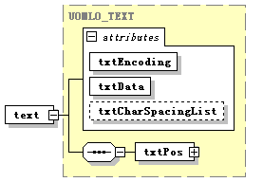
type | UOMLO_TEXT
properties
  isRef | 0
  content | complex
children | txtPos
attributes
  Name | Type | Use | Default | Fixed | Annotation
  txtEncoding | xs:string | required
  txtData | xs:string | required
  txtCharSpacingList | xs:string
source | <xs:Element name="text" type="UOMLO_TEXT"/>

Element UOMLT_COMPOUND/viewstream
diagram | 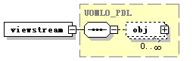
type | UOMLO_PDL
properties
  isRef | 0
  content | complex
children | obj
source | <xs:Element name="viewstream" type="UOMLO_PDL"/>

complexType UOMLT_DATE
diagram | 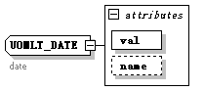
used by
  Elements | UOML_SET/dateVal UOML_RET/dateVal UOML_CALL/dateVal UOML_QUERY/condition/val/dateVal
attributes
  Name | Type | Use | Default | Fixed | Annotation
  val | xs:date | required
  name | xs:string
annotation
  documentation | date
source | <xs:complexType name="UOMLT_DATE">  <xs:annotation>  <xs:documentation>date</xs:documentation>  </xs:annotation>  <xs:attribute name="val" type="xs:date" use="required"/>  <xs:attribute name="name" type="xs:string"/>  </xs:complexType>

complexType UOMLT_DATETIME
diagram | 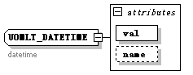
used by
  Elements | UOML_SET/dateTimeVal UOML_RET/dateTimeVal UOML_CALL/dateTimeVal UOML_QUERY/condition/val/dateTimeVal
attributes
  Name | Type | Use | Default | Fixed | Annotation
  val | xs:dateTime | required
  name | xs:string
annotation
  documentation | datetime
source | <xs:complexType name="UOMLT_DATETIME">  <xs:annotation>  <xs:documentation>datetime</xs:documentation>  </xs:annotation>  <xs:attribute name="val" type="xs:dateTime" use="required"/>  <xs:attribute name="name" type="xs:string"/>  </xs:complexType>

complexType UOMLT_DOUBLE
diagram | 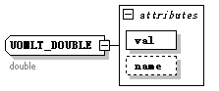
used by
  Elements | UOML_SET/floatVal UOML_RET/floatVal UOML_CALL/floatVal UOML_QUERY/condition/val/floatVal
attributes
  Name | Type | Use | Default | Fixed | Annotation
  val | xs:double | required
  name | xs:string
annotation
  documentation | double
source | <xs:complexType name="UOMLT_DOUBLE">  <xs:annotation>  <xs:documentation>double </xs:documentation>  </xs:annotation>  <xs:attribute name="val" type="xs:double" use="required"/>  <xs:attribute name="name" type="xs:string"/>  </xs:complexType>

complexType UOMLT_DURATION
diagram | 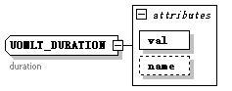
used by
  Elements | UOML_SET/durationVal UOML_RET/durationVal UOML_CALL/durationVal UOML_QUERY/condition/val/durationVal
attributes
  Name | Type | Use | Default | Fixed | Annotation
  val | xs:duration | required
  name | xs:string
annotation
  documentation | duration
source | <xs:complexType name="UOMLT_DURATION">  <xs:annotation>  <xs:documentation>duration</xs:documentation>  </xs:annotation>  <xs:attribute name="val" type="xs:duration" use="required"/>  <xs:attribute name="name" type="xs:string"/>  </xs:complexType>

complexType UOMLT_INT
diagram | 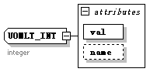
used by
  Elements | UOML_SET/intVal UOML_RET/intVal UOML_CALL/intVal UOML_QUERY/condition/val/intVal UOML_GET/output/mem_len UOML_INSERT/pos UOML_GET/pos
attributes
  Name | Type | Use | Default | Fixed | Annotation
  val | xs:int | required
  name | xs:string
annotation
  documentation | integer
source | <xs:complexType name="UOMLT_INT">  <xs:annotation>  <xs:documentation>integer</xs:documentation>  </xs:annotation>  <xs:attribute name="val" type="xs:int" use="required"/>  <xs:attribute name="name" type="xs:string"/>  </xs:complexType>

complexType UOMLT_STRING
diagram | 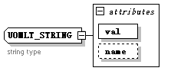
used by
  Elements | UOMLO_PLUGIN/data UOML_CLOSE/db_handle UOML_GET/output/format UOML_QUERY/handle UOML_SYSTEM/add_filter/handle UOML_SYSTEM/flush_db/handle UOML_USE/handle UOML_SET/handle UOML_CLOSE/handle UOML_DELETE/handle UOML_GET/handle UOML_INSERT/handle UOML_GET/output/mem_ptr UOML_QUERY/condition/operator UOML_GET/page UOML_GET/parent UOML_INSERT/parent UOML_SYSTEM/flush_db/password UOML_OPEN/path UOML_SYSTEM/flush_db/path UOML_GET/output/path UOML_SET/property UOML_GET/property UOML_SET/stringVal UOML_RET/stringVal UOML_CALL/stringVal UOML_QUERY/condition/val/stringVal UOML_QUERY/condition/term
attributes
  Name | Type | Use | Default | Fixed | Annotation
  val | xs:string | required
  name | xs:string
annotation
  documentation | string type
source | <xs:complexType name="UOMLT_STRING">  <xs:annotation>  <xs:documentation>string type</xs:documentation>  </xs:annotation>  <xs:attribute name="val" type="xs:string" use="required"/>  <xs:attribute name="name" type="xs:string"/>  </xs:complexType>

complexType UOMLT_TIME
diagram | 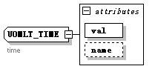
used by
  Elements | UOML_SET/timeVal UOML_RET/timeVal UOML_CALL/timeVal UOML_QUERY/condition/val/timeVal
attributes
  Name | Type | Use | Default | Fixed | Annotation
  val | xs:time | required
  name | xs:string
annotation
  documentation | time
source | <xs:complexType name="UOMLT_TIME">  <xs:annotation>  <xs:documentation>time</xs:documentation>  </xs:annotation>  <xs:attribute name="val" type="xs:time" use="required"/>  <xs:attribute name="name" type="xs:string"/>  </xs:complexType>

simpleType UOMLO_CHARSTYLE
type | restriction of xs:string
used by
  attribute | UOMLO_GRAPHICSTATE/@charStyle
facets
  enumeration | CHAR_NORMAL
  enumeration | CHAR_DOWN_DOT
  enumeration | CHAR_DOWN_LINE
  enumeration | CHAR_DOWN_WAVE
  enumeration | CHAR_MID_LINE
  enumeration | CHAR_BOLD
  enumeration | CHAR_ITALIC
  enumeration | CHAR_OUTLINE
  enumeration | CHAR_SHADOW
  enumeration | CHAR_HOLLOW
annotation
  documentation | char style
source | <xs:simpleType name="UOMLO_CHARSTYLE">  <xs:annotation>  <xs:documentation>char style</xs:documentation>  </xs:annotation>  <xs:restriction base="xs:string">  <xs:enumeration value="CHAR_NORMAL"/>  <xs:enumeration value="CHAR_DOWN_DOT"/>  <xs:enumeration value="CHAR_DOWN_LINE"/>  <xs:enumeration value="CHAR_DOWN_WAVE"/>  <xs:enumeration value="CHAR_MID_LINE"/>  <xs:enumeration value="CHAR_BOLD"/>  <xs:enumeration value="CHAR_ITALIC"/>  <xs:enumeration value="CHAR_OUTLINE"/>  <xs:enumeration value="CHAR_SHADOW"/>  <xs:enumeration value="CHAR_HOLLOW"/>  </xs:restriction>  </xs:simpleType>

simpleType UOMLO_CHARTXTDIR
type | restriction of xs:string
used by
  attributes | UOMLO_GRAPHICSTATE/@charDir UOMLO_GRAPHICSTATE/@textDir
facets
  enumeration | HEAD_LEFT
  enumeration | HEAD_RIGHT
  enumeration | HEAD_TOP
  enumeration | HEAD_BOTTOM
annotation
  documentation | Text characters direction
source | <xs:simpleType name="UOMLO_CHARTXTDIR">  <xs:annotation>  <xs:documentation>Text characters direction </xs:documentation>  </xs:annotation>  <xs:restriction base="xs:string">  <xs:enumeration value="HEAD_LEFT"/>  <xs:enumeration value="HEAD_RIGHT"/>  <xs:enumeration value="HEAD_TOP"/>  <xs:enumeration value="HEAD_BOTTOM"/>  </xs:restriction>  </xs:simpleType>

simpleType UOMLO_CMDNAME
type | restriction of xs:string
used by
  attribute | UOMLO_CMD/@cmdName
facets
  enumeration | COLOR_BACK
  enumeration | COLOR_LINE
  enumeration | COLOR_FILL
  enumeration | LINE_STYLE
  enumeration | LINE_WIDTH
  enumeration | LINE_CAP
  enumeration | FILL_RULE
  enumeration | RENDER_MODE
  enumeration | RASTER_OP
  enumeration | TEXT_DIR
  enumeration | CHAR_DIR
  enumeration | TEXTLINE_SPACE
  enumeration | CHAR_SPACE
  enumeration | WORD_SPACE
  enumeration | CHAR_RISING
  enumeration | CLIP_AREA
  enumeration | TEXT_MATRIX
  enumeration | IMAGE_MATRIX
  enumeration | GRAPH_MATRIX
  enumeration | PATTERN_MATRIX
  enumeration | EXT_MATRIX
  enumeration | PUSH_GS
  enumeration | POP_GS
  enumeration | CHAR_ROTATE
  enumeration | CHAR_SLANT
  enumeration | CHAR_SIZEX
  enumeration | CHAR_SIZEY
  enumeration | CHAR_WEIGHT
  enumeration | COLOR_SHADOW
  enumeration | SHADOW_WIDTH
  enumeration | SHADOW_DIR
  enumeration | SHADOW_LEN
  enumeration | SHADOW_NEG
  enumeration | SHADOW_ATL
  enumeration | CHAR_STYLE
  enumeration | COLOR_OUTLINE
  enumeration | COLOR_TEXT
annotation
  documentation | command name
source | <xs:simpleType name="UOMLO_CMDNAME">  <xs:annotation>  <xs:documentation>command name</xs:documentation>  </xs:annotation>  <xs:restriction base="xs:string">  <xs:enumeration value="COLOR_BACK"/>  <xs:enumeration value="COLOR_LINE"/>  <xs:enumeration value="COLOR_FILL"/>  <xs:enumeration value="LINE_STYLE"/>  <xs:enumeration value="LINE_WIDTH"/>  <xs:enumeration value="LINE_CAP"/>  <xs:enumeration value="FILL_RULE"/>  <xs:enumeration value="RENDER_MODE"/>  <xs:enumeration value="RASTER_OP"/>  <xs:enumeration value="TEXT_DIR"/>  <xs:enumeration value="CHAR_DIR"/>  <xs:enumeration value="TEXTLINE_SPACE"/>  <xs:enumeration value="CHAR_SPACE"/>  <xs:enumeration value="WORD_SPACE"/>  <xs:enumeration value="CHAR_RISING"/>  <xs:enumeration value="CLIP_AREA"/>  <xs:enumeration value="TEXT_MATRIX"/>  <xs:enumeration value="IMAGE_MATRIX"/>  <xs:enumeration value="GRAPH_MATRIX"/>  <xs:enumeration value="PATTERN_MATRIX"/>  <xs:enumeration value="EXT_MATRIX"/>  <xs:enumeration value="PUSH_GS"/>  <xs:enumeration value="POP_GS"/>  <xs:enumeration value="CHAR_ROTATE"/>  <xs:enumeration value="CHAR_SLANT"/>  <xs:enumeration value="CHAR_SIZEX"/>  <xs:enumeration value="CHAR_SIZEY"/>  <xs:enumeration value="CHAR_WEIGHT"/>  <xs:enumeration value="COLOR_SHADOW"/>  <xs:enumeration value="SHADOW_WIDTH"/>  <xs:enumeration value="SHADOW_DIR"/>  <xs:enumeration value="SHADOW_LEN"/>  <xs:enumeration value="SHADOW_NEG"/>  <xs:enumeration value="SHADOW_ATL"/>  <xs:enumeration value="CHAR_STYLE"/>  <xs:enumeration value="COLOR_OUTLINE"/>  <xs:enumeration value="COLOR_TEXT"/>  </xs:restriction>  </xs:simpleType>

simpleType UOMLO_FILLRULE
type | restriction of xs:string
used by
  attribute | UOMLO_GRAPHICSTATE/@fillRule
facets
  enumeration | RULE_EVENODD
  enumeration | RULE_WINDING
annotation
  documentation | Fill rules
source | <xs:simpleType name="UOMLO_FILLRULE">  <xs:annotation>  <xs:documentation>Fill rules </xs:documentation>  </xs:annotation>  <xs:restriction base="xs:string">  <xs:enumeration value="RULE_EVENODD"/>  <xs:enumeration value="RULE_WINDING"/>  </xs:restriction>  </xs:simpleType>

simpleType UOMLO_JOINCAP
type | xs:string
used by
  attribute | UOMLO_GRAPHICSTATE/@lineJoin
annotation
  documentation | Line join style
source | <xs:simpleType name="UOMLO_JOINCAP">  <xs:annotation>  <xs:documentation>Line join style </xs:documentation>  </xs:annotation>  <xs:restriction base="xs:string"/>  </xs:simpleType>

simpleType UOMLO_LINECAP
type | restriction of xs:string
used by
  attribute | UOMLO_GRAPHICSTATE/@lineCap
facets
  enumeration | END_BUTT
  enumeration | END_SQUARE
  enumeration | END_ROUND
  enumeration | END_ARROW
  enumeration | END_ARROW_2
annotation
  documentation | Line end style
source | <xs:simpleType name="UOMLO_LINECAP">  <xs:annotation>  <xs:documentation>Line end style </xs:documentation>  </xs:annotation>  <xs:restriction base="xs:string">  <xs:enumeration value="END_BUTT"/>  <xs:enumeration value="END_SQUARE"/>  <xs:enumeration value="END_ROUND"/>  <xs:enumeration value="END_ARROW"/>  <xs:enumeration value="END_ARROW_2"/>  </xs:restriction>  </xs:simpleType>

simpleType UOMLO_LINESTYLE
type | restriction of xs:string
used by
  attribute | UOMLO_GRAPHICSTATE/@lineStyle
facets
  enumeration | LINE_NORMAL
  enumeration | LINE_POSITIVE
  enumeration | LINE_NEGATIVE
  enumeration | LINE_DOUBLE
  enumeration | LINE_TOP_WENWU
  enumeration | LINE_BOTTOM_WENWU
  enumeration | LINE_DOT
  enumeration | LINE_WAVE
  enumeration | LINE_DOUBLE_WAVE
annotation
  documentation | line style
source | <xs:simpleType name="UOMLO_LINESTYLE">  <xs:annotation>  <xs:documentation>line style</xs:documentation>  </xs:annotation>  <xs:restriction base="xs:string">  <xs:enumeration value="LINE_NORMAL"/>  <xs:enumeration value="LINE_POSITIVE"/>  <xs:enumeration value="LINE_NEGATIVE"/>  <xs:enumeration value="LINE_DOUBLE"/>  <xs:enumeration value="LINE_TOP_WENWU"/>  <xs:enumeration value="LINE_BOTTOM_WENWU"/>  <xs:enumeration value="LINE_DOT"/>  <xs:enumeration value="LINE_WAVE"/>  <xs:enumeration value="LINE_DOUBLE_WAVE"/>  </xs:restriction>  </xs:simpleType>

simpleType UOMLO_ROP
type | restriction of xs:string
facets
  enumeration | ROP_COPY
  enumeration | ROP_N_COPY
  enumeration | ROP_RESET
  enumeration | ROP_SET
  enumeration | ROP_NOP
  enumeration | ROP_REV
  enumeration | ROP_AND
  enumeration | ROP_AND_N
  enumeration | ROP_N_AND
  enumeration | ROP_N_AND_N
  enumeration | ROP_OR
  enumeration | ROP_OR_N
  enumeration | ROP_N_OR
  enumeration | ROP_N_OR_N
  enumeration | ROP_XOR
  enumeration | ROP_XOR_N
  enumeration | ROP_N_XOR
  enumeration | ROP_N_XOR_N
  enumeration | ROP_EOR
annotation
  documentation | ROP operation
source | <xs:simpleType name="UOMLO_ROP">  <xs:annotation>  <xs:documentation>ROP operation </xs:documentation>  </xs:annotation>  <xs:restriction base="xs:string">  <xs:enumeration value="ROP_COPY"/>  <xs:enumeration value="ROP_N_COPY"/>  <xs:enumeration value="ROP_RESET"/>  <xs:enumeration value="ROP_SET"/>  <xs:enumeration value="ROP_NOP"/>  <xs:enumeration value="ROP_REV"/>  <xs:enumeration value="ROP_AND"/>  <xs:enumeration value="ROP_AND_N"/>  <xs:enumeration value="ROP_N_AND"/>  <xs:enumeration value="ROP_N_AND_N"/>  <xs:enumeration value="ROP_OR"/>  <xs:enumeration value="ROP_OR_N"/>  <xs:enumeration value="ROP_N_OR"/>  <xs:enumeration value="ROP_N_OR_N"/>  <xs:enumeration value="ROP_XOR"/>  <xs:enumeration value="ROP_XOR_N"/>  <xs:enumeration value="ROP_N_XOR"/>  <xs:enumeration value="ROP_N_XOR_N"/>  <xs:enumeration value="ROP_EOR"/>  </xs:restriction>  </xs:simpleType>

simpleType UOMLO_SHADOWDIR
type | restriction of xs:string
used by
  attribute | UOMLO_GRAPHICSTATE/@shadowDir
facets
  enumeration | SHADOW_LT
  enumeration | SHADOW_LB
  enumeration | SHADOW_RT
  enumeration | SHADOW_RB
annotation
  documentation | Shadow direction
source | <xs:simpleType name="UOMLO_SHADOWDIR">  <xs:annotation>  <xs:documentation>Shadow direction </xs:documentation>  </xs:annotation>  <xs:restriction base="xs:string">  <xs:enumeration value="SHADOW_LT"/>  <xs:enumeration value="SHADOW_LB"/>  <xs:enumeration value="SHADOW_RT"/>  <xs:enumeration value="SHADOW_RB"/>  </xs:restriction>  </xs:simpleType>

XML Schema documentation generated with XMLSpy Schema Editor http://www.altova.com/xmlspy

