Schema DeliveryOrder_NCA.xsd

schema location: | D:\siva\NCA XMLs REV\DeliveryOrder_NCA.xsd

Elements
AdditionalInformation
additionalMark
AddressInformation
billOfLadingDate
BillOfLadingIdentifier
Body
Broker
brokerContractIdentifier
Buyer
buyerContractIdentifier
Consignment
ConsignmentDetails
ContactDetails
Container
containerIdentification
ContainerIdentifiers
containerType
ContractIdentifier
contractType
CountryOfDestination
CountryOfOrigin
cropYear
dateOfArrivalAtDestination
DeliveryOrder
documentCreatorIdentifier
documentID
documentNumber
documentVersion
e-TransactionNumber
endDate
estimatedDateOfAvailability
GeneralInformation
GrossWeight
Header
icoMark
InstructionalInformation
line
locationCode
locationName
LocationOfStock
locomotiveNumber
MoveOrDeliverPeriod
NetWeight
numberOfBags
OrganizationIdentification
organizationName
packagingType
Parties
PlaceOfDischarge
PlaceOfLoading
positionOfSale
product
ProductDescription
ProductQuality
Quantity
quantityUnits
quantityValue
railCarNumber
responsibilityOfWeighing
RoutingSummary
seal
Seller
sellerContractIdentifier
ShipmentMark
startDate
status
value
Vessel
vesselName
voyageNumber
WeighingMethod
weightUnitCode

element AdditionalInformation
diagram | 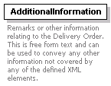
used by
  element | Body
annotation
  documentation | Remarks or other information relating to the Delivery Order. This is free form text and can be used to convey any other information not covered by any of the defined XML elements.
source | <xs:element name="AdditionalInformation">  <xs:annotation>  <xs:documentation>Remarks or other information relating to the Delivery Order. This is free form text and can be used to convey any other information not covered by any of the defined XML elements.</xs:documentation>  </xs:annotation>  <xs:complexType/>  </xs:element>

element additionalMark
diagram | 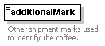
type | xs:string
used by
  element | ShipmentMark
annotation
  documentation | Other shipment marks used to identify the coffee.
source | <xs:element name="additionalMark" type="xs:string">  <xs:annotation>  <xs:documentation>Other shipment marks used to identify the coffee.</xs:documentation>  </xs:annotation>  </xs:element>

element AddressInformation
diagram | 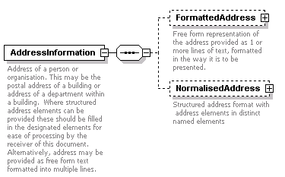
children | FormattedAddress NormalisedAddress
used by
  elements | Broker Buyer Parties/DeliverTo InstructionalInformation/DeliveryLocation InstructionalInformation/DeliveryOnAccountof Parties/ReleaseTo InstructionalInformation/RetieringForAccountOf Seller InstructionalInformation/Weighing/Weigher
annotation
  documentation | Address of a person or organisation. This may be the postal address of a building or address of a department within a building. Where structured address elements can be provided these should be filled in the designated elements for ease of processing by the receiver of this document. Alternatively, address may be provided as free form text formatted into multiple lines.
source | <xs:element name="AddressInformation">  <xs:annotation>  <xs:documentation>Address of a person or organisation. This may be the postal address of a building or address of a department within a building. Where structured address elements can be provided these should be filled in the designated elements for ease of processing by the receiver of this document. Alternatively, address may be provided as free form text formatted into multiple lines.</xs:documentation>  </xs:annotation>  <xs:complexType>  <xs:sequence>  <xs:element name="FormattedAddress" minOccurs="0">  <xs:annotation>  <xs:documentation>Free form representation of the address provided as 1 or more lines of text, formatted in the way it is to be presented.</xs:documentation>  </xs:annotation>  <xs:complexType>  <xs:sequence>  <xs:element ref="line" maxOccurs="unbounded"/>  </xs:sequence>  </xs:complexType>  </xs:element>  <xs:element name="NormalisedAddress" minOccurs="0">  <xs:annotation>  <xs:documentation>Structured address format with address elements in distinct named elements</xs:documentation>  </xs:annotation>  <xs:complexType>  <xs:sequence>  <xs:element name="StreetAddress" minOccurs="0">  <xs:annotation>  <xs:documentation>Door numner, street name, suite number etc part of the address within the city.</xs:documentation>  </xs:annotation>  <xs:complexType>  <xs:sequence>  <xs:element ref="line" maxOccurs="unbounded"/>  </xs:sequence>  </xs:complexType>  </xs:element>  <xs:element name="city" type="xs:string">  <xs:annotation>  <xs:documentation>Name of the city</xs:documentation>  </xs:annotation>  </xs:element>  <xs:element name="StateOrProvince" minOccurs="0">  <xs:annotation>  <xs:documentation>State or Province name</xs:documentation>  </xs:annotation>  <xs:complexType>  <xs:choice>  <xs:element name="stateOrProvinceCode" type="xs:string"/>  <xs:element name="stateOrProvinceName" type="xs:string"/>  </xs:choice>  </xs:complexType>  </xs:element>  <xs:element name="Country">  <xs:annotation>  <xs:documentation>Country in which the address exists. Should be either a universal code or name of the country</xs:documentation>  </xs:annotation>  <xs:complexType>  <xs:choice>  <xs:element name="countryName" type="xs:string"/>  <xs:element name="countryCode" type="xs:string"/>  </xs:choice>  </xs:complexType>  </xs:element>  <xs:element name="postalCode" type="xs:string" minOccurs="0">  <xs:annotation>  <xs:documentation>Postal code or zip part of the address</xs:documentation>  </xs:annotation>  </xs:element>  </xs:sequence>  </xs:complexType>  </xs:element>  </xs:sequence>  </xs:complexType>  </xs:element>

element AddressInformation/FormattedAddress
diagram | 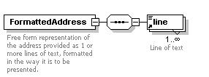
children | line
annotation
  documentation | Free form representation of the address provided as 1 or more lines of text, formatted in the way it is to be presented.
source | <xs:element name="FormattedAddress" minOccurs="0">  <xs:annotation>  <xs:documentation>Free form representation of the address provided as 1 or more lines of text, formatted in the way it is to be presented.</xs:documentation>  </xs:annotation>  <xs:complexType>  <xs:sequence>  <xs:element ref="line" maxOccurs="unbounded"/>  </xs:sequence>  </xs:complexType>  </xs:element>

element AddressInformation/NormalisedAddress
diagram | 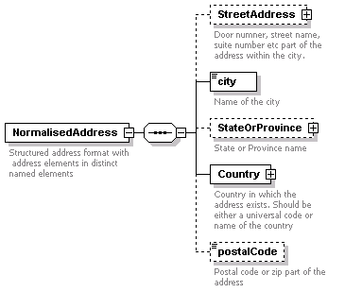
children | StreetAddress city StateOrProvince Country postalCode
annotation
  documentation | Structured address format with address elements in distinct named elements
source | <xs:element name="NormalisedAddress" minOccurs="0">  <xs:annotation>  <xs:documentation>Structured address format with address elements in distinct named elements</xs:documentation>  </xs:annotation>  <xs:complexType>  <xs:sequence>  <xs:element name="StreetAddress" minOccurs="0">  <xs:annotation>  <xs:documentation>Door numner, street name, suite number etc part of the address within the city.</xs:documentation>  </xs:annotation>  <xs:complexType>  <xs:sequence>  <xs:element ref="line" maxOccurs="unbounded"/>  </xs:sequence>  </xs:complexType>  </xs:element>  <xs:element name="city" type="xs:string">  <xs:annotation>  <xs:documentation>Name of the city</xs:documentation>  </xs:annotation>  </xs:element>  <xs:element name="StateOrProvince" minOccurs="0">  <xs:annotation>  <xs:documentation>State or Province name</xs:documentation>  </xs:annotation>  <xs:complexType>  <xs:choice>  <xs:element name="stateOrProvinceCode" type="xs:string"/>  <xs:element name="stateOrProvinceName" type="xs:string"/>  </xs:choice>  </xs:complexType>  </xs:element>  <xs:element name="Country">  <xs:annotation>  <xs:documentation>Country in which the address exists. Should be either a universal code or name of the country</xs:documentation>  </xs:annotation>  <xs:complexType>  <xs:choice>  <xs:element name="countryName" type="xs:string"/>  <xs:element name="countryCode" type="xs:string"/>  </xs:choice>  </xs:complexType>  </xs:element>  <xs:element name="postalCode" type="xs:string" minOccurs="0">  <xs:annotation>  <xs:documentation>Postal code or zip part of the address</xs:documentation>  </xs:annotation>  </xs:element>  </xs:sequence>  </xs:complexType>  </xs:element>

element AddressInformation/NormalisedAddress/StreetAddress
diagram | 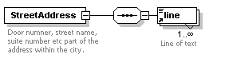
children | line
annotation
  documentation | Door numner, street name, suite number etc part of the address within the city.
source | <xs:element name="StreetAddress" minOccurs="0">  <xs:annotation>  <xs:documentation>Door numner, street name, suite number etc part of the address within the city.</xs:documentation>  </xs:annotation>  <xs:complexType>  <xs:sequence>  <xs:element ref="line" maxOccurs="unbounded"/>  </xs:sequence>  </xs:complexType>  </xs:element>

element AddressInformation/NormalisedAddress/city
diagram | 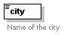
type | xs:string
annotation
  documentation | Name of the city
source | <xs:element name="city" type="xs:string">  <xs:annotation>  <xs:documentation>Name of the city</xs:documentation>  </xs:annotation>  </xs:element>

element AddressInformation/NormalisedAddress/StateOrProvince
diagram | 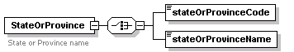
children | stateOrProvinceCode stateOrProvinceName
annotation
  documentation | State or Province name
source | <xs:element name="StateOrProvince" minOccurs="0">  <xs:annotation>  <xs:documentation>State or Province name</xs:documentation>  </xs:annotation>  <xs:complexType>  <xs:choice>  <xs:element name="stateOrProvinceCode" type="xs:string"/>  <xs:element name="stateOrProvinceName" type="xs:string"/>  </xs:choice>  </xs:complexType>  </xs:element>

element AddressInformation/NormalisedAddress/StateOrProvince/stateOrProvinceCode
diagram
type | xs:string
source | <xs:element name="stateOrProvinceCode" type="xs:string"/>

element AddressInformation/NormalisedAddress/StateOrProvince/stateOrProvinceName
diagram
type | xs:string
source | <xs:element name="stateOrProvinceName" type="xs:string"/>

element AddressInformation/NormalisedAddress/Country
diagram | 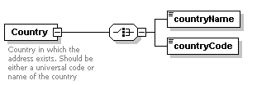
children | countryName countryCode
annotation
  documentation | Country in which the address exists. Should be either a universal code or name of the country
source | <xs:element name="Country">  <xs:annotation>  <xs:documentation>Country in which the address exists. Should be either a universal code or name of the country</xs:documentation>  </xs:annotation>  <xs:complexType>  <xs:choice>  <xs:element name="countryName" type="xs:string"/>  <xs:element name="countryCode" type="xs:string"/>  </xs:choice>  </xs:complexType>  </xs:element>

element AddressInformation/NormalisedAddress/Country/countryName
diagram
type | xs:string
source | <xs:element name="countryName" type="xs:string"/>

element AddressInformation/NormalisedAddress/Country/countryCode
diagram
type | xs:string
source | <xs:element name="countryCode" type="xs:string"/>

element AddressInformation/NormalisedAddress/postalCode
diagram | 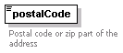
type | xs:string
annotation
  documentation | Postal code or zip part of the address
source | <xs:element name="postalCode" type="xs:string" minOccurs="0">  <xs:annotation>  <xs:documentation>Postal code or zip part of the address</xs:documentation>  </xs:annotation>  </xs:element>

element billOfLadingDate
diagram | 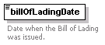
type | xs:date
used by
  element | RoutingSummary
annotation
  documentation | Date when the Bill of Lading was issued.
source | <xs:element name="billOfLadingDate" type="xs:date">  <xs:annotation>  <xs:documentation>Date when the Bill of Lading was issued.</xs:documentation>  </xs:annotation>  </xs:element>

element BillOfLadingIdentifier
diagram | 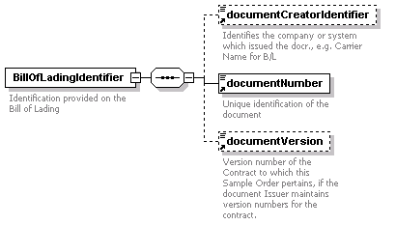
children | documentCreatorIdentifier documentNumber documentVersion
used by
  element | RoutingSummary
annotation
  documentation | Identification provided on the Bill of Lading
source | <xs:element name="BillOfLadingIdentifier">  <xs:annotation>  <xs:documentation>Identification provided on the Bill of Lading</xs:documentation>  </xs:annotation>  <xs:complexType>  <xs:sequence>  <xs:element ref="documentCreatorIdentifier" minOccurs="0"/>  <xs:element ref="documentNumber"/>  <xs:element ref="documentVersion" minOccurs="0"/>  </xs:sequence>  </xs:complexType>  </xs:element>

element Body
diagram | 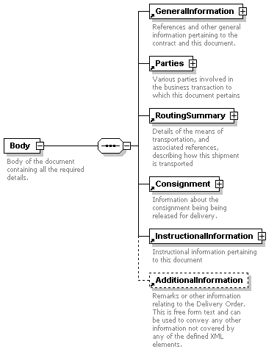
children | GeneralInformation Parties RoutingSummary Consignment InstructionalInformation AdditionalInformation
used by
  element | DeliveryOrder
annotation
  documentation | Body of the document containing all the required details.
source | <xs:element name="Body">  <xs:annotation>  <xs:documentation>Body of the document containing all the required details.</xs:documentation>  </xs:annotation>  <xs:complexType>  <xs:sequence>  <xs:element ref="GeneralInformation"/>  <xs:element ref="Parties"/>  <xs:element ref="RoutingSummary"/>  <xs:element ref="Consignment"/>  <xs:element ref="InstructionalInformation"/>  <xs:element ref="AdditionalInformation" minOccurs="0"/>  </xs:sequence>  </xs:complexType>  </xs:element>

element Broker
diagram | 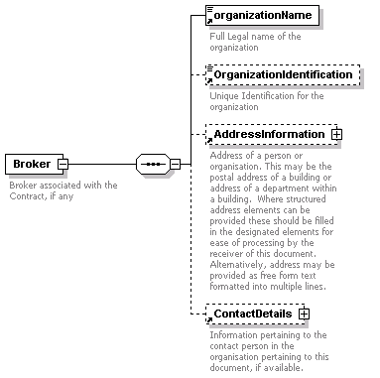
children | organizationName OrganizationIdentification AddressInformation ContactDetails
used by
  element | Parties
annotation
  documentation | Broker associated with the Contract, if any
source | <xs:element name="Broker">  <xs:annotation>  <xs:documentation>Broker associated with the Contract, if any</xs:documentation>  </xs:annotation>  <xs:complexType>  <xs:sequence>  <xs:element ref="organizationName"/>  <xs:element ref="OrganizationIdentification" minOccurs="0"/>  <xs:element ref="AddressInformation" minOccurs="0"/>  <xs:element ref="ContactDetails" minOccurs="0"/>  </xs:sequence>  </xs:complexType>  </xs:element>

element brokerContractIdentifier
diagram | 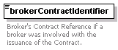
type | xs:string
used by
  element | GeneralInformation
annotation
  documentation | Broker's Contract Reference if a broker was involved with the issuance of the Contract.
source | <xs:element name="brokerContractIdentifier" type="xs:string">  <xs:annotation>  <xs:documentation>Broker's Contract Reference if a broker was involved with the issuance of the Contract.</xs:documentation>  </xs:annotation>  </xs:element>

element Buyer
diagram | 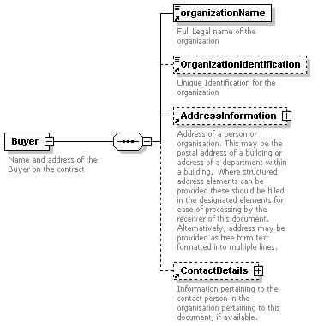
children | organizationName OrganizationIdentification AddressInformation ContactDetails
used by
  element | Parties
annotation
  documentation | Name and address of the Buyer on the contract
source | <xs:element name="Buyer">  <xs:annotation>  <xs:documentation>Name and address of the Buyer on the contract</xs:documentation>  </xs:annotation>  <xs:complexType>  <xs:sequence>  <xs:element ref="organizationName"/>  <xs:element ref="OrganizationIdentification" minOccurs="0"/>  <xs:element ref="AddressInformation" minOccurs="0"/>  <xs:element ref="ContactDetails" minOccurs="0"/>  </xs:sequence>  </xs:complexType>  </xs:element>

element buyerContractIdentifier
diagram | 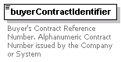
type | xs:string
used by
  element | GeneralInformation
annotation
  documentation | Buyer's Contract Reference Number. Alphanumeric Contract Number issued by the Company or System
source | <xs:element name="buyerContractIdentifier" type="xs:string">  <xs:annotation>  <xs:documentation>Buyer's Contract Reference Number. Alphanumeric Contract Number issued by the Company or System</xs:documentation>  </xs:annotation>  </xs:element>

element Consignment
diagram | 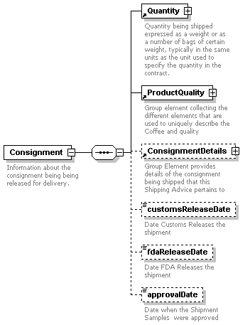
children | Quantity ProductQuality ConsignmentDetails customsReleaseDate fdaReleaseDate approvalDate
used by
  element | Body
annotation
  documentation | Information about the consignment being being released for delivery.
source | <xs:element name="Consignment">  <xs:annotation>  <xs:documentation>Information about the consignment being being released for delivery.</xs:documentation>  </xs:annotation>  <xs:complexType>  <xs:sequence>  <xs:element ref="Quantity"/>  <xs:element ref="ProductQuality"/>  <xs:element ref="ConsignmentDetails" minOccurs="0"/>  <xs:element name="customsReleaseDate" type="xs:date" minOccurs="0">  <xs:annotation>  <xs:documentation>Date Customs Releases the shipment</xs:documentation>  </xs:annotation>  </xs:element>  <xs:element name="fdaReleaseDate" type="xs:date" minOccurs="0">  <xs:annotation>  <xs:documentation>Date FDA Releases the shipment</xs:documentation>  </xs:annotation>  </xs:element>  <xs:element name="approvalDate" type="xs:date" minOccurs="0">  <xs:annotation>  <xs:documentation>Date when the Shipment Samples were approved</xs:documentation>  </xs:annotation>  </xs:element>  </xs:sequence>  </xs:complexType>  </xs:element>

element Consignment/customsReleaseDate
diagram | 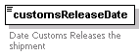
type | xs:date
annotation
  documentation | Date Customs Releases the shipment
source | <xs:element name="customsReleaseDate" type="xs:date" minOccurs="0">  <xs:annotation>  <xs:documentation>Date Customs Releases the shipment</xs:documentation>  </xs:annotation>  </xs:element>

element Consignment/fdaReleaseDate
diagram | 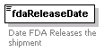
type | xs:date
annotation
  documentation | Date FDA Releases the shipment
source | <xs:element name="fdaReleaseDate" type="xs:date" minOccurs="0">  <xs:annotation>  <xs:documentation>Date FDA Releases the shipment</xs:documentation>  </xs:annotation>  </xs:element>

element Consignment/approvalDate
diagram | 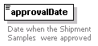
type | xs:date
annotation
  documentation | Date when the Shipment Samples were approved
source | <xs:element name="approvalDate" type="xs:date" minOccurs="0">  <xs:annotation>  <xs:documentation>Date when the Shipment Samples were approved</xs:documentation>  </xs:annotation>  </xs:element>

element ConsignmentDetails
diagram | 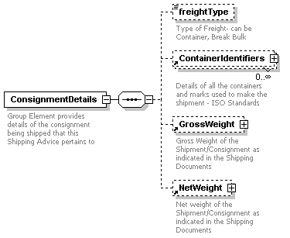
children | freightType ContainerIdentifiers GrossWeight NetWeight
used by
  element | Consignment
annotation
  documentation | Group Element provides details of the consignment being shipped that this Shipping Advice pertains to
source | <xs:element name="ConsignmentDetails">  <xs:annotation>  <xs:documentation>Group Element provides details of the consignment being shipped that this Shipping Advice pertains to</xs:documentation>  </xs:annotation>  <xs:complexType>  <xs:sequence>  <xs:element name="freightType" minOccurs="0">  <xs:annotation>  <xs:documentation>Type of Freight- can be Container, Break Bulk</xs:documentation>  </xs:annotation>  <xs:simpleType>  <xs:restriction base="xs:string">  <xs:enumeration value="Container"/>  <xs:enumeration value="Break Bulk"/>  </xs:restriction>  </xs:simpleType>  </xs:element>  <xs:element ref="ContainerIdentifiers" minOccurs="0" maxOccurs="unbounded"/>  <xs:element ref="GrossWeight" minOccurs="0"/>  <xs:element ref="NetWeight" minOccurs="0"/>  </xs:sequence>  </xs:complexType>  </xs:element>

element ConsignmentDetails/freightType
diagram | 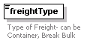
type | restriction of xs:string
facets
  enumeration | Container
  enumeration | Break Bulk
annotation
  documentation | Type of Freight- can be Container, Break Bulk
source | <xs:element name="freightType" minOccurs="0">  <xs:annotation>  <xs:documentation>Type of Freight- can be Container, Break Bulk</xs:documentation>  </xs:annotation>  <xs:simpleType>  <xs:restriction base="xs:string">  <xs:enumeration value="Container"/>  <xs:enumeration value="Break Bulk"/>  </xs:restriction>  </xs:simpleType>  </xs:element>

element ContactDetails
diagram | 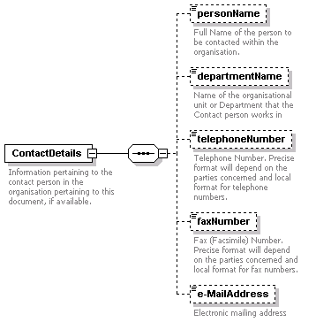
children | personName departmentName telephoneNumber faxNumber e-MailAddress
used by
  elements | Broker Buyer Parties/DeliverTo InstructionalInformation/DeliveryLocation InstructionalInformation/DeliveryOnAccountof Parties/ReleaseTo InstructionalInformation/RetieringForAccountOf Seller InstructionalInformation/Weighing/Weigher
annotation
  documentation | Information pertaining to the contact person in the organisation pertaining to this document, if available.
source | <xs:element name="ContactDetails">  <xs:annotation>  <xs:documentation>Information pertaining to the contact person in the organisation pertaining to this document, if available.</xs:documentation>  </xs:annotation>  <xs:complexType>  <xs:sequence>  <xs:element name="personName" type="xs:string" minOccurs="0">  <xs:annotation>  <xs:documentation>Full Name of the person to be contacted within the organisation.</xs:documentation>  </xs:annotation>  </xs:element>  <xs:element name="departmentName" type="xs:string" minOccurs="0">  <xs:annotation>  <xs:documentation>Name of the organisational unit or Department that the Contact person works in</xs:documentation>  </xs:annotation>  </xs:element>  <xs:element name="telephoneNumber" type="xs:string" minOccurs="0">  <xs:annotation>  <xs:documentation>Telephone Number. Precise format will depend on the parties concerned and local format for telephone numbers.</xs:documentation>  </xs:annotation>  </xs:element>  <xs:element name="faxNumber" type="xs:string" minOccurs="0">  <xs:annotation>  <xs:documentation>Fax (Facsimile) Number. Precise format will depend on the parties concerned and local format for fax numbers.</xs:documentation>  </xs:annotation>  </xs:element>  <xs:element name="e-MailAddress" type="xs:string" minOccurs="0">  <xs:annotation>  <xs:documentation>Electronic mailing address</xs:documentation>  </xs:annotation>  </xs:element>  </xs:sequence>  </xs:complexType>  </xs:element>

element ContactDetails/personName
diagram | 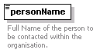
type | xs:string
annotation
  documentation | Full Name of the person to be contacted within the organisation.
source | <xs:element name="personName" type="xs:string" minOccurs="0">  <xs:annotation>  <xs:documentation>Full Name of the person to be contacted within the organisation.</xs:documentation>  </xs:annotation>  </xs:element>

element ContactDetails/departmentName
diagram | 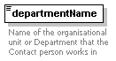
type | xs:string
annotation
  documentation | Name of the organisational unit or Department that the Contact person works in
source | <xs:element name="departmentName" type="xs:string" minOccurs="0">  <xs:annotation>  <xs:documentation>Name of the organisational unit or Department that the Contact person works in</xs:documentation>  </xs:annotation>  </xs:element>

element ContactDetails/telephoneNumber
diagram | 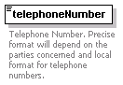
type | xs:string
annotation
  documentation | Telephone Number. Precise format will depend on the parties concerned and local format for telephone numbers.
source | <xs:element name="telephoneNumber" type="xs:string" minOccurs="0">  <xs:annotation>  <xs:documentation>Telephone Number. Precise format will depend on the parties concerned and local format for telephone numbers.</xs:documentation>  </xs:annotation>  </xs:element>

element ContactDetails/faxNumber
diagram | 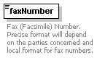
type | xs:string
annotation
  documentation | Fax (Facsimile) Number. Precise format will depend on the parties concerned and local format for fax numbers.
source | <xs:element name="faxNumber" type="xs:string" minOccurs="0">  <xs:annotation>  <xs:documentation>Fax (Facsimile) Number. Precise format will depend on the parties concerned and local format for fax numbers.</xs:documentation>  </xs:annotation>  </xs:element>

element ContactDetails/e-MailAddress
diagram | 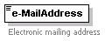
type | xs:string
annotation
  documentation | Electronic mailing address
source | <xs:element name="e-MailAddress" type="xs:string" minOccurs="0">  <xs:annotation>  <xs:documentation>Electronic mailing address</xs:documentation>  </xs:annotation>  </xs:element>

element Container
diagram | 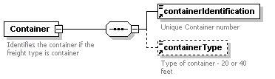
children | containerIdentification containerType
used by
  element | ContainerIdentifiers
annotation
  documentation | Identifies the container if the freight type is container
source | <xs:element name="Container">  <xs:annotation>  <xs:documentation>Identifies the container if the freight type is container</xs:documentation>  </xs:annotation>  <xs:complexType>  <xs:sequence>  <xs:element ref="containerIdentification"/>  <xs:element ref="containerType" minOccurs="0"/>  </xs:sequence>  </xs:complexType>  </xs:element>

element containerIdentification
diagram | 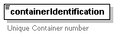
type | xs:string
used by
  element | Container
annotation
  documentation | Unique Container number
source | <xs:element name="containerIdentification" type="xs:string">  <xs:annotation>  <xs:documentation>Unique Container number</xs:documentation>  </xs:annotation>  </xs:element>

element ContainerIdentifiers
diagram | 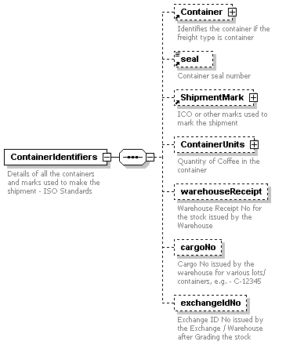
children | Container seal ShipmentMark ContainerUnits warehouseReceipt cargoNo exchangeIdNo
used by
  element | ConsignmentDetails
annotation
  documentation | Details of all the containers and marks used to make the shipment - ISO Standards
source | <xs:element name="ContainerIdentifiers">  <xs:annotation>  <xs:documentation>Details of all the containers and marks used to make the shipment - ISO Standards</xs:documentation>  </xs:annotation>  <xs:complexType>  <xs:sequence>  <xs:element ref="Container" minOccurs="0"/>  <xs:element ref="seal" minOccurs="0"/>  <xs:element ref="ShipmentMark" minOccurs="0"/>  <xs:element name="ContainerUnits" minOccurs="0">  <xs:annotation>  <xs:documentation>Quantity of Coffee in the container</xs:documentation>  </xs:annotation>  <xs:complexType>  <xs:sequence>  <xs:element name="quanityValue">  <xs:annotation>  <xs:documentation>Example - No of bags per container</xs:documentation>  </xs:annotation>  </xs:element>  <xs:element name="quantityUnits" minOccurs="0">  <xs:annotation>  <xs:documentation>69 Kg Bags</xs:documentation>  </xs:annotation>  </xs:element>  </xs:sequence>  </xs:complexType>  </xs:element>  <xs:element name="warehouseReceipt" minOccurs="0">  <xs:annotation>  <xs:documentation>Warehouse Receipt No for the stock issued by the Warehouse</xs:documentation>  </xs:annotation>  </xs:element>  <xs:element name="cargoNo" minOccurs="0">  <xs:annotation>  <xs:documentation>Cargo No issued by the warehouse for various lots/ containers, e.g. - C-12345</xs:documentation>  </xs:annotation>  </xs:element>  <xs:element name="exchangeIdNo" minOccurs="0">  <xs:annotation>  <xs:documentation>Exchange ID No issued by the Exchange / Warehouse after Grading the stock</xs:documentation>  </xs:annotation>  </xs:element>  </xs:sequence>  </xs:complexType>  </xs:element>

element ContainerIdentifiers/ContainerUnits
diagram | 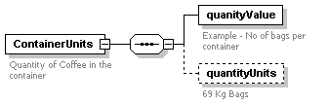
children | quanityValue quantityUnits
annotation
  documentation | Quantity of Coffee in the container
source | <xs:element name="ContainerUnits" minOccurs="0">  <xs:annotation>  <xs:documentation>Quantity of Coffee in the container</xs:documentation>  </xs:annotation>  <xs:complexType>  <xs:sequence>  <xs:element name="quanityValue">  <xs:annotation>  <xs:documentation>Example - No of bags per container</xs:documentation>  </xs:annotation>  </xs:element>  <xs:element name="quantityUnits" minOccurs="0">  <xs:annotation>  <xs:documentation>69 Kg Bags</xs:documentation>  </xs:annotation>  </xs:element>  </xs:sequence>  </xs:complexType>  </xs:element>

element ContainerIdentifiers/ContainerUnits/quanityValue
diagram | 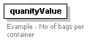
annotation
  documentation | Example - No of bags per container
source | <xs:element name="quanityValue">  <xs:annotation>  <xs:documentation>Example - No of bags per container</xs:documentation>  </xs:annotation>  </xs:element>

element ContainerIdentifiers/ContainerUnits/quantityUnits
diagram | 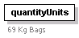
annotation
  documentation | 69 Kg Bags
source | <xs:element name="quantityUnits" minOccurs="0">  <xs:annotation>  <xs:documentation>69 Kg Bags</xs:documentation>  </xs:annotation>  </xs:element>

element ContainerIdentifiers/warehouseReceipt
diagram | 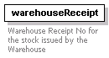
annotation
  documentation | Warehouse Receipt No for the stock issued by the Warehouse
source | <xs:element name="warehouseReceipt" minOccurs="0">  <xs:annotation>  <xs:documentation>Warehouse Receipt No for the stock issued by the Warehouse</xs:documentation>  </xs:annotation>  </xs:element>

element ContainerIdentifiers/cargoNo
diagram | 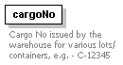
annotation
  documentation | Cargo No issued by the warehouse for various lots/ containers, e.g. - C-12345
source | <xs:element name="cargoNo" minOccurs="0">  <xs:annotation>  <xs:documentation>Cargo No issued by the warehouse for various lots/ containers, e.g. - C-12345</xs:documentation>  </xs:annotation>  </xs:element>

element ContainerIdentifiers/exchangeIdNo
diagram | 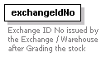
annotation
  documentation | Exchange ID No issued by the Exchange / Warehouse after Grading the stock
source | <xs:element name="exchangeIdNo" minOccurs="0">  <xs:annotation>  <xs:documentation>Exchange ID No issued by the Exchange / Warehouse after Grading the stock</xs:documentation>  </xs:annotation>  </xs:element>

element containerType
diagram | 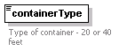
type | list of xs:string
used by
  element | Container
annotation
  documentation | Type of container - 20 or 40 feet
source | <xs:element name="containerType">  <xs:annotation>  <xs:documentation>Type of container - 20 or 40 feet</xs:documentation>  </xs:annotation>  <xs:simpleType>  <xs:list itemType="xs:string"/>  </xs:simpleType>  </xs:element>

element ContractIdentifier
diagram | 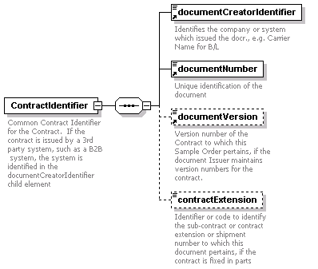
children | documentCreatorIdentifier documentNumber documentVersion contractExtension
used by
  element | GeneralInformation
annotation
  documentation | Common Contract Identifier for the Contract. If the contract is issued by a 3rd party system, such as a B2B system, the system is identified in the documentCreatorIdentifier child element
source | <xs:element name="ContractIdentifier">  <xs:annotation>  <xs:documentation>Common Contract Identifier for the Contract. If the contract is issued by a 3rd party system, such as a B2B system, the system is identified in the documentCreatorIdentifier child element</xs:documentation>  </xs:annotation>  <xs:complexType>  <xs:sequence>  <xs:element ref="documentCreatorIdentifier"/>  <xs:element ref="documentNumber"/>  <xs:element ref="documentVersion" minOccurs="0"/>  <xs:element name="contractExtension" type="xs:string" minOccurs="0">  <xs:annotation>  <xs:documentation>Identifier or code to identify the sub-contract or contract extension or shipment number to which this document pertains, if the contract is fixed in parts</xs:documentation>  </xs:annotation>  </xs:element>  </xs:sequence>  </xs:complexType>  </xs:element>

element ContractIdentifier/contractExtension
diagram | 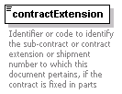
type | xs:string
annotation
  documentation | Identifier or code to identify the sub-contract or contract extension or shipment number to which this document pertains, if the contract is fixed in parts
source | <xs:element name="contractExtension" type="xs:string" minOccurs="0">  <xs:annotation>  <xs:documentation>Identifier or code to identify the sub-contract or contract extension or shipment number to which this document pertains, if the contract is fixed in parts</xs:documentation>  </xs:annotation>  </xs:element>

element contractType
diagram | 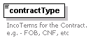
type | restriction of xs:string
used by
  element | GeneralInformation
facets
  maxLength | 14
  enumeration | C+F
  enumeration | CIF
  enumeration | Delivered
  enumeration | FOB
  enumeration | FOR
  enumeration | FOT
  enumeration | Ex-Docks
  enumeration | Ex-Warehouse
  enumeration | Spot
annotation
  documentation | IncoTerms for the Contract. e.g. - FOB, CNF, etc
source | <xs:element name="contractType">  <xs:annotation>  <xs:documentation>IncoTerms for the Contract. e.g. - FOB, CNF, etc</xs:documentation>  </xs:annotation>  <xs:simpleType>  <xs:restriction base="xs:string">  <xs:maxLength value="14"/>  <xs:enumeration value="C+F"/>  <xs:enumeration value="CIF"/>  <xs:enumeration value="Delivered"/>  <xs:enumeration value="FOB"/>  <xs:enumeration value="FOR"/>  <xs:enumeration value="FOT"/>  <xs:enumeration value="Ex-Docks"/>  <xs:enumeration value="Ex-Warehouse"/>  <xs:enumeration value="Spot"/>  </xs:restriction>  </xs:simpleType>  </xs:element>

element CountryOfDestination
diagram | 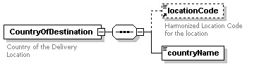
children | locationCode countryName
used by
  element | RoutingSummary
annotation
  documentation | Country of the Delivery Location
source | <xs:element name="CountryOfDestination">  <xs:annotation>  <xs:documentation>Country of the Delivery Location</xs:documentation>  </xs:annotation>  <xs:complexType>  <xs:sequence>  <xs:element ref="locationCode" minOccurs="0"/>  <xs:element name="countryName" type="xs:string"/>  </xs:sequence>  </xs:complexType>  </xs:element>

element CountryOfDestination/countryName
diagram
type | xs:string
source | <xs:element name="countryName" type="xs:string"/>

element CountryOfOrigin
diagram | 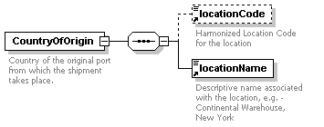
children | locationCode locationName
used by
  element | ProductQuality
annotation
  documentation | Country of the original port from which the shipment takes place.
source | <xs:element name="CountryOfOrigin">  <xs:annotation>  <xs:documentation>Country of the original port from which the shipment takes place.</xs:documentation>  </xs:annotation>  <xs:complexType>  <xs:sequence>  <xs:element ref="locationCode" minOccurs="0"/>  <xs:element ref="locationName"/>  </xs:sequence>  </xs:complexType>  </xs:element>

element cropYear
diagram | 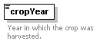
type | xs:string
used by
  element | ProductQuality
annotation
  documentation | Year in which the crop was harvested.
source | <xs:element name="cropYear" type="xs:string">  <xs:annotation>  <xs:documentation>Year in which the crop was harvested.</xs:documentation>  </xs:annotation>  </xs:element>

element dateOfArrivalAtDestination
diagram | 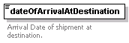
type | xs:date
used by
  element | RoutingSummary
annotation
  documentation | Arrival Date of shipment at destination.
source | <xs:element name="dateOfArrivalAtDestination" type="xs:date">  <xs:annotation>  <xs:documentation>Arrival Date of shipment at destination.</xs:documentation>  </xs:annotation>  </xs:element>

element DeliveryOrder
diagram | 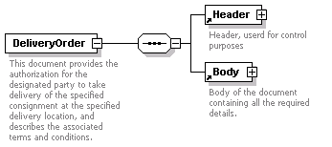
children | Header Body
annotation
  documentation | This document provides the authorization for the designated party to take delivery of the specified consignment at the specified delivery location, and describes the associated terms and conditions.
source | <xs:element name="DeliveryOrder">  <xs:annotation>  <xs:documentation>This document provides the authorization for the designated party to take delivery of the specified consignment at the specified delivery location, and describes the associated terms and conditions.</xs:documentation>  </xs:annotation>  <xs:complexType>  <xs:sequence>  <xs:element ref="Header"/>  <xs:element ref="Body"/>  </xs:sequence>  </xs:complexType>  </xs:element>

element documentCreatorIdentifier
diagram | 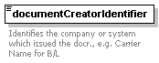
type | xs:string
used by
  elements | BillOfLadingIdentifier ContractIdentifier
annotation
  documentation | Identifies the company or system which issued the docr., e.g. Carrier Name for B/L
source | <xs:element name="documentCreatorIdentifier" type="xs:string">  <xs:annotation>  <xs:documentation>Identifies the company or system which issued the docr., e.g. Carrier Name for B/L</xs:documentation>  </xs:annotation>  </xs:element>

element documentID
diagram | 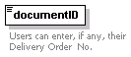
type | xs:string
used by
  element | Header
annotation
  documentation | Users can enter, if any, their Delivery Order No.
source | <xs:element name="documentID" type="xs:string">  <xs:annotation>  <xs:documentation>Users can enter, if any, their Delivery Order No.</xs:documentation>  </xs:annotation>  </xs:element>

element documentNumber
diagram | 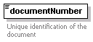
type | restriction of xs:string
used by
  elements | BillOfLadingIdentifier ContractIdentifier
facets
  maxLength | 14
annotation
  documentation | Unique identification of the document
source | <xs:element name="documentNumber">  <xs:annotation>  <xs:documentation>Unique identification of the document</xs:documentation>  </xs:annotation>  <xs:simpleType>  <xs:restriction base="xs:string">  <xs:maxLength value="14"/>  </xs:restriction>  </xs:simpleType>  </xs:element>

element documentVersion
diagram | 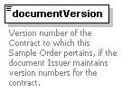
type | xs:decimal
used by
  elements | BillOfLadingIdentifier ContractIdentifier
annotation
  documentation | Version number of the Contract to which this Sample Order pertains, if the document Issuer maintains version numbers for the contract.
source | <xs:element name="documentVersion" type="xs:decimal">  <xs:annotation>  <xs:documentation>Version number of the Contract to which this Sample Order pertains, if the document Issuer maintains version numbers for the contract.</xs:documentation>  </xs:annotation>  </xs:element>

element e-TransactionNumber
diagram | 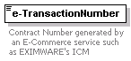
type | xs:string
used by
  element | GeneralInformation
annotation
  documentation | Contract Number generated by an E-Commerce service such as EXIMWARE's ICM
source | <xs:element name="e-TransactionNumber" type="xs:string">  <xs:annotation>  <xs:documentation>Contract Number generated by an E-Commerce service such as EXIMWARE's ICM</xs:documentation>  </xs:annotation>  </xs:element>

element endDate
diagram | 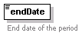
type | xs:date
used by
  element | MoveOrDeliverPeriod
annotation
  documentation | End date of the period
source | <xs:element name="endDate" type="xs:date">  <xs:annotation>  <xs:documentation>End date of the period</xs:documentation>  </xs:annotation>  </xs:element>

element estimatedDateOfAvailability
diagram | 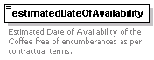
type | xs:date
used by
  element | RoutingSummary
annotation
  documentation | Estimated Date of Availability of the Coffee free of encumberances as per contractual terms.
source | <xs:element name="estimatedDateOfAvailability" type="xs:date">  <xs:annotation>  <xs:documentation>Estimated Date of Availability of the Coffee free of encumberances as per contractual terms.</xs:documentation>  </xs:annotation>  </xs:element>

element GeneralInformation
diagram | 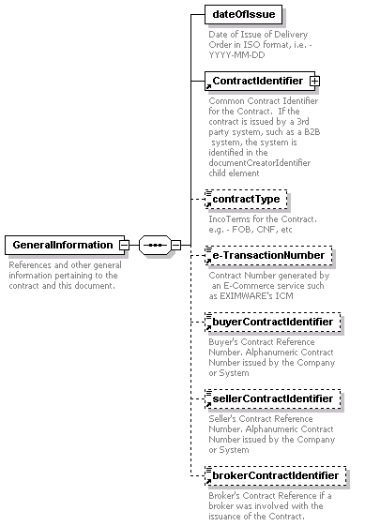
children | dateOfIssue ContractIdentifier contractType e-TransactionNumber buyerContractIdentifier sellerContractIdentifier brokerContractIdentifier
used by
  element | Body
annotation
  documentation | References and other general information pertaining to the contract and this document.
source | <xs:element name="GeneralInformation">  <xs:annotation>  <xs:documentation>References and other general information pertaining to the contract and this document.</xs:documentation>  </xs:annotation>  <xs:complexType>  <xs:sequence>  <xs:element name="dateOfIssue">  <xs:annotation>  <xs:documentation>Date of Issue of Delivery Order in ISO format, i.e. - YYYY-MM-DD</xs:documentation>  </xs:annotation>  <xs:complexType/>  </xs:element>  <xs:element ref="ContractIdentifier"/>  <xs:element ref="contractType" minOccurs="0"/>  <xs:element ref="e-TransactionNumber" minOccurs="0"/>  <xs:element ref="buyerContractIdentifier" minOccurs="0"/>  <xs:element ref="sellerContractIdentifier" minOccurs="0"/>  <xs:element ref="brokerContractIdentifier" minOccurs="0"/>  </xs:sequence>  </xs:complexType>  </xs:element>

element GeneralInformation/dateOfIssue
diagram | 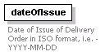
annotation
  documentation | Date of Issue of Delivery Order in ISO format, i.e. - YYYY-MM-DD
source | <xs:element name="dateOfIssue">  <xs:annotation>  <xs:documentation>Date of Issue of Delivery Order in ISO format, i.e. - YYYY-MM-DD</xs:documentation>  </xs:annotation>  <xs:complexType/>  </xs:element>

element GrossWeight
diagram | 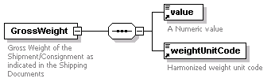
children | value weightUnitCode
used by
  element | ConsignmentDetails
annotation
  documentation | Gross Weight of the Shipment/Consignment as indicated in the Shipping Documents
source | <xs:element name="GrossWeight">  <xs:annotation>  <xs:documentation>Gross Weight of the Shipment/Consignment as indicated in the Shipping Documents</xs:documentation>  </xs:annotation>  <xs:complexType>  <xs:sequence>  <xs:element ref="value"/>  <xs:element ref="weightUnitCode"/>  </xs:sequence>  </xs:complexType>  </xs:element>

element Header
diagram | 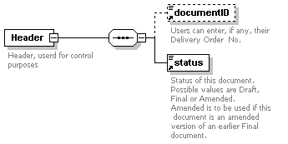
children | documentID status
used by
  element | DeliveryOrder
annotation
  documentation | Header, userd for control purposes
source | <xs:element name="Header">  <xs:annotation>  <xs:documentation>Header, userd for control purposes</xs:documentation>  </xs:annotation>  <xs:complexType>  <xs:sequence>  <xs:element ref="documentID" minOccurs="0"/>  <xs:element ref="status"/>  </xs:sequence>  </xs:complexType>  </xs:element>

element icoMark
diagram | 
type | xs:string
used by
  element | ShipmentMark
annotation
  documentation | Universal standardized ICO mark for the coffee if available.
source | <xs:element name="icoMark" type="xs:string">  <xs:annotation>  <xs:documentation>Universal standardized ICO mark for the coffee if available.</xs:documentation>  </xs:annotation>  </xs:element>

element InstructionalInformation
diagram | 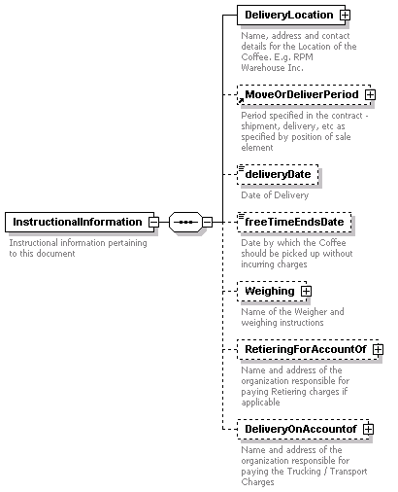
children | DeliveryLocation MoveOrDeliverPeriod deliveryDate freeTimeEndsDate Weighing RetieringForAccountOf DeliveryOnAccountof
used by
  element | Body
annotation
  documentation | Instructional information pertaining to this document
source | <xs:element name="InstructionalInformation">  <xs:annotation>  <xs:documentation>Instructional information pertaining to this document</xs:documentation>  </xs:annotation>  <xs:complexType>  <xs:sequence>  <xs:element name="DeliveryLocation">  <xs:annotation>  <xs:documentation>Name, address and contact details for the Location of the Coffee. E.g. RPM Warehouse Inc.</xs:documentation>  </xs:annotation>  <xs:complexType>  <xs:sequence>  <xs:element ref="organizationName"/>  <xs:element ref="OrganizationIdentification" minOccurs="0"/>  <xs:element ref="AddressInformation" minOccurs="0"/>  <xs:element ref="ContactDetails" minOccurs="0"/>  </xs:sequence>  </xs:complexType>  </xs:element>  <xs:element ref="MoveOrDeliverPeriod" minOccurs="0"/>  <xs:element name="deliveryDate" type="xs:date" minOccurs="0">  <xs:annotation>  <xs:documentation>Date of Delivery</xs:documentation>  </xs:annotation>  </xs:element>  <xs:element name="freeTimeEndsDate" type="xs:date" minOccurs="0">  <xs:annotation>  <xs:documentation>Date by which the Coffee should be picked up without incurring charges</xs:documentation>  </xs:annotation>  </xs:element>  <xs:element name="Weighing" minOccurs="0">  <xs:annotation>  <xs:documentation>Name of the Weigher and weighing instructions</xs:documentation>  </xs:annotation>  <xs:complexType>  <xs:sequence>  <xs:element name="percentToweigh" type="xs:decimal"/>  <xs:element name="Weigher">  <xs:annotation>  <xs:documentation>Name and address of the Organization that does the weighing, e.g. R.Markey Sons</xs:documentation>  </xs:annotation>  <xs:complexType>  <xs:sequence>  <xs:element ref="organizationName"/>  <xs:element ref="OrganizationIdentification" minOccurs="0"/>  <xs:element ref="AddressInformation" minOccurs="0"/>  <xs:element ref="ContactDetails" minOccurs="0"/>  </xs:sequence>  </xs:complexType>  </xs:element>  <xs:element ref="responsibilityOfWeighing" minOccurs="0"/>  <xs:element name="weighByDate" type="xs:date" minOccurs="0">  <xs:annotation>  <xs:documentation>Latest Date by when the Weighing should be completed </xs:documentation>  </xs:annotation>  </xs:element>  <xs:element ref="WeighingMethod" minOccurs="0"/>  </xs:sequence>  </xs:complexType>  </xs:element>  <xs:element name="RetieringForAccountOf" minOccurs="0">  <xs:annotation>  <xs:documentation>Name and address of the organization responsible for paying Retiering charges if applicable</xs:documentation>  </xs:annotation>  <xs:complexType>  <xs:sequence>  <xs:element ref="organizationName"/>  <xs:element ref="OrganizationIdentification" minOccurs="0"/>  <xs:element ref="AddressInformation" minOccurs="0"/>  <xs:element ref="ContactDetails" minOccurs="0"/>  </xs:sequence>  </xs:complexType>  </xs:element>  <xs:element name="DeliveryOnAccountof" minOccurs="0">  <xs:annotation>  <xs:documentation>Name and address of the organization responsible for paying the Trucking / Transport Charges</xs:documentation>  </xs:annotation>  <xs:complexType>  <xs:sequence>  <xs:element ref="organizationName"/>  <xs:element ref="OrganizationIdentification" minOccurs="0"/>  <xs:element ref="AddressInformation" minOccurs="0"/>  <xs:element ref="ContactDetails" minOccurs="0"/>  </xs:sequence>  </xs:complexType>  </xs:element>  </xs:sequence>  </xs:complexType>  </xs:element>

element InstructionalInformation/DeliveryLocation
diagram | 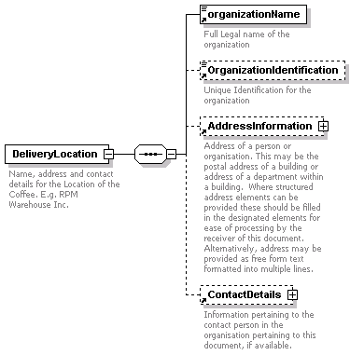
children | organizationName OrganizationIdentification AddressInformation ContactDetails
annotation
  documentation | Name, address and contact details for the Location of the Coffee. E.g. RPM Warehouse Inc.
source | <xs:element name="DeliveryLocation">  <xs:annotation>  <xs:documentation>Name, address and contact details for the Location of the Coffee. E.g. RPM Warehouse Inc.</xs:documentation>  </xs:annotation>  <xs:complexType>  <xs:sequence>  <xs:element ref="organizationName"/>  <xs:element ref="OrganizationIdentification" minOccurs="0"/>  <xs:element ref="AddressInformation" minOccurs="0"/>  <xs:element ref="ContactDetails" minOccurs="0"/>  </xs:sequence>  </xs:complexType>  </xs:element>

element InstructionalInformation/deliveryDate
diagram | 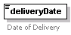
type | xs:date
annotation
  documentation | Date of Delivery
source | <xs:element name="deliveryDate" type="xs:date" minOccurs="0">  <xs:annotation>  <xs:documentation>Date of Delivery</xs:documentation>  </xs:annotation>  </xs:element>

element InstructionalInformation/freeTimeEndsDate
diagram | 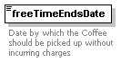
type | xs:date
annotation
  documentation | Date by which the Coffee should be picked up without incurring charges
source | <xs:element name="freeTimeEndsDate" type="xs:date" minOccurs="0">  <xs:annotation>  <xs:documentation>Date by which the Coffee should be picked up without incurring charges</xs:documentation>  </xs:annotation>  </xs:element>

element InstructionalInformation/Weighing
diagram | 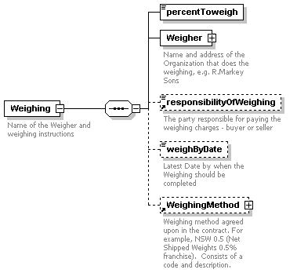
children | percentToweigh Weigher responsibilityOfWeighing weighByDate WeighingMethod
annotation
  documentation | Name of the Weigher and weighing instructions
source | <xs:element name="Weighing" minOccurs="0">  <xs:annotation>  <xs:documentation>Name of the Weigher and weighing instructions</xs:documentation>  </xs:annotation>  <xs:complexType>  <xs:sequence>  <xs:element name="percentToweigh" type="xs:decimal"/>  <xs:element name="Weigher">  <xs:annotation>  <xs:documentation>Name and address of the Organization that does the weighing, e.g. R.Markey Sons</xs:documentation>  </xs:annotation>  <xs:complexType>  <xs:sequence>  <xs:element ref="organizationName"/>  <xs:element ref="OrganizationIdentification" minOccurs="0"/>  <xs:element ref="AddressInformation" minOccurs="0"/>  <xs:element ref="ContactDetails" minOccurs="0"/>  </xs:sequence>  </xs:complexType>  </xs:element>  <xs:element ref="responsibilityOfWeighing" minOccurs="0"/>  <xs:element name="weighByDate" type="xs:date" minOccurs="0">  <xs:annotation>  <xs:documentation>Latest Date by when the Weighing should be completed </xs:documentation>  </xs:annotation>  </xs:element>  <xs:element ref="WeighingMethod" minOccurs="0"/>  </xs:sequence>  </xs:complexType>  </xs:element>

element InstructionalInformation/Weighing/percentToweigh
diagram
type | xs:decimal
source | <xs:element name="percentToweigh" type="xs:decimal"/>

element InstructionalInformation/Weighing/Weigher
diagram | 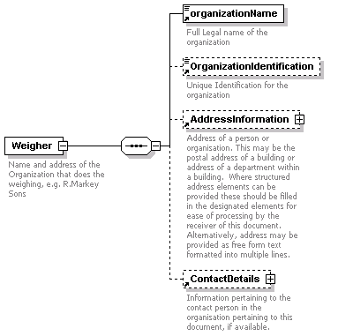
children | organizationName OrganizationIdentification AddressInformation ContactDetails
annotation
  documentation | Name and address of the Organization that does the weighing, e.g. R.Markey Sons
source | <xs:element name="Weigher">  <xs:annotation>  <xs:documentation>Name and address of the Organization that does the weighing, e.g. R.Markey Sons</xs:documentation>  </xs:annotation>  <xs:complexType>  <xs:sequence>  <xs:element ref="organizationName"/>  <xs:element ref="OrganizationIdentification" minOccurs="0"/>  <xs:element ref="AddressInformation" minOccurs="0"/>  <xs:element ref="ContactDetails" minOccurs="0"/>  </xs:sequence>  </xs:complexType>  </xs:element>

element InstructionalInformation/Weighing/weighByDate
diagram | 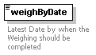
type | xs:date
annotation
  documentation | Latest Date by when the Weighing should be completed
source | <xs:element name="weighByDate" type="xs:date" minOccurs="0">  <xs:annotation>  <xs:documentation>Latest Date by when the Weighing should be completed </xs:documentation>  </xs:annotation>  </xs:element>

element InstructionalInformation/RetieringForAccountOf
diagram | 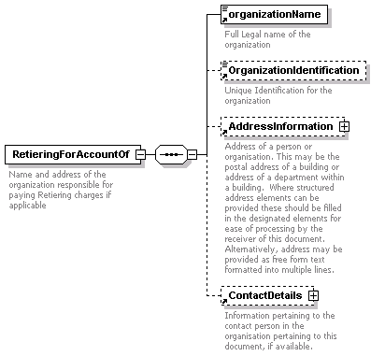
children | organizationName OrganizationIdentification AddressInformation ContactDetails
annotation
  documentation | Name and address of the organization responsible for paying Retiering charges if applicable
source | <xs:element name="RetieringForAccountOf" minOccurs="0">  <xs:annotation>  <xs:documentation>Name and address of the organization responsible for paying Retiering charges if applicable</xs:documentation>  </xs:annotation>  <xs:complexType>  <xs:sequence>  <xs:element ref="organizationName"/>  <xs:element ref="OrganizationIdentification" minOccurs="0"/>  <xs:element ref="AddressInformation" minOccurs="0"/>  <xs:element ref="ContactDetails" minOccurs="0"/>  </xs:sequence>  </xs:complexType>  </xs:element>

element InstructionalInformation/DeliveryOnAccountof
diagram | 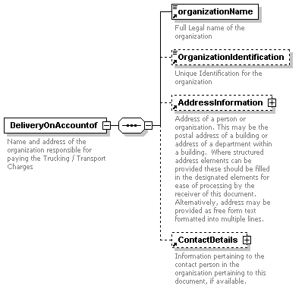
children | organizationName OrganizationIdentification AddressInformation ContactDetails
annotation
  documentation | Name and address of the organization responsible for paying the Trucking / Transport Charges
source | <xs:element name="DeliveryOnAccountof" minOccurs="0">  <xs:annotation>  <xs:documentation>Name and address of the organization responsible for paying the Trucking / Transport Charges</xs:documentation>  </xs:annotation>  <xs:complexType>  <xs:sequence>  <xs:element ref="organizationName"/>  <xs:element ref="OrganizationIdentification" minOccurs="0"/>  <xs:element ref="AddressInformation" minOccurs="0"/>  <xs:element ref="ContactDetails" minOccurs="0"/>  </xs:sequence>  </xs:complexType>  </xs:element>

element line
diagram | 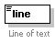
type | xs:string
used by
  elements | AddressInformation/FormattedAddress AddressInformation/NormalisedAddress/StreetAddress
annotation
  documentation | Line of text
source | <xs:element name="line" type="xs:string">  <xs:annotation>  <xs:documentation>Line of text</xs:documentation>  </xs:annotation>  </xs:element>

element locationCode
diagram | 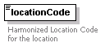
type | xs:string
used by
  elements | CountryOfDestination CountryOfOrigin PlaceOfDischarge PlaceOfLoading RoutingSummary/PlaceOfOrigin
annotation
  documentation | Harmonized Location Code for the location
source | <xs:element name="locationCode" type="xs:string">  <xs:annotation>  <xs:documentation>Harmonized Location Code for the location</xs:documentation>  </xs:annotation>  </xs:element>

element locationName
diagram | 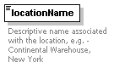
type | xs:string
used by
  elements | CountryOfOrigin LocationOfStock PlaceOfDischarge PlaceOfLoading RoutingSummary/PlaceOfOrigin
annotation
  documentation | Descriptive name associated with the location, e.g. - Continental Warehouse, New York
source | <xs:element name="locationName" type="xs:string">  <xs:annotation>  <xs:documentation>Descriptive name associated with the location, e.g. - Continental Warehouse, New York</xs:documentation>  </xs:annotation>  </xs:element>

element LocationOfStock
diagram | 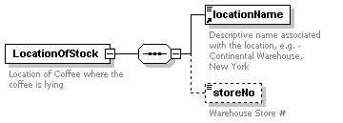
children | locationName storeNo
used by
  element | RoutingSummary
annotation
  documentation | Location of Coffee where the coffee is lying
source | <xs:element name="LocationOfStock">  <xs:annotation>  <xs:documentation>Location of Coffee where the coffee is lying</xs:documentation>  </xs:annotation>  <xs:complexType>  <xs:sequence>  <xs:element ref="locationName"/>  <xs:element name="storeNo" type="xs:string" minOccurs="0">  <xs:annotation>  <xs:documentation>Warehouse Store #</xs:documentation>  </xs:annotation>  </xs:element>  </xs:sequence>  </xs:complexType>  </xs:element>

element LocationOfStock/storeNo
diagram | 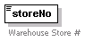
type | xs:string
annotation
  documentation | Warehouse Store #
source | <xs:element name="storeNo" type="xs:string" minOccurs="0">  <xs:annotation>  <xs:documentation>Warehouse Store #</xs:documentation>  </xs:annotation>  </xs:element>

element locomotiveNumber
diagram | 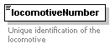
type | xs:string
used by
  element | RoutingSummary/MeansOfTransport/RailTransportIdentification
annotation
  documentation | Unique identification of the locomotive
source | <xs:element name="locomotiveNumber" type="xs:string">  <xs:annotation>  <xs:documentation>Unique identification of the locomotive</xs:documentation>  </xs:annotation>  </xs:element>

element MoveOrDeliverPeriod
diagram | 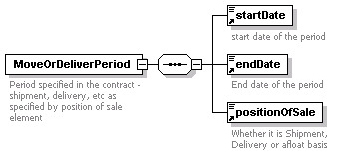
children | startDate endDate positionOfSale
used by
  element | InstructionalInformation
annotation
  documentation | Period specified in the contract - shipment, delivery, etc as specified by position of sale element
source | <xs:element name="MoveOrDeliverPeriod">  <xs:annotation>  <xs:documentation>Period specified in the contract - shipment, delivery, etc as specified by position of sale element</xs:documentation>  </xs:annotation>  <xs:complexType>  <xs:sequence>  <xs:element ref="startDate"/>  <xs:element ref="endDate"/>  <xs:element ref="positionOfSale"/>  </xs:sequence>  </xs:complexType>  </xs:element>

element NetWeight
diagram | 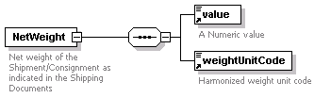
children | value weightUnitCode
used by
  element | ConsignmentDetails
annotation
  documentation | Net weight of the Shipment/Consignment as indicated in the Shipping Documents
source | <xs:element name="NetWeight">  <xs:annotation>  <xs:documentation>Net weight of the Shipment/Consignment as indicated in the Shipping Documents</xs:documentation>  </xs:annotation>  <xs:complexType>  <xs:sequence>  <xs:element ref="value"/>  <xs:element ref="weightUnitCode"/>  </xs:sequence>  </xs:complexType>  </xs:element>

element numberOfBags
diagram | 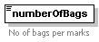
type | xs:integer
used by
  element | ShipmentMark
annotation
  documentation | No of bags per marks
source | <xs:element name="numberOfBags" type="xs:integer">  <xs:annotation>  <xs:documentation>No of bags per marks</xs:documentation>  </xs:annotation>  </xs:element>

element OrganizationIdentification
diagram | 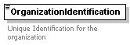
type | xs:string
used by
  elements | Broker Buyer Parties/DeliverTo InstructionalInformation/DeliveryLocation InstructionalInformation/DeliveryOnAccountof Parties/ReleaseTo InstructionalInformation/RetieringForAccountOf Seller InstructionalInformation/Weighing/Weigher
annotation
  documentation | Unique Identification for the organization
source | <xs:element name="OrganizationIdentification" type="xs:string">  <xs:annotation>  <xs:documentation>Unique Identification for the organization</xs:documentation>  </xs:annotation>  </xs:element>

element organizationName
diagram | 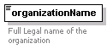
type | restriction of xs:string
used by
  elements | Broker Buyer Parties/DeliverTo InstructionalInformation/DeliveryLocation InstructionalInformation/DeliveryOnAccountof Parties/ReleaseTo InstructionalInformation/RetieringForAccountOf Seller InstructionalInformation/Weighing/Weigher
facets
  maxLength | 50
annotation
  documentation | Full Legal name of the organization
source | <xs:element name="organizationName">  <xs:annotation>  <xs:documentation>Full Legal name of the organization</xs:documentation>  </xs:annotation>  <xs:simpleType>  <xs:restriction base="xs:string">  <xs:maxLength value="50"/>  </xs:restriction>  </xs:simpleType>  </xs:element>

element packagingType
diagram | 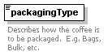
type | restriction of xs:string
used by
  element | Quantity
facets
  enumeration | BGS
  enumeration | CT
  enumeration | BLK
  enumeration | SS
  enumeration | BTD
annotation
  documentation | Describes how the coffee is to be packaged. E.g. Bags, Bulk, etc.
source | <xs:element name="packagingType">  <xs:annotation>  <xs:documentation>Describes how the coffee is to be packaged. E.g. Bags, Bulk, etc.</xs:documentation>  </xs:annotation>  <xs:simpleType>  <xs:restriction base="xs:string">  <xs:enumeration value="BGS"/>  <xs:enumeration value="CT"/>  <xs:enumeration value="BLK"/>  <xs:enumeration value="SS"/>  <xs:enumeration value="BTD"/>  </xs:restriction>  </xs:simpleType>  </xs:element>

element Parties
diagram | 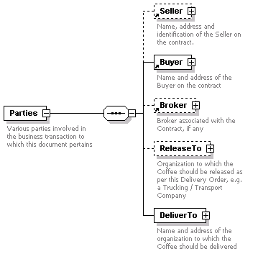
children | Seller Buyer Broker ReleaseTo DeliverTo
used by
  element | Body
annotation
  documentation | Various parties involved in the business transaction to which this document pertains
source | <xs:element name="Parties">  <xs:annotation>  <xs:documentation>Various parties involved in the business transaction to which this document pertains</xs:documentation>  </xs:annotation>  <xs:complexType>  <xs:sequence>  <xs:element ref="Seller" minOccurs="0"/>  <xs:element ref="Buyer"/>  <xs:element ref="Broker" minOccurs="0"/>  <xs:element name="ReleaseTo" minOccurs="0">  <xs:annotation>  <xs:documentation>Organization to which the Coffee should be released as per this Delivery Order, e.g. a Trucking / Transport Company</xs:documentation>  </xs:annotation>  <xs:complexType>  <xs:sequence>  <xs:element ref="organizationName"/>  <xs:element ref="OrganizationIdentification" minOccurs="0"/>  <xs:element ref="AddressInformation" minOccurs="0"/>  <xs:element ref="ContactDetails" minOccurs="0"/>  </xs:sequence>  </xs:complexType>  </xs:element>  <xs:element name="DeliverTo">  <xs:annotation>  <xs:documentation>Name and address of the organization to which the Coffee should be delivered</xs:documentation>  </xs:annotation>  <xs:complexType>  <xs:sequence>  <xs:element ref="organizationName"/>  <xs:element ref="OrganizationIdentification" minOccurs="0"/>  <xs:element ref="AddressInformation" minOccurs="0"/>  <xs:element ref="ContactDetails" minOccurs="0"/>  </xs:sequence>  </xs:complexType>  </xs:element>  </xs:sequence>  </xs:complexType>  </xs:element>

element Parties/ReleaseTo
diagram | 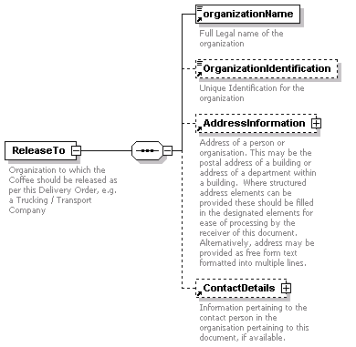
children | organizationName OrganizationIdentification AddressInformation ContactDetails
annotation
  documentation | Organization to which the Coffee should be released as per this Delivery Order, e.g. a Trucking / Transport Company
source | <xs:element name="ReleaseTo" minOccurs="0">  <xs:annotation>  <xs:documentation>Organization to which the Coffee should be released as per this Delivery Order, e.g. a Trucking / Transport Company</xs:documentation>  </xs:annotation>  <xs:complexType>  <xs:sequence>  <xs:element ref="organizationName"/>  <xs:element ref="OrganizationIdentification" minOccurs="0"/>  <xs:element ref="AddressInformation" minOccurs="0"/>  <xs:element ref="ContactDetails" minOccurs="0"/>  </xs:sequence>  </xs:complexType>  </xs:element>

element Parties/DeliverTo
diagram | 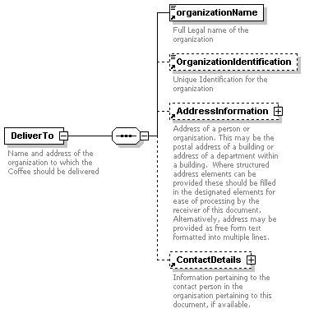
children | organizationName OrganizationIdentification AddressInformation ContactDetails
annotation
  documentation | Name and address of the organization to which the Coffee should be delivered
source | <xs:element name="DeliverTo">  <xs:annotation>  <xs:documentation>Name and address of the organization to which the Coffee should be delivered</xs:documentation>  </xs:annotation>  <xs:complexType>  <xs:sequence>  <xs:element ref="organizationName"/>  <xs:element ref="OrganizationIdentification" minOccurs="0"/>  <xs:element ref="AddressInformation" minOccurs="0"/>  <xs:element ref="ContactDetails" minOccurs="0"/>  </xs:sequence>  </xs:complexType>  </xs:element>

element PlaceOfDischarge
diagram | 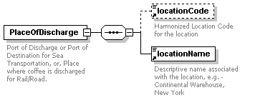
children | locationCode locationName
used by
  element | RoutingSummary
annotation
  documentation | Port of Discharge or Port of Destination for Sea Transportation, or, Place where coffee is discharged for Rail/Road.
source | <xs:element name="PlaceOfDischarge">  <xs:annotation>  <xs:documentation>Port of Discharge or Port of Destination for Sea Transportation, or, Place where coffee is discharged for Rail/Road.</xs:documentation>  </xs:annotation>  <xs:complexType>  <xs:sequence>  <xs:element ref="locationCode" minOccurs="0"/>  <xs:element ref="locationName"/>  </xs:sequence>  </xs:complexType>  </xs:element>

element PlaceOfLoading
diagram | 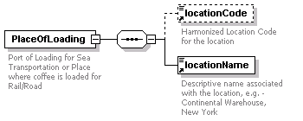
children | locationCode locationName
used by
  element | RoutingSummary
annotation
  documentation | Port of Loading for Sea Transportation or Place where coffee is loaded for Rail/Road
source | <xs:element name="PlaceOfLoading">  <xs:annotation>  <xs:documentation>Port of Loading for Sea Transportation or Place where coffee is loaded for Rail/Road</xs:documentation>  </xs:annotation>  <xs:complexType>  <xs:sequence>  <xs:element ref="locationCode" minOccurs="0"/>  <xs:element ref="locationName"/>  </xs:sequence>  </xs:complexType>  </xs:element>

element positionOfSale
diagram | 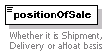
type | restriction of xs:string
used by
  element | MoveOrDeliverPeriod
facets
  enumeration | Afloat
  enumeration | Arrival
  enumeration | Arrival or Delivery at Seller's option
  enumeration | Crossing
  enumeration | DAF
  enumeration | Delivery
  enumeration | Ship
  enumeration | Spot
annotation
  documentation | Whether it is Shipment, Delivery or afloat basis
source | <xs:element name="positionOfSale">  <xs:annotation>  <xs:documentation>Whether it is Shipment, Delivery or afloat basis</xs:documentation>  </xs:annotation>  <xs:simpleType>  <xs:restriction base="xs:string">  <xs:enumeration value="Afloat"/>  <xs:enumeration value="Arrival"/>  <xs:enumeration value="Arrival or Delivery at Seller's option"/>  <xs:enumeration value="Crossing"/>  <xs:enumeration value="DAF"/>  <xs:enumeration value="Delivery"/>  <xs:enumeration value="Ship"/>  <xs:enumeration value="Spot"/>  </xs:restriction>  </xs:simpleType>  </xs:element>

element product
diagram | 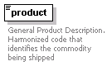
type | xs:string
used by
  element | ProductQuality
annotation
  documentation | General Product Description. Harmonized code that identifies the commodity being shipped
source | <xs:element name="product" type="xs:string">  <xs:annotation>  <xs:documentation>General Product Description. Harmonized code that identifies the commodity being shipped</xs:documentation>  </xs:annotation>  </xs:element>

element ProductDescription
diagram | 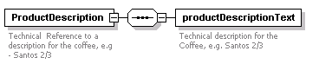
children | productDescriptionText
annotation
  documentation | Technical Reference to a description for the coffee, e.g - Santos 2/3
source | <xs:element name="ProductDescription">  <xs:annotation>  <xs:documentation>Technical Reference to a description for the coffee, e.g - Santos 2/3 </xs:documentation>  </xs:annotation>  <xs:complexType>  <xs:sequence>  <xs:element name="productDescriptionText">  <xs:annotation>  <xs:documentation>Technical description for the Coffee, e.g. Santos 2/3</xs:documentation>  </xs:annotation>  </xs:element>  </xs:sequence>  </xs:complexType>  </xs:element>

element ProductDescription/productDescriptionText
diagram | 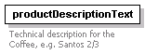
annotation
  documentation | Technical description for the Coffee, e.g. Santos 2/3
source | <xs:element name="productDescriptionText">  <xs:annotation>  <xs:documentation>Technical description for the Coffee, e.g. Santos 2/3</xs:documentation>  </xs:annotation>  </xs:element>

element ProductQuality
diagram | 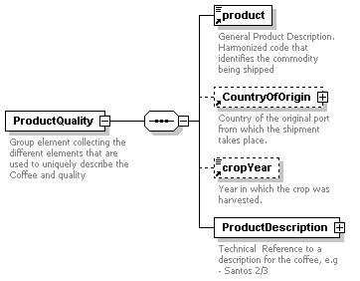
children | product CountryOfOrigin cropYear ProductDescription
used by
  element | Consignment
annotation
  documentation | Group element collecting the different elements that are used to uniquely describe the Coffee and quality
source | <xs:element name="ProductQuality">  <xs:annotation>  <xs:documentation>Group element collecting the different elements that are used to uniquely describe the Coffee and quality</xs:documentation>  </xs:annotation>  <xs:complexType>  <xs:sequence>  <xs:element ref="product"/>  <xs:element ref="CountryOfOrigin" minOccurs="0"/>  <xs:element ref="cropYear" minOccurs="0"/>  <xs:element name="ProductDescription">  <xs:annotation>  <xs:documentation>Technical Reference to a description for the coffee, e.g - Santos 2/3 </xs:documentation>  </xs:annotation>  <xs:complexType>  <xs:sequence>  <xs:element name="ProductDescriptionCode" minOccurs="0">  <xs:annotation>  <xs:documentation>Unique code reference to the technical description of the coffee like material codes. Can have multiple occurrences to list the buyer's code, seller's code, TLM code, etc.</xs:documentation>  </xs:annotation>  <xs:complexType>  <xs:sequence>  <xs:element name="codeReferenceType">  <xs:annotation>  <xs:documentation>Reference to the System or Organization or Standard which defines the code value, e.g. TLM</xs:documentation>  </xs:annotation>  </xs:element>  <xs:element name="codeValue" type="xs:string">  <xs:annotation>  <xs:documentation>Unique code reference to the technical description of the Coffee</xs:documentation>  </xs:annotation>  </xs:element>  </xs:sequence>  </xs:complexType>  </xs:element>  <xs:element name="productDescriptionText">  <xs:annotation>  <xs:documentation>Technical description for the Coffee, e.g. Santos 2/3</xs:documentation>  </xs:annotation>  </xs:element>  </xs:sequence>  </xs:complexType>  </xs:element>  </xs:sequence>  </xs:complexType>  </xs:element>

element ProductQuality/ProductDescription
diagram | 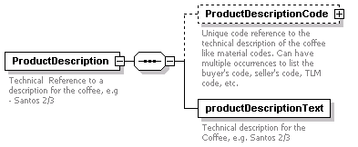
children | ProductDescriptionCode productDescriptionText
annotation
  documentation | Technical Reference to a description for the coffee, e.g - Santos 2/3
source | <xs:element name="ProductDescription">  <xs:annotation>  <xs:documentation>Technical Reference to a description for the coffee, e.g - Santos 2/3 </xs:documentation>  </xs:annotation>  <xs:complexType>  <xs:sequence>  <xs:element name="ProductDescriptionCode" minOccurs="0">  <xs:annotation>  <xs:documentation>Unique code reference to the technical description of the coffee like material codes. Can have multiple occurrences to list the buyer's code, seller's code, TLM code, etc.</xs:documentation>  </xs:annotation>  <xs:complexType>  <xs:sequence>  <xs:element name="codeReferenceType">  <xs:annotation>  <xs:documentation>Reference to the System or Organization or Standard which defines the code value, e.g. TLM</xs:documentation>  </xs:annotation>  </xs:element>  <xs:element name="codeValue" type="xs:string">  <xs:annotation>  <xs:documentation>Unique code reference to the technical description of the Coffee</xs:documentation>  </xs:annotation>  </xs:element>  </xs:sequence>  </xs:complexType>  </xs:element>  <xs:element name="productDescriptionText">  <xs:annotation>  <xs:documentation>Technical description for the Coffee, e.g. Santos 2/3</xs:documentation>  </xs:annotation>  </xs:element>  </xs:sequence>  </xs:complexType>  </xs:element>

element ProductQuality/ProductDescription/ProductDescriptionCode
diagram | 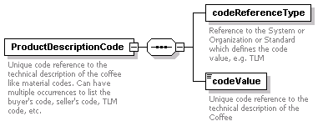
children | codeReferenceType codeValue
annotation
  documentation | Unique code reference to the technical description of the coffee like material codes. Can have multiple occurrences to list the buyer's code, seller's code, TLM code, etc.
source | <xs:element name="ProductDescriptionCode" minOccurs="0">  <xs:annotation>  <xs:documentation>Unique code reference to the technical description of the coffee like material codes. Can have multiple occurrences to list the buyer's code, seller's code, TLM code, etc.</xs:documentation>  </xs:annotation>  <xs:complexType>  <xs:sequence>  <xs:element name="codeReferenceType">  <xs:annotation>  <xs:documentation>Reference to the System or Organization or Standard which defines the code value, e.g. TLM</xs:documentation>  </xs:annotation>  </xs:element>  <xs:element name="codeValue" type="xs:string">  <xs:annotation>  <xs:documentation>Unique code reference to the technical description of the Coffee</xs:documentation>  </xs:annotation>  </xs:element>  </xs:sequence>  </xs:complexType>  </xs:element>

element ProductQuality/ProductDescription/ProductDescriptionCode/codeReferenceType
diagram | 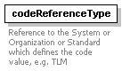
annotation
  documentation | Reference to the System or Organization or Standard which defines the code value, e.g. TLM
source | <xs:element name="codeReferenceType">  <xs:annotation>  <xs:documentation>Reference to the System or Organization or Standard which defines the code value, e.g. TLM</xs:documentation>  </xs:annotation>  </xs:element>

element ProductQuality/ProductDescription/ProductDescriptionCode/codeValue
diagram | 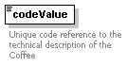
type | xs:string
annotation
  documentation | Unique code reference to the technical description of the Coffee
source | <xs:element name="codeValue" type="xs:string">  <xs:annotation>  <xs:documentation>Unique code reference to the technical description of the Coffee</xs:documentation>  </xs:annotation>  </xs:element>

element ProductQuality/ProductDescription/productDescriptionText
diagram
annotation
  documentation | Technical description for the Coffee, e.g. Santos 2/3
source | <xs:element name="productDescriptionText">  <xs:annotation>  <xs:documentation>Technical description for the Coffee, e.g. Santos 2/3</xs:documentation>  </xs:annotation>  </xs:element>

element Quantity
diagram | 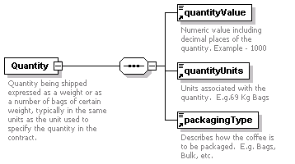
children | quantityValue quantityUnits packagingType
used by
  element | Consignment
annotation
  documentation | Quantity being shipped expressed as a weight or as a number of bags of certain weight, typically in the same units as the unit used to specify the quantity in the contract.
source | <xs:element name="Quantity">  <xs:annotation>  <xs:documentation>Quantity being shipped expressed as a weight or as a number of bags of certain weight, typically in the same units as the unit used to specify the quantity in the contract.</xs:documentation>  </xs:annotation>  <xs:complexType>  <xs:sequence>  <xs:element ref="quantityValue"/>  <xs:element ref="quantityUnits"/>  <xs:element ref="packagingType"/>  </xs:sequence>  </xs:complexType>  </xs:element>

element quantityUnits
diagram | 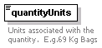
type | restriction of xs:string
used by
  element | Quantity
facets
  enumeration | 60KB
  enumeration | 69KB
  enumeration | 70KB
  enumeration | MT
  enumeration | LBS
  enumeration | KGS
  enumeration | 46KB
annotation
  documentation | Units associated with the quantity. E.g.69 Kg Bags
source | <xs:element name="quantityUnits">  <xs:annotation>  <xs:documentation>Units associated with the quantity. E.g.69 Kg Bags</xs:documentation>  </xs:annotation>  <xs:simpleType>  <xs:restriction base="xs:string">  <xs:enumeration value="60KB"/>  <xs:enumeration value="69KB"/>  <xs:enumeration value="70KB"/>  <xs:enumeration value="MT"/>  <xs:enumeration value="LBS"/>  <xs:enumeration value="KGS"/>  <xs:enumeration value="46KB"/>  </xs:restriction>  </xs:simpleType>  </xs:element>

element quantityValue
diagram | 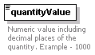
type | xs:double
used by
  element | Quantity
annotation
  documentation | Numeric value including decimal places of the quantity. Example - 1000
source | <xs:element name="quantityValue" type="xs:double">  <xs:annotation>  <xs:documentation>Numeric value including decimal places of the quantity. Example - 1000</xs:documentation>  </xs:annotation>  </xs:element>

element railCarNumber
diagram | 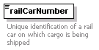
type | xs:string
used by
  element | RoutingSummary/MeansOfTransport/RailTransportIdentification
annotation
  documentation | Unique identification of a rail car on which cargo is being shipped
source | <xs:element name="railCarNumber" type="xs:string">  <xs:annotation>  <xs:documentation>Unique identification of a rail car on which cargo is being shipped</xs:documentation>  </xs:annotation>  </xs:element>

element responsibilityOfWeighing
diagram | 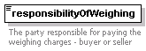
type | restriction of xs:string
used by
  element | InstructionalInformation/Weighing
facets
  enumeration | Buyer
  enumeration | Seller
annotation
  documentation | The party responsible for paying the weighing charges - buyer or seller
source | <xs:element name="responsibilityOfWeighing">  <xs:annotation>  <xs:documentation>The party responsible for paying the weighing charges - buyer or seller</xs:documentation>  </xs:annotation>  <xs:simpleType>  <xs:restriction base="xs:string">  <xs:enumeration value="Buyer"/>  <xs:enumeration value="Seller"/>  </xs:restriction>  </xs:simpleType>  </xs:element>

element RoutingSummary
diagram | 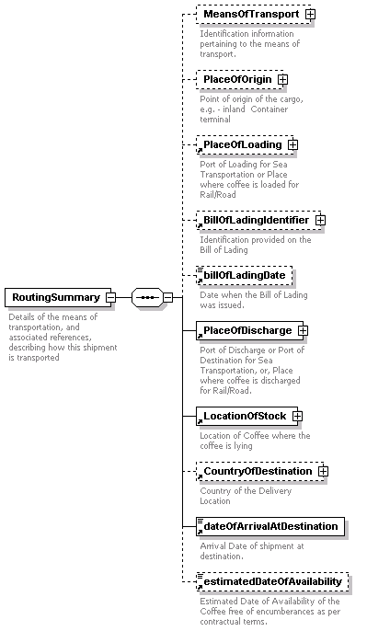
children | MeansOfTransport PlaceOfOrigin PlaceOfLoading BillOfLadingIdentifier billOfLadingDate PlaceOfDischarge LocationOfStock CountryOfDestination dateOfArrivalAtDestination estimatedDateOfAvailability
used by
  element | Body
annotation
  documentation | Details of the means of transportation, and associated references, describing how this shipment is transported
source | <xs:element name="RoutingSummary">  <xs:annotation>  <xs:documentation>Details of the means of transportation, and associated references, describing how this shipment is transported</xs:documentation>  </xs:annotation>  <xs:complexType>  <xs:sequence>  <xs:element name="MeansOfTransport" minOccurs="0">  <xs:annotation>  <xs:documentation>Identification information pertaining to the means of transport. </xs:documentation>  </xs:annotation>  <xs:complexType>  <xs:choice>  <xs:element name="SeaTransportIdentification">  <xs:annotation>  <xs:documentation>Identification of the vessel and voyage if the shipment is made via sea/ocean transport.</xs:documentation>  </xs:annotation>  <xs:complexType>  <xs:sequence>  <xs:element name="Voyage" maxOccurs="unbounded">  <xs:annotation>  <xs:documentation>Details of the Vessel and voyage. Can have multiple entries to provide details of Feeder and Main Vessel segments.</xs:documentation>  </xs:annotation>  <xs:complexType>  <xs:sequence>  <xs:element ref="Vessel"/>  <xs:element ref="voyageNumber" minOccurs="0"/>  <xs:element name="estimatedDateOfArrivalAtDestination" type="xs:date">  <xs:annotation>  <xs:documentation>Estimated Date of Arrival of shipment at destination.</xs:documentation>  </xs:annotation>  </xs:element>  </xs:sequence>  </xs:complexType>  </xs:element>  </xs:sequence>  </xs:complexType>  </xs:element>  <xs:element name="RailTransportIdentification">  <xs:annotation>  <xs:documentation>Identification of the rail car if the shipment is transported by rail</xs:documentation>  </xs:annotation>  <xs:complexType>  <xs:sequence>  <xs:element name="carrier" type="xs:string">  <xs:annotation>  <xs:documentation>Name of the carrier / Railroad organisation, e.g. Norfolk Southern</xs:documentation>  </xs:annotation>  </xs:element>  <xs:element ref="locomotiveNumber"/>  <xs:element ref="railCarNumber"/>  </xs:sequence>  </xs:complexType>  </xs:element>  <xs:element name="RoadTransportIdentification">  <xs:annotation>  <xs:documentation>Identification of the truck or other vehicle, if this shipment is transported overland via road.</xs:documentation>  </xs:annotation>  <xs:complexType>  <xs:sequence>  <xs:element name="carrier" type="xs:string">  <xs:annotation>  <xs:documentation>Name of the carrier / trucking organisation, e.g. Allied Van Lines</xs:documentation>  </xs:annotation>  </xs:element>  <xs:element name="licensePlateNumber" type="xs:string">  <xs:annotation>  <xs:documentation>License Plate Number of the truck</xs:documentation>  </xs:annotation>  </xs:element>  </xs:sequence>  </xs:complexType>  </xs:element>  </xs:choice>  </xs:complexType>  </xs:element>  <xs:element name="PlaceOfOrigin" minOccurs="0">  <xs:annotation>  <xs:documentation>Point of origin of the cargo, e.g. - inland Container terminal </xs:documentation>  </xs:annotation>  <xs:complexType>  <xs:sequence>  <xs:element ref="locationCode"/>  <xs:element ref="locationName"/>  </xs:sequence>  </xs:complexType>  </xs:element>  <xs:element ref="PlaceOfLoading" minOccurs="0"/>  <xs:element ref="BillOfLadingIdentifier" minOccurs="0"/>  <xs:element ref="billOfLadingDate" minOccurs="0"/>  <xs:element ref="PlaceOfDischarge"/>  <xs:element ref="LocationOfStock"/>  <xs:element ref="CountryOfDestination" minOccurs="0"/>  <xs:element ref="dateOfArrivalAtDestination"/>  <xs:element ref="estimatedDateOfAvailability" minOccurs="0"/>  </xs:sequence>  </xs:complexType>  </xs:element>

element RoutingSummary/MeansOfTransport
diagram | 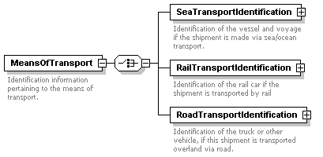
children | SeaTransportIdentification RailTransportIdentification RoadTransportIdentification
annotation
  documentation | Identification information pertaining to the means of transport.
source | <xs:element name="MeansOfTransport" minOccurs="0">  <xs:annotation>  <xs:documentation>Identification information pertaining to the means of transport. </xs:documentation>  </xs:annotation>  <xs:complexType>  <xs:choice>  <xs:element name="SeaTransportIdentification">  <xs:annotation>  <xs:documentation>Identification of the vessel and voyage if the shipment is made via sea/ocean transport.</xs:documentation>  </xs:annotation>  <xs:complexType>  <xs:sequence>  <xs:element name="Voyage" maxOccurs="unbounded">  <xs:annotation>  <xs:documentation>Details of the Vessel and voyage. Can have multiple entries to provide details of Feeder and Main Vessel segments.</xs:documentation>  </xs:annotation>  <xs:complexType>  <xs:sequence>  <xs:element ref="Vessel"/>  <xs:element ref="voyageNumber" minOccurs="0"/>  <xs:element name="estimatedDateOfArrivalAtDestination" type="xs:date">  <xs:annotation>  <xs:documentation>Estimated Date of Arrival of shipment at destination.</xs:documentation>  </xs:annotation>  </xs:element>  </xs:sequence>  </xs:complexType>  </xs:element>  </xs:sequence>  </xs:complexType>  </xs:element>  <xs:element name="RailTransportIdentification">  <xs:annotation>  <xs:documentation>Identification of the rail car if the shipment is transported by rail</xs:documentation>  </xs:annotation>  <xs:complexType>  <xs:sequence>  <xs:element name="carrier" type="xs:string">  <xs:annotation>  <xs:documentation>Name of the carrier / Railroad organisation, e.g. Norfolk Southern</xs:documentation>  </xs:annotation>  </xs:element>  <xs:element ref="locomotiveNumber"/>  <xs:element ref="railCarNumber"/>  </xs:sequence>  </xs:complexType>  </xs:element>  <xs:element name="RoadTransportIdentification">  <xs:annotation>  <xs:documentation>Identification of the truck or other vehicle, if this shipment is transported overland via road.</xs:documentation>  </xs:annotation>  <xs:complexType>  <xs:sequence>  <xs:element name="carrier" type="xs:string">  <xs:annotation>  <xs:documentation>Name of the carrier / trucking organisation, e.g. Allied Van Lines</xs:documentation>  </xs:annotation>  </xs:element>  <xs:element name="licensePlateNumber" type="xs:string">  <xs:annotation>  <xs:documentation>License Plate Number of the truck</xs:documentation>  </xs:annotation>  </xs:element>  </xs:sequence>  </xs:complexType>  </xs:element>  </xs:choice>  </xs:complexType>  </xs:element>

element RoutingSummary/MeansOfTransport/SeaTransportIdentification
diagram | 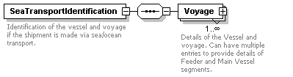
children | Voyage
annotation
  documentation | Identification of the vessel and voyage if the shipment is made via sea/ocean transport.
source | <xs:element name="SeaTransportIdentification">  <xs:annotation>  <xs:documentation>Identification of the vessel and voyage if the shipment is made via sea/ocean transport.</xs:documentation>  </xs:annotation>  <xs:complexType>  <xs:sequence>  <xs:element name="Voyage" maxOccurs="unbounded">  <xs:annotation>  <xs:documentation>Details of the Vessel and voyage. Can have multiple entries to provide details of Feeder and Main Vessel segments.</xs:documentation>  </xs:annotation>  <xs:complexType>  <xs:sequence>  <xs:element ref="Vessel"/>  <xs:element ref="voyageNumber" minOccurs="0"/>  <xs:element name="estimatedDateOfArrivalAtDestination" type="xs:date">  <xs:annotation>  <xs:documentation>Estimated Date of Arrival of shipment at destination.</xs:documentation>  </xs:annotation>  </xs:element>  </xs:sequence>  </xs:complexType>  </xs:element>  </xs:sequence>  </xs:complexType>  </xs:element>

element RoutingSummary/MeansOfTransport/SeaTransportIdentification/Voyage
diagram | 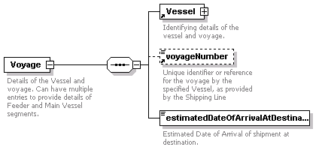
children | Vessel voyageNumber estimatedDateOfArrivalAtDestination
annotation
  documentation | Details of the Vessel and voyage. Can have multiple entries to provide details of Feeder and Main Vessel segments.
source | <xs:element name="Voyage" maxOccurs="unbounded">  <xs:annotation>  <xs:documentation>Details of the Vessel and voyage. Can have multiple entries to provide details of Feeder and Main Vessel segments.</xs:documentation>  </xs:annotation>  <xs:complexType>  <xs:sequence>  <xs:element ref="Vessel"/>  <xs:element ref="voyageNumber" minOccurs="0"/>  <xs:element name="estimatedDateOfArrivalAtDestination" type="xs:date">  <xs:annotation>  <xs:documentation>Estimated Date of Arrival of shipment at destination.</xs:documentation>  </xs:annotation>  </xs:element>  </xs:sequence>  </xs:complexType>  </xs:element>

element RoutingSummary/MeansOfTransport/SeaTransportIdentification/Voyage/estimatedDateOfArrivalAtDestination
diagram | 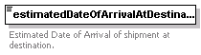
type | xs:date
annotation
  documentation | Estimated Date of Arrival of shipment at destination.
source | <xs:element name="estimatedDateOfArrivalAtDestination" type="xs:date">  <xs:annotation>  <xs:documentation>Estimated Date of Arrival of shipment at destination.</xs:documentation>  </xs:annotation>  </xs:element>

element RoutingSummary/MeansOfTransport/RailTransportIdentification
diagram | 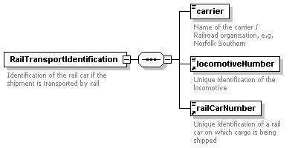
children | carrier locomotiveNumber railCarNumber
annotation
  documentation | Identification of the rail car if the shipment is transported by rail
source | <xs:element name="RailTransportIdentification">  <xs:annotation>  <xs:documentation>Identification of the rail car if the shipment is transported by rail</xs:documentation>  </xs:annotation>  <xs:complexType>  <xs:sequence>  <xs:element name="carrier" type="xs:string">  <xs:annotation>  <xs:documentation>Name of the carrier / Railroad organisation, e.g. Norfolk Southern</xs:documentation>  </xs:annotation>  </xs:element>  <xs:element ref="locomotiveNumber"/>  <xs:element ref="railCarNumber"/>  </xs:sequence>  </xs:complexType>  </xs:element>

element RoutingSummary/MeansOfTransport/RailTransportIdentification/carrier
diagram | 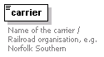
type | xs:string
annotation
  documentation | Name of the carrier / Railroad organisation, e.g. Norfolk Southern
source | <xs:element name="carrier" type="xs:string">  <xs:annotation>  <xs:documentation>Name of the carrier / Railroad organisation, e.g. Norfolk Southern</xs:documentation>  </xs:annotation>  </xs:element>

element RoutingSummary/MeansOfTransport/RoadTransportIdentification
diagram | 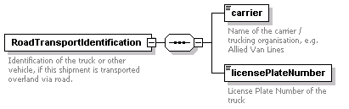
children | carrier licensePlateNumber
annotation
  documentation | Identification of the truck or other vehicle, if this shipment is transported overland via road.
source | <xs:element name="RoadTransportIdentification">  <xs:annotation>  <xs:documentation>Identification of the truck or other vehicle, if this shipment is transported overland via road.</xs:documentation>  </xs:annotation>  <xs:complexType>  <xs:sequence>  <xs:element name="carrier" type="xs:string">  <xs:annotation>  <xs:documentation>Name of the carrier / trucking organisation, e.g. Allied Van Lines</xs:documentation>  </xs:annotation>  </xs:element>  <xs:element name="licensePlateNumber" type="xs:string">  <xs:annotation>  <xs:documentation>License Plate Number of the truck</xs:documentation>  </xs:annotation>  </xs:element>  </xs:sequence>  </xs:complexType>  </xs:element>

element RoutingSummary/MeansOfTransport/RoadTransportIdentification/carrier
diagram | 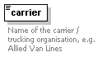
type | xs:string
annotation
  documentation | Name of the carrier / trucking organisation, e.g. Allied Van Lines
source | <xs:element name="carrier" type="xs:string">  <xs:annotation>  <xs:documentation>Name of the carrier / trucking organisation, e.g. Allied Van Lines</xs:documentation>  </xs:annotation>  </xs:element>

element RoutingSummary/MeansOfTransport/RoadTransportIdentification/licensePlateNumber
diagram | 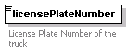
type | xs:string
annotation
  documentation | License Plate Number of the truck
source | <xs:element name="licensePlateNumber" type="xs:string">  <xs:annotation>  <xs:documentation>License Plate Number of the truck</xs:documentation>  </xs:annotation>  </xs:element>

element RoutingSummary/PlaceOfOrigin
diagram | 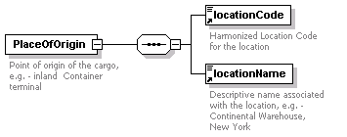
children | locationCode locationName
annotation
  documentation | Point of origin of the cargo, e.g. - inland Container terminal
source | <xs:element name="PlaceOfOrigin" minOccurs="0">  <xs:annotation>  <xs:documentation>Point of origin of the cargo, e.g. - inland Container terminal </xs:documentation>  </xs:annotation>  <xs:complexType>  <xs:sequence>  <xs:element ref="locationCode"/>  <xs:element ref="locationName"/>  </xs:sequence>  </xs:complexType>  </xs:element>

element seal
diagram | 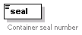
type | xs:string
used by
  element | ContainerIdentifiers
annotation
  documentation | Container seal number
source | <xs:element name="seal" type="xs:string">  <xs:annotation>  <xs:documentation>Container seal number</xs:documentation>  </xs:annotation>  </xs:element>

element Seller
diagram | 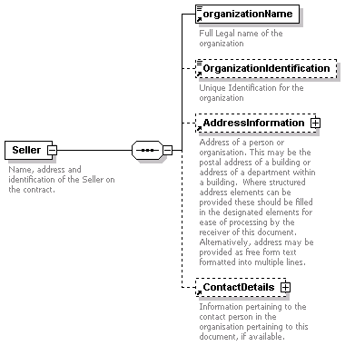
children | organizationName OrganizationIdentification AddressInformation ContactDetails
used by
  element | Parties
annotation
  documentation | Name, address and identification of the Seller on the contract.
source | <xs:element name="Seller">  <xs:annotation>  <xs:documentation>Name, address and identification of the Seller on the contract.</xs:documentation>  </xs:annotation>  <xs:complexType>  <xs:sequence>  <xs:element ref="organizationName"/>  <xs:element ref="OrganizationIdentification" minOccurs="0"/>  <xs:element ref="AddressInformation" minOccurs="0"/>  <xs:element ref="ContactDetails" minOccurs="0"/>  </xs:sequence>  </xs:complexType>  </xs:element>

element sellerContractIdentifier
diagram | 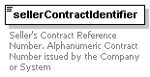
type | xs:string
used by
  element | GeneralInformation
annotation
  documentation | Seller's Contract Reference Number. Alphanumeric Contract Number issued by the Company or System
source | <xs:element name="sellerContractIdentifier" type="xs:string">  <xs:annotation>  <xs:documentation>Seller's Contract Reference Number. Alphanumeric Contract Number issued by the Company or System</xs:documentation>  </xs:annotation>  </xs:element>

element ShipmentMark
diagram | 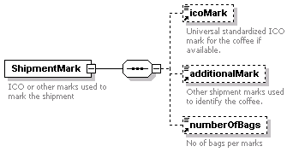
children | icoMark additionalMark numberOfBags
used by
  element | ContainerIdentifiers
annotation
  documentation | ICO or other marks used to mark the shipment
source | <xs:element name="ShipmentMark">  <xs:annotation>  <xs:documentation>ICO or other marks used to mark the shipment</xs:documentation>  </xs:annotation>  <xs:complexType>  <xs:sequence>  <xs:element ref="icoMark" minOccurs="0"/>  <xs:element ref="additionalMark" minOccurs="0"/>  <xs:element ref="numberOfBags" minOccurs="0"/>  </xs:sequence>  </xs:complexType>  </xs:element>

element startDate
diagram | 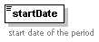
type | xs:date
used by
  element | MoveOrDeliverPeriod
annotation
  documentation | start date of the period
source | <xs:element name="startDate" type="xs:date">  <xs:annotation>  <xs:documentation>start date of the period</xs:documentation>  </xs:annotation>  </xs:element>

element status
diagram | 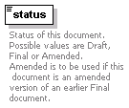
type | list of xs:string
used by
  element | Header
annotation
  documentation | Status of this document. Possible values are Draft, Final or Amended. Amended is to be used if this document is an amended version of an earlier Final document.
source | <xs:element name="status">  <xs:annotation>  <xs:documentation>Status of this document. Possible values are Draft, Final or Amended. Amended is to be used if this document is an amended version of an earlier Final document.</xs:documentation>  </xs:annotation>  <xs:simpleType>  <xs:list itemType="xs:string"/>  </xs:simpleType>  </xs:element>

element value
diagram | 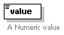
type | xs:decimal
used by
  elements | GrossWeight NetWeight
annotation
  documentation | A Numeric value
source | <xs:element name="value" type="xs:decimal">  <xs:annotation>  <xs:documentation>A Numeric value</xs:documentation>  </xs:annotation>  </xs:element>

element Vessel
diagram | 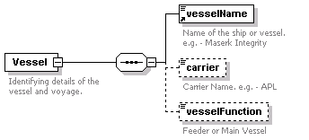
children | vesselName carrier vesselFunction
used by
  element | RoutingSummary/MeansOfTransport/SeaTransportIdentification/Voyage
annotation
  documentation | Identifying details of the vessel and voyage.
source | <xs:element name="Vessel">  <xs:annotation>  <xs:documentation>Identifying details of the vessel and voyage.</xs:documentation>  </xs:annotation>  <xs:complexType>  <xs:sequence>  <xs:element ref="vesselName"/>  <xs:element name="carrier" type="xs:string" minOccurs="0">  <xs:annotation>  <xs:documentation>Carrier Name. e.g. - APL </xs:documentation>  </xs:annotation>  </xs:element>  <xs:element name="vesselFunction" minOccurs="0">  <xs:annotation>  <xs:documentation>Feeder or Main Vessel</xs:documentation>  </xs:annotation>  <xs:simpleType>  <xs:restriction base="xs:string">  <xs:enumeration value="Feeder"/>  <xs:enumeration value="Main"/>  </xs:restriction>  </xs:simpleType>  </xs:element>  </xs:sequence>  </xs:complexType>  </xs:element>

element Vessel/carrier
diagram | 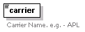
type | xs:string
annotation
  documentation | Carrier Name. e.g. - APL
source | <xs:element name="carrier" type="xs:string" minOccurs="0">  <xs:annotation>  <xs:documentation>Carrier Name. e.g. - APL </xs:documentation>  </xs:annotation>  </xs:element>

element Vessel/vesselFunction
diagram | 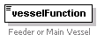
type | restriction of xs:string
facets
  enumeration | Feeder
  enumeration | Main
annotation
  documentation | Feeder or Main Vessel
source | <xs:element name="vesselFunction" minOccurs="0">  <xs:annotation>  <xs:documentation>Feeder or Main Vessel</xs:documentation>  </xs:annotation>  <xs:simpleType>  <xs:restriction base="xs:string">  <xs:enumeration value="Feeder"/>  <xs:enumeration value="Main"/>  </xs:restriction>  </xs:simpleType>  </xs:element>

element vesselName
diagram | 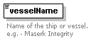
type | xs:string
used by
  element | Vessel
annotation
  documentation | Name of the ship or vessel. e.g. - Maserk Integrity
source | <xs:element name="vesselName" type="xs:string">  <xs:annotation>  <xs:documentation>Name of the ship or vessel. e.g. - Maserk Integrity</xs:documentation>  </xs:annotation>  </xs:element>

element voyageNumber
diagram | 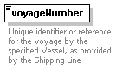
type | xs:string
used by
  element | RoutingSummary/MeansOfTransport/SeaTransportIdentification/Voyage
annotation
  documentation | Unique identifier or reference for the voyage by the specified Vessel, as provided by the Shipping Line
source | <xs:element name="voyageNumber" type="xs:string">  <xs:annotation>  <xs:documentation>Unique identifier or reference for the voyage by the specified Vessel, as provided by the Shipping Line</xs:documentation>  </xs:annotation>  </xs:element>

element WeighingMethod
diagram | 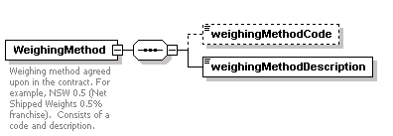
children | weighingMethodCode weighingMethodDescription
used by
  element | InstructionalInformation/Weighing
annotation
  documentation | Weighing method agreed upon in the contract. For example, NSW 0.5 (Net Shipped Weights 0.5% franchise). Consists of a code and description.
source | <xs:element name="WeighingMethod">  <xs:annotation>  <xs:documentation>Weighing method agreed upon in the contract. For example, NSW 0.5 (Net Shipped Weights 0.5% franchise). Consists of a code and description.</xs:documentation>  </xs:annotation>  <xs:complexType>  <xs:sequence>  <xs:element name="weighingMethodCode" minOccurs="0">  <xs:simpleType>  <xs:restriction base="xs:string">  <xs:enumeration value="NULL"/>  <xs:enumeration value="SW 0.5"/>  <xs:enumeration value="SW 1"/>  <xs:enumeration value="LW"/>  <xs:enumeration value="DW"/>  <xs:enumeration value="PW"/>  <xs:enumeration value="RW"/>  <xs:enumeration value="SiW"/>  </xs:restriction>  </xs:simpleType>  </xs:element>  <xs:element name="weighingMethodDescription" type="xs:string"/>  </xs:sequence>  </xs:complexType>  </xs:element>

element WeighingMethod/weighingMethodCode
diagram
type | restriction of xs:string
facets
  enumeration | NULL
  enumeration | SW 0.5
  enumeration | SW 1
  enumeration | LW
  enumeration | DW
  enumeration | PW
  enumeration | RW
  enumeration | SiW
source | <xs:element name="weighingMethodCode" minOccurs="0">  <xs:simpleType>  <xs:restriction base="xs:string">  <xs:enumeration value="NULL"/>  <xs:enumeration value="SW 0.5"/>  <xs:enumeration value="SW 1"/>  <xs:enumeration value="LW"/>  <xs:enumeration value="DW"/>  <xs:enumeration value="PW"/>  <xs:enumeration value="RW"/>  <xs:enumeration value="SiW"/>  </xs:restriction>  </xs:simpleType>  </xs:element>

element WeighingMethod/weighingMethodDescription
diagram
type | xs:string
source | <xs:element name="weighingMethodDescription" type="xs:string"/>

element weightUnitCode
diagram | 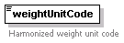
type | restriction of xs:string
used by
  elements | GrossWeight NetWeight
facets
  enumeration | MT
  enumeration | LBS
  enumeration | KGS
  enumeration | 46KB
  enumeration | 60KB
  enumeration | 69KB
  enumeration | 70KB
  enumeration | 75KB
annotation
  documentation | Harmonized weight unit code
source | <xs:element name="weightUnitCode">  <xs:annotation>  <xs:documentation>Harmonized weight unit code</xs:documentation>  </xs:annotation>  <xs:simpleType>  <xs:restriction base="xs:string">  <xs:enumeration value="MT"/>  <xs:enumeration value="LBS"/>  <xs:enumeration value="KGS"/>  <xs:enumeration value="46KB"/>  <xs:enumeration value="60KB"/>  <xs:enumeration value="69KB"/>  <xs:enumeration value="70KB"/>  <xs:enumeration value="75KB"/>  </xs:restriction>  </xs:simpleType>  </xs:element>

XML Schema documentation generated with XML Spy Schema Editor www.xmlspy.com

